

Question/Answer Booklet

JAPANESE: SECOND
LANGUAGE

WRITTEN PAPER
STAGE 3B, 2015

Student Number: In figures
In Words
Student Name:

Time allowed for this paper
Reading/viewing time before commencing work: ten minutes
Working time for paper: two and a half hours

Materials required/recommended for this paper

To be provided by the supervisor
This Question/Answer Booklet
Sound recording

To be provided by the candidate
Standard items: pens (blue/black preferred), pencils (including colour), sharpener, eraser, correction fluid/tape, ruler, highlighters
Special items: dictionaries: one combined dictionary (Japanese/English and English/Japanese) or two separate dictionaries (one English/Japanese and one Japanese/English dictionary). No electronic dictionaries are allowed
Note: Dictionaries must not contain any notes or other marks

Important note to candidates
No other items may be taken into the examination room. It is your responsibility to ensure that you do not have any unauthorised notes or other items of a non-personal nature in the examination room. If you have any unauthorised material with you, hand it to the supervisor before reading any further.

Structure of the examination

The mid-year Japanese: Second Language Stage 3 examination consists of a written component worth 75 per cent of the total examination score and a practical (oral) examination worth 25 per cent of the total examination score.

Section | Number of questions available | Number of questions  to be answered | Suggested working time  (minutes) | Marks available | Percentage of total exam | Your  Mark
Section One:  Response (Listening and responding) | 15 | 15 | 30 minutes | 44 | 25 | /25
Section Two:  Response (Viewing, reading and responding) | 13 | 13 | 60 minutes | 48 | 30 | /30
Section Three:  Written Communication  Part A: Stimulus and response  Part B: Extended writing | 1  2 | 1  1 | 60 minutes | 30 | 20 | /20
 |  |  |  | Total | 75 | /75

Instructions to candidates

- Write your answers in Standard Australian English or in Japanese as required in this Question/Answer Booklet.

- You must be careful to confine your responses to the specific questions asked and to follow any instructions that are specific to a particular question. You may not use SMS style abbreviations in any section of the paper.

- Spare pages are included at the end of this booklet. They can be used for planning your responses and/or as additional space if required to continue an answer.

- Planning: If you use the spare pages for planning, indicate this clearly at the top of the page.
- Continuing an answer: If you need to use the space to continue an answer, indicate in the original answer space where the answer is continued, i.e. give the page number. Fill in the number of the question that you are continuing to answer at the top of the page.

- Hand in this Question/Answer Booklet at the end of the examination.

Test Piece of Audio Text with Script

Listen to the short text, which is printed below. This will help you to become accustomed to the speakers’ voices. There are no questions or marks associated with this text.

女： 今日の午後は何かよていがある？
男： うん、4時からクリケットのれんしゅうがあるんだ。
女： クリケットって、私ルールがよく分からないのよね。
男： えっ、日本にはクリケットはないの？
女： うん、ぜんぜんないよ。日本にいる時、私、いちどもクリケットの事を聞いた
事がなかったわ。
男： へ～え、そう。じゃ、日本で人気があるスポーツは何？
女： そうねえ、やきゅうやサッカーかな。

Turn over and begin Section One.

Section One: Response (Listening and responding) 25% (44 marks)
This section contains fifteen (15) questions. Answer all questions in English in the spaces provided.

You will hear four (4) texts in Japanese. Text 1 is divided into two parts. Each text, including parts of Text 1, will be played twice, with a short pause between the first and second readings. After the second reading, there will be time to answer the questions.

You make take notes during this time. Your notes will not be marked. You may come back to this section at any time during the working time for this paper.

Suggested working time: 30 minutes

TEXT 1 (5 marks)

Listen to Jarrod talk about getting a driver’s license.
Space for Notes
Part (i)

Are the statements true or false? Circle the correct answer.

1. Jarrod needs his driver’s license because his boss wants him to work more. | True | False
2. If Jarrod gets his license, his parents won’t have to pick him up, and he can get home from late shifts easily on his own. | True | False
3. Because he hasn’t had his license, he’s had to take the train, bus and cycle to work. | True | False
4. Jarrod has found it tough because without his license it has taken an hour and a half to get to and from work. | True | False
5. The worst problem has been that, when Jarrod returns home late at night, there are not many buses or trains. | True | False

TEXT 1 (2 marks)

Listen to Jarrod continue to talk about getting a driver’s license.
Space for Notes
Part (ii)
- (1 mark)

Circle the most appropriate alternative from a, b, c, or d.

Shoo was surprised that Jarrod had bought a car because

- Japanese people usually wait until they are at university to buy one
- Japanese people usually wait until after high school graduation to buy a car because they are an expensive thing.
- cars are an expensive thing and university and high school students can’t easily buy one.
- Shoo won’t buy a car until he has his license and he won’t get his license until after he graduates from high school.

- (1 mark)

Circle the most appropriate alternative from a, b, c, or d.

Having a car is a worry because

- Jarrod believes that having a car means you need insurance, which is more expensive lately.
- Jarrod’s older sister recently bought a car and according to her, cars are expensive with petrol and insurance.
- Shoo believes that when you start to drive, you have to have insurance and petrol which is also expensive.
- it costs money for cars, and according to Jarrod’s older sister, when you start to drive you have to have insurance and petrol which is also expensive lately.

TEXT 2 (13 marks)
Space for Notes

Listen to Maho and Chris talk about the past year.

How does Chris think he went in his exams?
______________________________________________________

______________________________________________________
______________________________________________________
(3 marks)

How has Chris been going with trying to study with a tutor?

______________________________________________________

______________________________________________________
______________________________________________________
(3 marks)

Why does Maho want to rent a kimono to wear to the Adult’s Day ceremony?
______________________________________________________

______________________________________________________
______________________________________________________
______________________________________________________

______________________________________________________

______________________________________________________
______________________________________________________
(4 marks)

Why does Maho need to make a booking beforehand?

______________________________________________________

______________________________________________________
______________________________________________________
(3 marks)
TEXT 3 (11 marks)
Space for Notes
Listen to Alice and her Japanese teacher discuss future plans.

How does Alice plan to use her Japanese after graduation?
______________________________________________________
______________________________________________________
(2 marks)

Describe Alice’s thoughts about becoming a teacher.
______________________________________________________
______________________________________________________
______________________________________________________
(3 marks)

In order for Alice not to forget the Japanese she has studied, what will she do?
______________________________________________________
______________________________________________________
______________________________________________________
______________________________________________________
(3 marks)

Describe what Alice has been doing recently.
______________________________________________________
______________________________________________________
______________________________________________________
(3 marks)

TEXT 4 (13 marks)
Space for Notes
Listen to Rina and David talk about the past year.

Why didn’t Rina go to the party?
______________________________________________________
______________________________________________________
______________________________________________________
______________________________________________________
(4 marks)

What did David’s parents say to David about study?
______________________________________________________
______________________________________________________
______________________________________________________
(2 marks)

What concern(s) does David mention about a venue for the school ball?
______________________________________________________
______________________________________________________

______________________________________________________
(3 marks)

Why does Rina think a venue in town would be good?
______________________________________________________
______________________________________________________
______________________________________________________
______________________________________________________
(4 marks)

END OF SECTION ONE

THIS PAGE HAS BEEN LEFT BLANK INTENTIONALLY
Section Two: Response (Viewing, reading and responding) (30%) (48 Marks)
This section contains three (3) texts and 13 questions. Answer all questions in English in the spaces provided.
Suggested working time: 60 minutes.
_________________________________________________________________________

Text 5 (16 marks)
Read the following ‘blogs’ and respond to the questions below in English.


 |  ありさ  今年、一番よかった事はぜったいに  スクールボール。その日はみんながきれいなドレスやスーツを着ているのを見られたし、リムジンにも乗れたし、すばらしいごちそうも食べられたし、楽しい事しかなかった！でも、あんなに高いドレスを買ったのに、その後、そのドレスを着られるチャンスがぜんぜんないのがざんねん！ |  たいき  今年、うんてんめんきょがとれた！  今は、自分で行きたい所にいつでも行けるようになったし、どんなに学校のかばんがおもくても、雨がふっても、車で学校まで行けるからだいじょうぶ。めんきょをとって、わるいてんなんて何もないよ！
 |  はやと  今年はお金がなくて、たいへんな年に  なったよ。スクールボールに着て行く  タキシードを買うために、りょうしんからお金をかりたんだ。だから、今、  りょうしんに毎月60ドルずつかえさなければならない。お小づかいももらって  いないし、アルバイトも週に一回しかしていないし、どうやったら、そのお金をかえせるか分からないよ！ |  ゆうた  今年一番大きなもんだいだったのは、ストレス！毎日、勉強をしなくてはいけないというプレッシャーがストレスになってしまった。  だから、ストレスがたまらないように、時々は勉強をしないで、自分の好きな事だけをするようにした。友だちと勉強以外の事について話したり、テレビをちょっと見たりするだけで、ストレスがずいぶんなくなったよ。ストレスを上手にコントロール  することがたいせつだよね。

Give TWO reasons why the school ball was so much fun for Arisa.

___________________________________________________________________

___________________________________________________________________

___________________________________________________________________

___________________________________________________________________
(3 marks)

Describe the concerns Hayato and Arisa have had since the school ball.

Hayato: ____________________________________________________________

___________________________________________________________________

___________________________________________________________________

Arisa: _____________________________________________________________

___________________________________________________________________

___________________________________________________________________
(5 marks)

Why does Taiki say that there are no bad points about having a driver’s license?

___________________________________________________________________

___________________________________________________________________

___________________________________________________________________

___________________________________________________________________

___________________________________________________________________

___________________________________________________________________ (4 marks)

What did Yuuta do to reduce stress?

___________________________________________________________________

___________________________________________________________________

___________________________________________________________________

___________________________________________________________________

___________________________________________________________________
(4 marks)

Text 6 (15 marks)
Read the ‘student survey’ and answer the questions in English.



もうすぐ高校をそつぎょうする高校三年生たちに、「しょうらい、何をしたいか」 アンケートをとってみました。
- 大学やせんもん学校に行って勉強するつもりだ 58％
- 仕事をしようと思っている 24％
- すぐに勉強や仕事をしないで、今から何をするかきめる 18％
高校をそつぎょう後、勉強をつづけようと思っている人たちに、なぜ、大学に行きたいのかを聞いてみました。そして、しょうらい、自分のやりたい仕事のために、大学やせんもん学校に行って勉強しなければならないから、というりゆうが一番多かったです。２番目は、自分は大学に行かないで、すぐはたらきたいから、というりゆうです。３番目は、りょうしんが大学に行ってほしいと思っているのに、大学に行くことにきょうみがないし、まだきたくないから、でした。
高校を出てから、すぐにはたらこうと思っている人たちは、今年は、とくらべて少なかったです。すぐに仕事をしようと思っているりゆうは、勉強するよりもはたらくほうが好きだからです。それに、大学に行くお金が高すぎるし、しょうらいをするために、今、アルバイトをしてをしておきたいからです。
さいきん、高校そつぎょう後、すぐに大学に行ったり、仕事をしたりしないで、少しゆっくりしてから勉強や仕事をしたい学生が多くなってきています。大学で何を勉強したいか、まだ分からないという人がふえているみたいです。それから、高校の間、アルバイトしてためたお金で旅行をするよていだという学生もたくさんいました。今までたくさん勉強してきて、つかれてしまって少し休みたいし、１人で旅行ができるかどうかチャレンジしてみたいからです。旅行をしている間に自分が何をしたいか見つけられるかもしれません。

What types of people do the survey percentages represent?
58%:__________________________________________________________________
24%:__________________________________________________________________
18%:__________________________________________________________________

______________________________________________________________________
(4 marks)

What reason(s) is stated as to why people are choosing to work straight away?
___________________________________________________________________

___________________________________________________________________
___________________________________________________________________
___________________________________________________________________

___________________________________________________________________
(4 marks)

Why is there an increase in students not working or studying straight away after graduating high school?
___________________________________________________________________

___________________________________________________________________

___________________________________________________________________
(3 marks)

Why might someone want to travel after graduation?
___________________________________________________________________
___________________________________________________________________
___________________________________________________________________
___________________________________________________________________
___________________________________________________________________
(4 marks)

Text 7 (17 marks)

Read the following letter, and respond to the questions in English.
長山先生へ
こんにちは。おひさしぶりです。お元気ですか。ぼくは5年前に
そつぎょうしたジャクソンです。おぼえていますか。
じつは、ぼくは今、日本に住んでいます。オーストラリアの大学を
そつぎょうした後、英語を教えるために日本に来ました。北海道の小さな町にある小学校で英語のアシスタントとしてはたらいています。北海道の冬は思ったよりさむくて、本当にたくさんの雪がふるのでびっくりししました。雪がふる前は自転車で仕事に行っていましたが、最近は雪が多すぎて、自転車で行けなくなってしまいました。だから、今バスに乗っています。しかし、ここはいなかなので、あまりバスが来なくてとてもふべんです。だから、最近、こちらでうんてんめんきょをとろうと思っています。めんきょがあったら、とてもべんりだし、中古車はオーストラリアとちがって安いみたいだから、いいアイデアかなと思っています。でも、めんきょがとれても、雪の道を安全にうんてんできるかどうかちょっと心配しています。こちらの
友だちにアドバイスをしてもらったほうがいいかもしれませんね。
あと３ヶ月半で、この仕事が終わるよていです。仕事が終わっても、
オーストラリアには帰らないで、ここで日本語が使える仕事をさがそうと
思っています。ぼくはゲームが好きだし、コンピューターにもきょうみが

あるから、ソニーみたいな大きな会社ではたらきたいと思います。
それでは、また、お手紙を書きますね。先生、お体に気をつけてください。

１月１５日 ジャクソン ホワイト

Where is Jackson in Japan and why is he there?
___________________________________________________________________

___________________________________________________________________

___________________________________________________________________

___________________________________________________________________
(3 marks)

Explain why he has changed his method of travel to work.
___________________________________________________________________

___________________________________________________________________

___________________________________________________________________

___________________________________________________________________
(4 marks)

What is inconvenient?
___________________________________________________________________

___________________________________________________________________

___________________________________________________________________
(2 marks)

What does Jackson see as the problem in having a driver’s license?
___________________________________________________________________

___________________________________________________________________

___________________________________________________________________
(2 marks)

Describe Jackson’s plans after three and a half month’s time. Why is that his plan?
___________________________________________________________________

___________________________________________________________________

___________________________________________________________________

___________________________________________________________________

___________________________________________________________________

___________________________________________________________________
(6 marks)
END OF SECTION TWO

Section Three: Written Communication (20%) (30 Marks)
This section has two (2) parts and three (3) questions. Answer two (2) questions (one from each part) in Japanese.

Part A: Stimulus and response
There is one (1) question. Answer the question in Japanese.
Write approximately 250-300ji using plain form on the squared paper following the question.

Part B: Extended writing
There are two (2) questions. Answer one (1) question in Japanese.
Write approximately 350-400ji using polite form on the squared paper following the question.

Spare pages are included at the end of this booklet. They can be used for planning your responses and/or as additional space if required to continue an answer.
- Planning: If you use the spare pages for planning, indicate this clearly at the top of the page.
- Continuing an answer: If you need to use the space to continue an answer, indicate in the original answer space where the answer is continued, i.e. give the page number. Fill in the number of the question that you are continuing to answer at the top of the page.

Suggested working time: 60 minutes.

Part A: Stimulus and response (10 marks)

Write your response to Question 30 on the squared paper following this section.

Question 30 (10 marks)

chris@maimeeru.com
学校の新聞
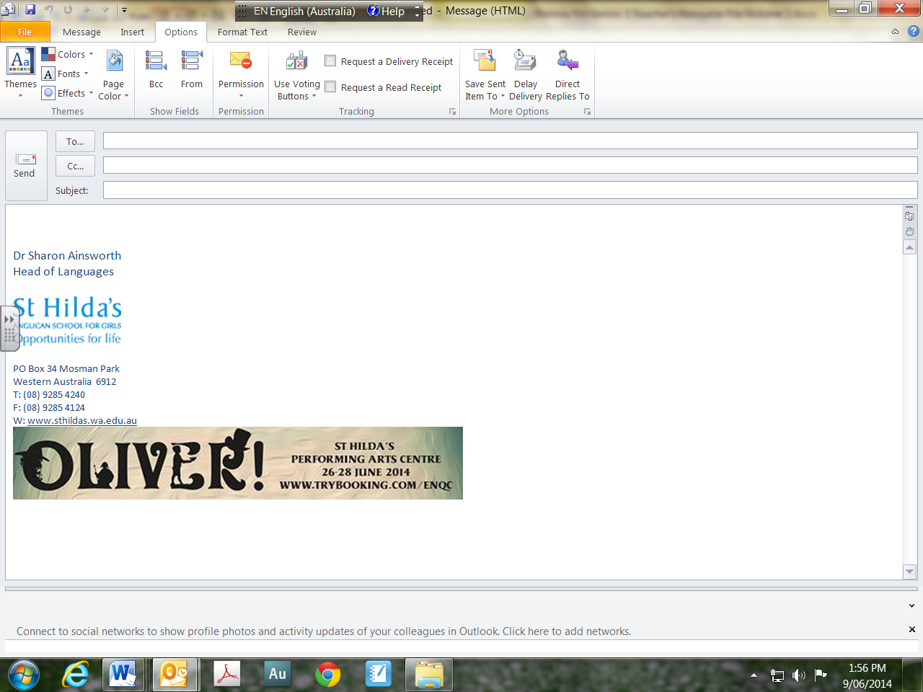
クリス、元気？
学校の新聞のためにきじを書いてくれる？ テーマは「高校そつぎょうから10年！」。
この10年間はどうだった？ 楽しかった？ たいへんだった？
今まで何をしていた？ そして、今は何をしている？
色々書いてほしいんだ。おねがい！

あきら

You have just received this message from your former Japanese classmate at your sister school. He is now working as a teacher there. Write a descriptive account in 250–300 ji, addressing the topic mentioned. Use plain form.

Start your answer to Question 30 here

340ji

Continue your answer to Question 30 here.

340ji

THIS PAGE HAS BEEN LEFT BLANK INTENTIONALLY
Part B: Extended writing (20 marks)

Answer one (1) of the following questions in Japanese. Write approximately 350–400 ji using polite form endings in the squared paper following this section.

Question 31 (20 marks)

Your Japanese home room teacher at your sister school has asked you to write an article describing what Australian students do immediately after finishing high school and what your plans are for next year and beyond. Your Japanese teacher is hoping that you might be planning to use your Japanese in your career. Write an article describing your plans for the summer holidays and beyond and discussing typical high school student activities post-graduation.

Include the following information:

- Describe your plans for the summer holiday period and beyond
- Describe typical Australian student post-graduation plans and activities
- Discuss how you plan to use Japanese in your future career

or

Question 32 (20 marks)

The Japanese assistant teacher who came to your Australian school last year has asked you for information for his school magazine about what the last year in school is like for Australian students and the sorts of plans you have for the summer holidays and next year. Write an article reflecting on the challenges and highlights of the last year of school as well as discussing plans for the summer and next year.

Include the following information:

- Describe the challenges and highlights for Australian students in the last year at school
- Reflect on your last year of school describing highlights and challenges
- Describe your plans for the summer holidays and next year

Start your answer here for: Question () 31 or 32

340ji
Continue your answer to question 31 or 32 here

340ji

Additional working space

____________________________________________________________________________

____________________________________________________________________________

____________________________________________________________________________

____________________________________________________________________________

____________________________________________________________________________

____________________________________________________________________________

____________________________________________________________________________

____________________________________________________________________________

____________________________________________________________________________

____________________________________________________________________________

____________________________________________________________________________

____________________________________________________________________________

____________________________________________________________________________

____________________________________________________________________________

____________________________________________________________________________

____________________________________________________________________________

____________________________________________________________________________

____________________________________________________________________________

____________________________________________________________________________

____________________________________________________________________________

____________________________________________________________________________

____________________________________________________________________________

____________________________________________________________________________

____________________________________________________________________________

____________________________________________________________________________

____________________________________________________________________________

____________________________________________________________________________

____________________________________________________________________________

END OF PAPER
Published by S.G. Ainsworth ABN 70218501911
Y. Haddrell ABN 97634237437
S.R. Haddrell ABN 27279332707

