Methodist Ladies’ College
Semester 2 Examination, 2016

Question/Answer Booklet

JAPANESE: SECOND LANGUAGE
ATAR Year 12

Student Name: ______________________________________________________

Teacher Name: ______________________________________________________

Time allowed for this paper
Reading time before commencing work: ten minutes
Working time for paper: two and a half hours

Materials required/recommended for this paper
To be provided by the supervisor
Number of additional
answer booklets used
(if applicable):
This Question/Answer Booklet
Sound recording

To be provided by the candidate
Standard items: pens (blue/black preferred), pencils (including coloured), sharpener, correction fluid/tape, eraser, ruler, highlighters
Special items: print dictionaries: one combined dictionary (Japanese/English and English/Japanese dictionary) or two separate dictionaries (one English/Japanese and one Japanese/English dictionary)
No electronic dictionaries are allowed
Notes: Dictionaries must not contain any notes or other marks

Important note to candidates
No other items may be taken into the examination room. It is your responsibility to ensure that you do not have any unauthorised notes or other items of a non-personal nature in the examination room. If you have any unauthorised material with you, hand it to the supervisor before reading any further.
Structure of the examination
The Methodist Ladies' College Japanese: Second Language ATAR Year 12 examination consists of the following sections:

Structure of this paper
Section | Number of questions available | Number of questions to be answered | Suggested working time (minutes) |  | Marks available | Percentage of total exam | Your mark
Section One:  Response (listening) | 15 | 15 | 30 |  | 46 | 30 | /30
Section Two:  Response (viewing, reading) | 19 | 19 | 60 |  | 60 | 40 | /40
Section Three:  Written communication  (extended writing) | 3 | 2 |  | 60 | Part A  10  Part B  20 | Part A  12%  Part B  18% | /30
 |  |  |  |  | Total | 100 | /100

Instructions to candidates
- The rules for the conduct of ATAR course examinations are detailed in the 2016 Year 12 Information Handbook. Sitting this examination implies that you agree to abide by these rules.

- Write your answers in Standard Australian English or Japanese in this Question/Answer Booklet

- You must be careful to confine your responses to the specific questions asked and to follow any instruction that are specific to a particular questions. You may not use SMS-style abbreviations in any section of the paper.

- Spare pages are included at the end of this booklet. They can be used for planning your responses and/or as additional space if required to continue an answer.
- Planning: If you use the spare pages for planning, indicate this clearly at the top of the page.
- Continuing an answer: If you need to use the space to continue an answer, indicate in the original answer space where the answer is continued, i.e. give the page number. Fill in the number of the questions that you are continuing to answer at the top of the page.

Test Piece of Audio Text with Script

Listen to the short text, which is printed below. This will help you to become accustomed to the speakers’ voices. There are no questions or marks associated with this text.

女： 今日の午後は何かよていがある？
男： うん、4時からクリケットのれんしゅうがあるんだ。
女： クリケットって、私ルールがよく分からないのよね。
男： えっ、日本にはクリケットはないの？
女： うん、ぜんぜんないよ。日本にいる時、私、いちどもクリケットのことを聞いた
ことがなかったわ。
男： へ～え、そう。じゃ、日本で人気があるスポーツは何？
女： そうねえ、やきゅうやサッカーかな。

Turn over and begin Section One.

Section One: Response (Listening and responding) 30% (46 marks)
This section contains fifteen (15) questions. Answer all questions in English in the spaces provided.

You will hear four (4) texts in Japanese. Text 1 is divided into two parts. Each text, including parts of Text 1, will be played twice, with a short pause between the first and second readings. After the second reading, there will be time to answer the questions.

You make take notes during this time. Your notes will not be marked. You may come back to this section at any time during the working time for this paper.

Suggested working time: 30 minutes

TEXT 1 (5 marks)

Kota is making a speech at assembly.
Space for Notes
Part (i)

Are the statements true or false? Circle the correct answer.

1. Kota spent one and a half years on exchange at his sister school. | True | False
2. There were many events at the school but the most memorabe events of the year were the School Ball and an event like a camp. | True | False
3. Kota could enjoy all of the events because he was an exchange student and he didn’t have to study that hard. | True | False
4. Kota’s host brother also enjoyed all the events even though he had to study a lot. | True | False
5. Kota isn’t sure if his host brother was able to enjoy these events in the same way as he could. | True | False

TEXT 1 (2 marks)

Kota continues to make a speech at assembly.
Space for Notes
Part (ii)
- (1 mark)

Circle the most appropriate alternative from a, b, c, or d.

Kota

- found the best part of Year 12 to be a dance party and he was surprised it was the school ball he had heard mentioned for the first time.
- heard the word ‘ball’ when he heard the school ball mentioned for the first time and he thought it meant something to do with some sort of sport.
- found many things surprising in the events he attended in Year 12 including some of the sporting events and the school ball.
- heard that the school ball was the best part of Year 12 and he was surprised at how much fun the event was.

- (1 mark)

Circle the most appropriate alternative from a, b, c, or d.

While the School Ball

- was only for a night, it was all his friends talked about for about half a year beforehand.
- cost a lot of money for the suit and dress, and the limousine, it was all his friends in Japan talked about when he returned home.
- was something a Japanese high school couldn’t consider, it was something all his friends talked about when he returned to Japan.
- was all his friends talked about for about a year beforehand, Kota found it cost a lot of money.

TEXT 2 (11 marks)
Space for Notes
Mami and Chris talk about events of the year.

What was the best part of the year for Chris?
______________________________________________________
______________________________________________________
______________________________________________________
(3 marks)

Why did Chris feel he could spend each day stress free?
______________________________________________________

______________________________________________________
______________________________________________________
(2 marks)

What does Mami say about her university entrance examinations?
______________________________________________________

______________________________________________________
______________________________________________________
(3 marks)

Why does Mami disagree when Chris says that she always gets better results than he does?
______________________________________________________

______________________________________________________
______________________________________________________
(3 marks)

TEXT 3 (14 marks)
Space for Notes
Kana is talking to her father about graduating.

Why won’t Kana be returning home next week?
______________________________________________________
______________________________________________________
______________________________________________________
(3 marks)

Why does Kana want to relax a bit before returning home?
______________________________________________________
______________________________________________________
______________________________________________________
(3 marks)

Why won’t money be a problem for Kana?
______________________________________________________
______________________________________________________
______________________________________________________
______________________________________________________
(4 marks)

Why is Kana’s father absolutely opposed to her plans?
______________________________________________________
______________________________________________________
______________________________________________________
______________________________________________________
(4 marks)

TEXT 4 (14 marks)
Space for Notes
Ella is talking to her teacher about future plans.

Has Ella already decided on her subjects for university? Explain.
______________________________________________________
______________________________________________________
______________________________________________________
______________________________________________________
(3 marks)

Why does Ella think her university study plans are a good idea?
______________________________________________________
______________________________________________________

______________________________________________________

______________________________________________________
(4 marks)

Describe what surprised Ella about her trip to Japan.
______________________________________________________
______________________________________________________

______________________________________________________

______________________________________________________
(4 marks)

What does Ella believe her study of Japanese will prepare her for?
______________________________________________________
______________________________________________________
______________________________________________________
(3 marks)
END OF SECTION ONE

THIS PAGE HAS BEEN LEFT BLANK INTENTIONALLY
Section Two: Response (Viewing, reading and responding) (40%) (60 Marks)
This section contains four (4) texts and 19 questions. Text 5 has two parts. Answer all questions in English in the spaces provided.
Suggested working time: 60 minutes.
_________________________________________________________________________

Text 5 (14 marks)
Part (i)

Read the following ‘diary entry’, and respond to the questions in English.


４月７日（日） 天気：くもり
あー、ドキドキしている。いよいよ明日は私がはじめて大学に行く日だ。大学に入るのはずっと前からのゆめだったけど、ついに、その日がやって来た。もちろん楽しみにしているけれど、今は楽しみというより、きんちょうしているんだ。だって、同じ高校の友だちがいるかどうか分からないし、大学のじゅぎょうは高校の時とちがって、むずかしくてかもしれないし、明日、きんちょうしすぎてトイレに行きたくなっても、トイレがどこにあるかも分からない！
もう、すでに大学で勉強している友人によると、大学というのは小さな町
みたいな所だそうだ。夜おそくにあいているがあったり、２４時間いつでも食べ物が買える売店があったり、おさけが飲める店もあるみたいだ。
そういう事を聞くと、ワクワクするな！ でも、やっぱり一番楽しみにしていることは
かわいい女の子たちに会えるチャンスが毎日あるということだ！ぼくはようちえんの時からずっと男子校に行っていたから、女の子に会えるチャンスなんてぜんぜん
なかったからなー。
明日、大学にちこくしないように、今夜ははやくねなくちゃ！




Describe the author’s feelings about tomorrow.

___________________________________________________________________

___________________________________________________________________

___________________________________________________________________

(3 marks)

Why does the author feel like that?

___________________________________________________________________

___________________________________________________________________

___________________________________________________________________

___________________________________________________________________
(4 marks)

How does the author know so much about university?

___________________________________________________________________

___________________________________________________________________

(2 marks)

Describe the facilities of the university.

___________________________________________________________________

___________________________________________________________________

___________________________________________________________________

___________________________________________________________________

___________________________________________________________________

___________________________________________________________________
(5 marks)

Text 5 (12 marks)
Part (ii)

Read the second day of following ‘diary entry’, and respond to the questions in English.

４月８日（月） 天気：雨

今日は人生で一番いい日になると思ったのに、さいあくの日になって
しまった。
まず、大学にちこくしてしまった！昨日の夜はドキドキしていたから、
ぜんぜんねむれなくて、朝ねぼうしてしまったんだ。（大ショック!!）そして、
やっと大学に着いた時は、思っていたより大学のキャンパスが広くて、まい子に
なってしまってこまった。それで、だれかに教室の場所を聞こうと思ったけれど、たちがこわそうだったから聞けなかった。その上、朝おべんとうを作る時間が
なかったから、売店で何か買おうと思ったのに、うちにさいふをおきわすれて
しまったことに気がついた。しんじられない！それに、お金をわすれてこまっていた
ぼくを見て、女の子たちがわらっていて、すっごくはずかしかったよー！
何とか教室を見つけられてホッとしたけど、はがっかり。。。ぼくの
クラスメートは男しかいなかった‼ うそだろー！ どうしてなんだ！ あー、大学がに楽しい所かどうか分からなくなってきたよ。

How does the author describe their first day?
___________________________________________________________________
___________________________________________________________________
___________________________________________________________________
(2 marks)

Why was the author so shocked?
___________________________________________________________________
___________________________________________________________________
___________________________________________________________________

___________________________________________________________________
(3 marks)

Explain why the author didn’t easily find the classroom.
___________________________________________________________________

___________________________________________________________________

___________________________________________________________________

___________________________________________________________________
(4 marks)

Why was the author so embarrassed?
___________________________________________________________________
___________________________________________________________________

___________________________________________________________________
(2 marks)

What was so disappointing for the author?
___________________________________________________________________
___________________________________________________________________
___________________________________________________________________
(1 mark)

Text 6 (17 marks)

Read the following ‘blog’, and respond to the questions in English.
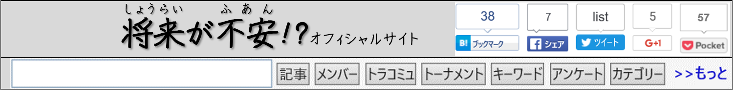
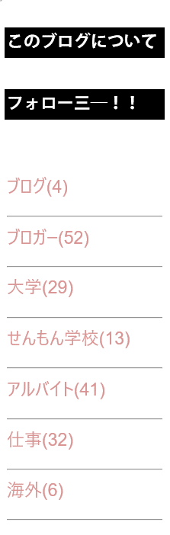 |  あや   2016年10月13日 (21:43)  私は、何をしたいか、まだ、ぜんぜん分からない。でも、  子どもの時からずっと動物にきょうみがあったし、今もペットを  ５ひきもかっているし、動物にかんけいがある仕事ができたら  楽しそう。だから、みたいな仕事ができたらいいなと思う。  だけど、になるためには、大学で5年も勉強しなくちゃ  いけないそうだし、もちろん、高校でもいいせいせきをとって  おかなかければならない。それはかなりのプレッシャーだ。
 さとし
2016年10月13日 (21:58)
ぼくのはもうきまっている。ぼくの家族は古本屋をけいえい
しているから、が年をとって仕事をやめたら、ぼくがその店をやることになっている。ぼくのしゅみは読書だから、その仕事はべつにいやじゃない。でも、時々本のストーリーがおもしろすぎると、ぼくはの店がどんなにいそがしくても手つだわない。2、3時間ぐらいやマンガなどを読んでしまって、にしかられる。今、少しなのは、、インターネットで本を読む人がふえて、本を買って読む人が少なくなってしまったことだ。
 じゅん
2016年10月13日 (22:51)
ぼくは小学生の時はプロのサッカーになりたかったけど、のであしをけがしてから、そのゆめをあきらめた。
その後、けいさつかんやしょうぼうしみたいなユニフォームを
着る仕事がかっこよさそうだなと思ったけど、夜のシフトがある仕事はいやだからやめた。は、小学校のの先生が
いいかなと思う。大好きなサッカーも教えられるし、夏休みも長いし、子どもも好きだしね。でも、、モンスターペアレンツといううるさいお父さんとお母さんがいるみたいだから、ちょっといやだなと思う。

What does Aya believe would be pressure for her in becoming a vet?
___________________________________________________________________

___________________________________________________________________

___________________________________________________________________
(2 marks)

Explain how Satoshi’s job is already decided for him.
___________________________________________________________________

___________________________________________________________________

___________________________________________________________________
(3 marks)

Explain why Satoshi is sometimes scolded by his parents.
___________________________________________________________________

___________________________________________________________________

___________________________________________________________________

___________________________________________________________________
(4 marks)

List the occupations Jun considered when he was younger and give the reason why he
gave up on each of them.
___________________________________________________________________

___________________________________________________________________

___________________________________________________________________

___________________________________________________________________
( 4 marks)

Recently, what job is Jun interested in doing? Why?
___________________________________________________________________

___________________________________________________________________

___________________________________________________________________

___________________________________________________________________ (4 marks)
Text 7 (17 marks)

Read the following ‘advertisement’, and respond to the questions in English.


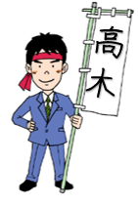
うんてんめんきょがとれるになりましたか？車やバイクをうんてんしたい
ですか？親にたのまないで、行きたい所にいつでも自分で行けるようになり
たいですか？「はい」とこたえた人は私のドライビングスクールへようこそ！
はじめまして。高木です。私は30年うんてんを教えたけいけんが
あって、オートバイ、車、バス、何でも教えられます！


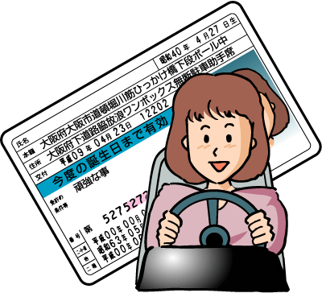
高木ドライビングスクールの6つのポイント‼

1.すばらしいロケーション
高木ドライビングスクールは東京から電車で10分ぐらいしかかからない町にあるので、とてもべんりです。から電車一本で行けますよ。
2.リアルなコース
東京をイメージしてドライビングコースを作りました。広い道もあるし、せまいもあるし、もちろん電車のふみきりもあるので、いいれんしゅうになります。
3.何よりうれしい安いレッスン料
レッスン料の安さだったら、ほかのどのドライビングスクールにもけません！
4.けいけんが長い先生たち
うんてんを教えてくれる先生たちはベテランの先生でひょうばんです。どの先生も10年教えたけいけんがありますし、教え方もくわしくてやさしいです。
5.カフェテリア
レッスンとレッスンの間、もちろんおなかがすくでしょう！うちから何か食べる物を持って来なくても、高木ドライビングスクールのカフェテリアで、おべんとうやパンやスナックなどを買えるから大じょうぶです。あたたかい飲み物もありますよ。
6.ネットカフェ
つぎのレッスンを待っている間、高木ドライビングスクールのネットカフェで時間をすごすのはどうですか？おいしいコーヒーを飲みながら、インターネットが使えるし、オンラインでえいがも見られます。

＊高木ドライビングスクールにきょうみがある方はイーメールかお電話をください。
＊このこうこくを見たおには、カフェテリアで使える1,000円のギフトカードをプレゼントします。お待ちしております。
高木ドライビングスクール 03-3789-9211 takagidrivingschool.com.jp

What THREE questions does Takagi ask of prospective customers?
___________________________________________________________________

___________________________________________________________________

___________________________________________________________________

___________________________________________________________________
(4 marks)

Describe what makes the driving course so realistic.
___________________________________________________________________

___________________________________________________________________

___________________________________________________________________

___________________________________________________________________
(4 marks)

Why are the driving school teachers so reputable?
___________________________________________________________________

___________________________________________________________________

___________________________________________________________________
(3 marks)

List the activities you are able to do between lessons.
___________________________________________________________________

___________________________________________________________________

___________________________________________________________________

___________________________________________________________________

___________________________________________________________________
(4 marks)

Why should you mention that you have seen this advertisement?
___________________________________________________________________

___________________________________________________________________
(2 marks)
END OF SECTION TWO

Section Three: Written Communication (30%) (30 marks)
This section has two (2) parts and three (3) questions. Answer two (2) questions in Japanese.

Part A: Stimulus and response
There is one (1) question. Answer the question in Japanese.
Write approximately 250-300ji using plain form on the squared paper following the question.

Part B: Extended writing
There are two (2) questions. Answer one (1) question in Japanese.
Write approximately 350-400ji using polite form on the squared paper following the question.

Spare pages are included at the end of this booklet. They can be used for planning your responses and/or as additional space if required to continue an answer.
- Planning: If you use the spare pages for planning, indicate this clearly at the top of the page.
- Continuing an answer: If you need to use the space to continue an answer, indicate in the original answer space where the answer is continued, i.e. give the page number. Fill in the number of the question that you are continuing to answer at the top of the page.

Suggested working time: 60 minutes.

Part A: Stimulus and response (12%) (10 marks)

Write your response to Question 30 on the squared paper following this section.

(10 marks)

You receive the following:

You have just received the previous email from your Japanese friend. Write an ‘e-mail’ reply in 250–300 ji to your friend, addressing the points made and any questions asked. Use plain form.

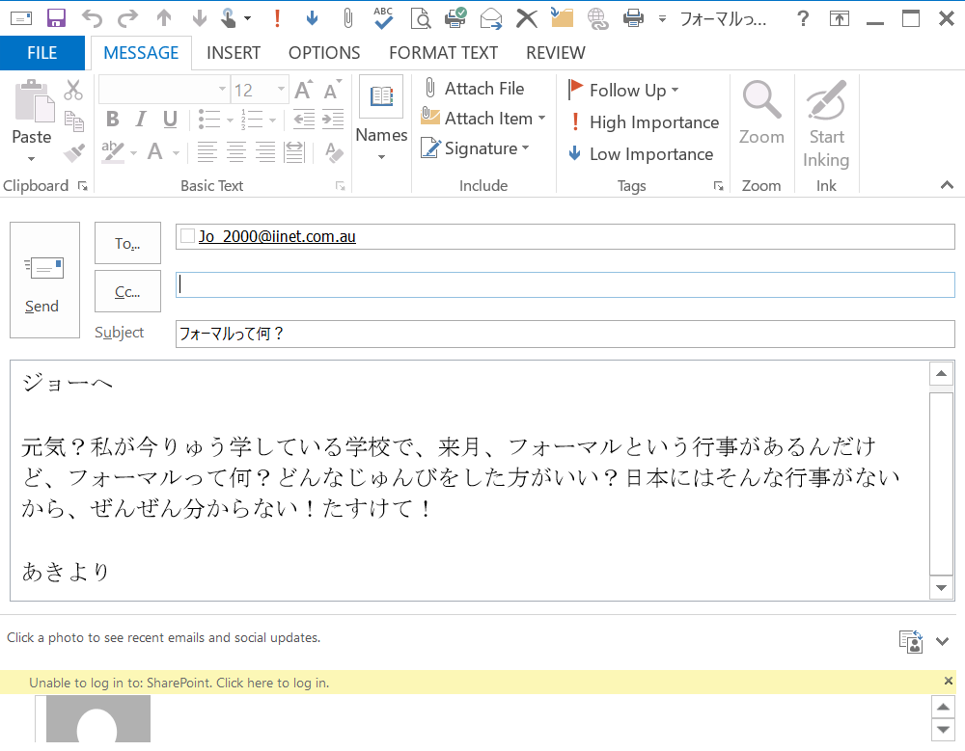
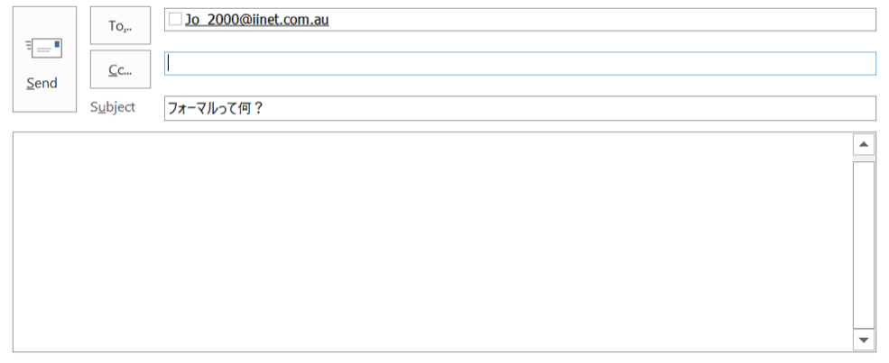
元気？
私が今している学校で、来月、フォーマルという行事があるんだけど、フォーマルって何？ どんなじゅんびをしたらいい？ 1人で行ってもいいの？ ジョーはだれと行くの？ 日本にはそんな行事がないから、ぜんぜん分からない！
たすけて！

あきより
Start your answer to Question 35 here

340ji
Continue your answer to Question 35 here.

340ji

THIS PAGE HAS BEEN LEFT BLANK INTENTIONALLY
Part B: Extended writing (18%) (20 marks)

Answer one (1) of the following questions in Japanese. Write approximately 350–400 ji using polite form endings in the squared paper following this section.

(20 marks)

Your Japanese sister-school has asked you to write an article for their school magazine about your experience of studying Japanese. Write an article titled ‘Learning Japanese at high-school’.

Include the following information:

- How long and why you began studying Japanese
- The most difficult and most enjoyable aspects of studying Japanese
- What you would like to do in the future using your Japanese language skills.

or

(20 marks)

Your Japanese e-pal sent you an email with a link to an online magazine about driver’s licence in Japan and foreign countries. The magazine states that 17 years of age is too young for people in countries like Australia and New Zealand to get their driver’s licence. Write an article titled ‘It is okay to get your driver’s licence at 17 years of age’.

Include the following information:

- Justify why you believe 17 years of age is fine
- Discuss the benefits of having your driver’s licence
- Compare this to life without a driver’s licence.

Start your answer here for: Question () 36 or 37

340ji
Continue your answer to question 36 or 37 here

340ji
Continue your answer to question 36 or 37 here

340ji
Additional working space

____________________________________________________________________________

____________________________________________________________________________

____________________________________________________________________________

____________________________________________________________________________

____________________________________________________________________________

____________________________________________________________________________

____________________________________________________________________________

____________________________________________________________________________

____________________________________________________________________________

____________________________________________________________________________

____________________________________________________________________________

____________________________________________________________________________

____________________________________________________________________________

____________________________________________________________________________

____________________________________________________________________________

____________________________________________________________________________

____________________________________________________________________________

____________________________________________________________________________

____________________________________________________________________________

____________________________________________________________________________

____________________________________________________________________________

____________________________________________________________________________

____________________________________________________________________________

____________________________________________________________________________

____________________________________________________________________________

____________________________________________________________________________
END OF PAPER

Published by S.G. Ainsworth ABN 70218501911
Y. Haddrell ABN 97634237437
S.R. Haddrell ABN 27279332707

