

Question/Answer Booklet

JAPANESE: SECOND

LANGUAGE ATAR

WRITTEN PAPER
UNIT 2, 2015

Student Name: ___________________________

Time allowed for this paper
Reading/viewing time before commencing work: ten minutes
Working time for paper: two and a half hours

Materials required/recommended for this paper

To be provided by the supervisor
This Question/Answer Booklet
Sound recording

To be provided by the candidate
Standard items: pens (blue/black preferred), pencils (including colour), sharpener, eraser, correction fluid/tape, ruler, highlighters
Special items: dictionaries: one combined dictionary (Japanese/English and English/Japanese) or two separate dictionaries (one English/Japanese and one Japanese/English dictionary). No electronic dictionaries are allowed
Note: Dictionaries must not contain any notes or other marks

Important note to candidates
No other items may be taken into the examination room. It is your responsibility to ensure that you do not have any unauthorised notes or other items of a non-personal nature in the examination room. If you have any unauthorised material with you, hand it to the supervisor before reading any further.

Structure of the examination

The Year 11 ATAR Japanese: Second Language Unit 2 examination consists of the following sections:

Section | Number of questions available | Number of questions  to be answered | Suggested working time  (minutes) | Marks available | Percentage of total exam | Your Mark
Section One:  Response (Listening) | 14 | 14 | 30 minutes | 40 | 30 | /30
Section Two:  Response (Viewing and reading) | 15 | 15 | 70 minutes | 51 | 40 | /40
Section Three:  Written Communication  Extended writing | 2 | 1 | 50 minutes | 30 | 30 | /30
 |  |  |  | Totals | 100 | /100

Instructions to candidates

- Write your answers in Standard Australian English or in Japanese as required in this Question/Answer Booklet.

- You must be careful to confine your responses to the specific questions asked and to follow any instructions that are specific to a particular question. You may not use SMS style abbreviations in any section of the paper.

- Spare pages are included at the end of this booklet. They can be used for planning your responses and/or as additional space if required to continue an answer.

- Planning: If you use the spare pages for planning, indicate this clearly at the top of the page.
- Continuing an answer: If you need to use the space to continue an answer, indicate in the original answer space where the answer is continued, i.e. give the page number. Fill in the number of the question that you are continuing to answer at the top of the page.

- Hand in this Question/Answer Booklet at the end of the examination.

Test Piece of Audio Text with Script

Listen to the short text, which is printed below. This will help you to become accustomed to the speakers’ voices. There are no questions or marks associated with this text.

女： ジョンさんは、日本語が上手ですね。
男： いいえ、まだ下手ですよ。
女： どこで日本語をべんきょうしましたか。
男： ハイスクールで、８年生から１１年生までべんきょうしました。
女： そうですか。先生は日本人ですか。
男： いいえ、オーストラリア人でした。でも、先生のおくさんは日本人でした。

Turn over and begin Section One.

Section One: Response (Listening and responding) 30% (40 marks)
This section contains fourteen (14) questions. Answer all questions in English in the spaces provided.

You will hear three (3) texts in Japanese. Text 1 is divided into three parts. Each text, including parts of Text 1, will be played twice with a short pause between the first and second readings. After the second reading, there will be time to answer the questions.

You make take notes during this time. Your notes will not be marked. You may come back to this section at any time during the working time for this paper.

Suggested working time: 30 minutes

TEXT 1 (4 marks)

Chris is talking about welcoming an exchange student.
Space for Notes

Part (i)

Are the statements true or false? Circle the correct answer.

An Exchange Student
1. Naoto brought a lot of presents for his four week home stay. | True | False
2. Naoto gave Chris’ siblings an anime character doll because Naoto’s hobby is anime and comics. | True | False
3. Naoto made a beautiful pink sweater for Chris’ mother. | True | False
4. Chris’ mother can’t wear the sweater at present because its summer but looks forward to wearing it in winter. | True | False

 TEXT 1 (2 marks)

Chris continues to talk about welcoming an exchange student.
Space for Notes

Part (ii)
- (1 mark)

Circle the most appropriate alternative from a, b, c, or d.

Naoto prepared before coming to Australia by

- studying English conversation on Skype with various people.
- learning about Australia online and skyping in English about rules of Chris’ home and school.
- skyping with Chris in English everyday and learning about Australian animals and culture.
- studying English online and skyping with Chris’ school friends.

- (1 mark)

Circle the most appropriate alternative from a, b, c, or d.

According to Chris’ commentary, Naoto

- likes to read and write English better than speaking English.
- reads and writes English much better than he speaks it.
- thinks it isn’t important to be able to read and write English.
- will email Chris from now, because the emails have to be in read and written in English.

TEXT 1 (11 marks)
Space for Notes

Chris continues to talk about welcoming an exchange student.

Part (iii)

- (2 marks)

Describe what happened yesterday.
______________________________________________________
______________________________________________________
- (4 marks)

What does Chris say about Naoto and lamb meat?

______________________________________________________

______________________________________________________

______________________________________________________

______________________________________________________
______________________________________________________

- (2 marks)

What does Chris say about his family by comparison to others and why?

______________________________________________________

______________________________________________________

______________________________________________________

- (3 marks)

Why does Chris say “I was really happy when I heard that”?

______________________________________________________

______________________________________________________
______________________________________________________
______________________________________________________

TEXT 2 (12 marks)

Space for Notes
Mike and Rie are discussing gift giving.

- (4 marks)

Explain why Mike is giving Rie a present.
______________________________________________________
______________________________________________________
______________________________________________________
______________________________________________________
- (4 marks)

Describe the present for Rie’s family.

______________________________________________________
______________________________________________________
______________________________________________________
______________________________________________________
- (1 mark)

Describe the present for Rie’s mother.

______________________________________________________

- (3 marks)

Describe the present for Rie’s father.

______________________________________________________

______________________________________________________

______________________________________________________

______________________________________________________

TEXT 3 (11 marks)
Space for Notes

Maika is talking with her teacher about her time in Australia.

- (5 marks)

Recount what Maika said about the sports she did while in Australia.

______________________________________________________

______________________________________________________

______________________________________________________

______________________________________________________

______________________________________________________

- (3 marks)

Why did Maika have an opportunity to see netball?

______________________________________________________

______________________________________________________

______________________________________________________

______________________________________________________

- (3 marks)

Why does Maika say that she wasn’t really worried?

______________________________________________________

______________________________________________________

______________________________________________________

______________________________________________________

______________________________________________________

END OF SECTION ONE

THIS PAGE HAS BEEN LEFT BLANK INTENTIONALLY
Section Two: Response (Viewing, reading and responding) (40%) (50 Marks)

This section contains four (4) texts and seventeen (17) questions. Answer all questions in English in the spaces provided.

Suggested working time: 70 minutes.
____________________________________________________________________________

TEXT 4 (16 marks)

Read the postcard and pond to the questions in English.

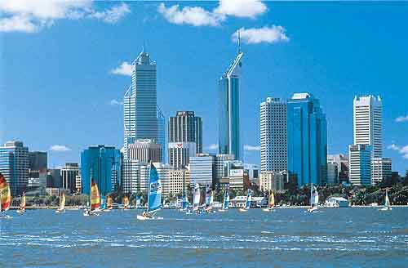

みなみちゃんへ
元気？このえはがき、すごいと思わない？ このしゃしんは、
スカボロビーチという海に行った時に、ぼくがとった。となりに
いるのはホストブラザーとクラスメート。先週の金曜日に学校のディナーダンスというダンスパーティーがあって、その後、ホストブラザーがこの海につれて行ってくれた。
本当は学校のきそくではパーティーの後、すぐに家にかえらなければならなかったけど、ぼくたちはこの海に行って、きれいな海を見ながらピザを食べたり、おしゃべりをしたりして、楽しい時間をすごした。夜に海を見に行ったのは、はじめてだったけど、海のおとがきれいで、すてきだった。とてもすばらしい思い出になったから、ダンスパーティーより、海に行った時のほうが楽しかった！
つぎの日の土曜日の朝はサッカーのしあいがあったから、６時半におきなくてはいけなかった。でも、とてもつかれていたから、おきることができなかった。だから、サッカーのしあいに行くことが出来なかったので、コーチもチームメートもみんなおこっていた！（ごめん、ごめん！）
来週はホストファミリーとつりに行くつもり。つりはしたことがないから、みんな、つりの仕方をおしえてくれると思う。楽しみ!
じゃ、またね。へんじをまっているよ。
はやとより
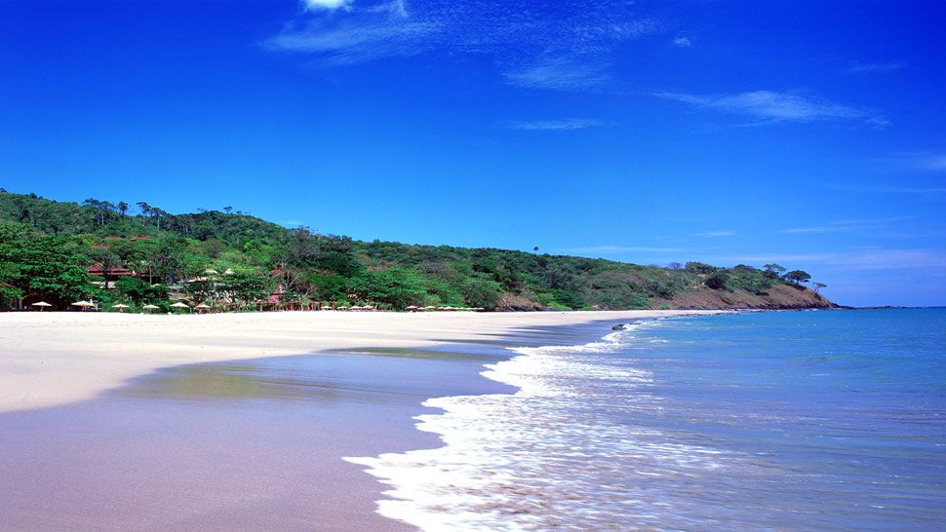

Describe where, when and by whom the photo was taken.
___________________________________________________________________
___________________________________________________________________
___________________________________________________________________
___________________________________________________________________
(4 marks)

What school rule did they disobey?
___________________________________________________________________
___________________________________________________________________
(2 marks)

Describe FOUR things that made it a wonderful memory for Hayato.
___________________________________________________________________
___________________________________________________________________
___________________________________________________________________
___________________________________________________________________
(4 marks)

Why were Hayato’s coach and team mates angry?
___________________________________________________________________
___________________________________________________________________
___________________________________________________________________
___________________________________________________________________ (4 marks)

What will the host family teach Hayato and why?
___________________________________________________________________
___________________________________________________________________

___________________________________________________________________
(2 marks)

TEXT 5 (15 marks)

Read the following email and respond to the questions in English.

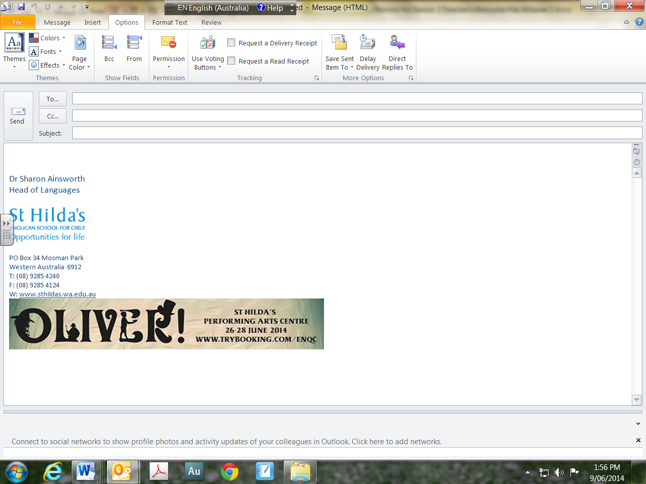
tomo@redhillschool.edu.au
おひさしぶりです。
山本先生へ
おひさしぶりです。お元気ですか。 私はとても元気です。オーストラリアに来てからもう3週間たちました。今、こちらは夏で、日本の夏とくらべると、本当にあついです。先週末、友だちとみんなで海に行った時、ビーチのすながあつすぎて、はだしであるくことができませんでした。それはとてもびっくりしました。けっきょく、私たちは海の近くの店でビーチサンダルを買わなくてはいけませんでした。でも、ここの夏は昼間はとてもあついけれど、夜になると、すずしくなるから、時々、セーターをきなければなりません。それはおもしろいと思います。
きのうはクリスマスでした。日本のクリスマスより、ここのクリスマスのほうがもっと大きくて、たくさんの人がおいわいしていると思いました。クリスマスが近くなると、みんなクリスマスカードをあげたり、もらったりしていました。私は日本にいた時、クリスマスカードをもらったことがなかったので、日本とちがってとても楽しかったです。色々なカードをもらったけれど、ホストのお姉さんからのカードが、一番おもしろかったです。そのカードの絵はサンタクロースとカンガルーがボクシングをしていたからです！
それでは、先生、つぎのメールにはこちらのお正月のすごし方について書きますね。日本はさむいから、かぜをひきやすいでしょうから気をつけてください。
では、お元気で。 小町より

Describe what surprised Komachi last weekend.
___________________________________________________________________
___________________________________________________________________
___________________________________________________________________
(2 marks)

What does Komachi think is interesting?
___________________________________________________________________
___________________________________________________________________
___________________________________________________________________

___________________________________________________________________
(4 marks)

List the difference(s) Komachi illustrates between Australian and Japanese Christmas.
___________________________________________________________________
___________________________________________________________________

___________________________________________________________________

___________________________________________________________________
(4 marks)

Describe the most interesting aspect about Christmas for Komachi.
___________________________________________________________________
___________________________________________________________________

___________________________________________________________________
(3 marks)

What will Komachi write about next time?

___________________________________________________________________

___________________________________________________________________
(2 marks)

TEXT 6 (20 marks)

Read the advertisement and respond to the questions below in English.



マイ フィットネス
入会 |  | せつび | サービス | フィットネス | キッズ | オンラインショッピング
新しいスポーツジムが東京駅前にオープン！！！
モダンで新しいスポーツジムが、東京駅からあるいて5分！

セルフチェックテスト
 | 最近、よくつかれますか。
 | けんこうてきな食事より体によくない物をよく食べますか。
 | 朝、すぐにおきることは、むずかしいと思いますか。
最近、あまりうんどうをしていないから、うんどうしたいと
思っていますか。
今、マイ フィットネスに入会すると。。。

さいしょの100人のおきゃくさまにスポーツタオルとドリンクボトルを
プレゼント！


けんこうてきな食事やうんどうについて、フリーでカウンセリングを
うけることができます。

10時間のトレーニングプランを買ったら、10％ディスカウントします！

マイ フィットネスのオーナーのプロフィール
このスポーツジムのオーナーの安川ありさは子どもの時、体がよわくて、
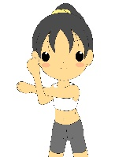
よく病気になりました。しかし、ティーンネイジャーになった時、安川はけんこうになりたいと思って、スポーツを始めました。そして、大学では大好きなバレーボールをつづけながら、食べ物のえいようやスポーツサイエンスについてべんきょうしました。

みなさん、私たちと楽しい時間をすごしながら、いっしょにけんこうに
なりましょう！今すぐ、お電話ください!!
安川までTEL：０３－３６６８－４５６８

Describe the location of the sport’s gym.
___________________________________________________________________
___________________________________________________________________
(2 marks)

List the criteria questions of the ‘Self Check Test’.
___________________________________________________________________
___________________________________________________________________
___________________________________________________________________
___________________________________________________________________
(4 marks)

Describe what benefits are available to you, if you join the sport’s gym.
___________________________________________________________________
___________________________________________________________________
___________________________________________________________________
___________________________________________________________________
(6 marks)

What series of events led the owner to beginning sports? Explain.
___________________________________________________________________
___________________________________________________________________
___________________________________________________________________
___________________________________________________________________
(5 marks)

How did the owner spend her time at university?
___________________________________________________________________
___________________________________________________________________
___________________________________________________________________
(3 marks)
END OF SECTION TWO
Section Three: Written Communication (30%) (30 Marks)
This section has two (2) questions. Answer one (1) question in Japanese. Write approximately 350-400 ji using polite form on the squared paper following this section.

Spare pages are included at the end of this booklet. They can be used for planning your responses and/or as additional space if required to continue an answer.
- Planning: If you use the spare pages for planning, indicate this clearly at the top of the page.
- Continuing an answer: If you need to use the space to continue an answer, indicate in the original answer space where the answer is continued, i.e. give the page number. Fill in the number of the question that you are continuing to answer at the top of the page.

Suggested working time: 50 minutes.

Question 30 (30 marks)
The Japanese host family, the Yasukawa family, who you stayed with last year on exchange, is planning to visit Perth next summer holiday. They have asked you to provide them with various information which will assist them in preparing for their journey. Write a reply letter to the family. Include the following information:

- Describe the weather in Australia at that time and compare it to Japan.
- Recommend several activities they can do in Perth at that time of the year.
- Give advice on what they should bring to Perth with them.
- Describe what most Australian do over Christmas time.

Or

Question 31 (30 marks)
Your Japanese host sister wrote to you, as she is interested in the lifestyle of young Australians. She would like to know about eating habit and sports they play. She is interested in knowing whether Australian teenagers lead healthy lifestyles. Write a reply letter to your host sister. Include the following information:

- The types of food Australian teenagers eat
- The types of sports Australian teenagers play
- Whether you think Australian teenagers lead a healthy lifestyle
- What Australian teenagers could do to become more healthy

Start your answer here for: Question () 30 or 31

340ji
Continue your answer to question 30 or 31 here

340ji

Additional working space

____________________________________________________________________________

____________________________________________________________________________

____________________________________________________________________________

____________________________________________________________________________

____________________________________________________________________________

____________________________________________________________________________

____________________________________________________________________________

____________________________________________________________________________

____________________________________________________________________________

____________________________________________________________________________

____________________________________________________________________________

____________________________________________________________________________

____________________________________________________________________________

____________________________________________________________________________

____________________________________________________________________________

____________________________________________________________________________

____________________________________________________________________________

____________________________________________________________________________

____________________________________________________________________________

____________________________________________________________________________

____________________________________________________________________________

____________________________________________________________________________

____________________________________________________________________________

____________________________________________________________________________

____________________________________________________________________________

____________________________________________________________________________

____________________________________________________________________________

____________________________________________________________________________

END OF PAPER

Published by S.G. Ainsworth ABN 70218501911
Y. Haddrell ABN 97634237437
S.R. Haddrell ABN 27279332707

