Methodist Ladies’ College
Semester 1 Examination, 2016

Question/Answer Booklet

JAPANESE: SECOND LANGUAGE
ATAR Year 12

Student Name: ______________________________________________________

Teacher Name: ______________________________________________________

Time allowed for this paper
Reading time before commencing work: ten minutes
Working time for paper: two and a half hours

Materials required/recommended for this paper
To be provided by the supervisor
Number of additional
answer booklets used
(if applicable):
This Question/Answer Booklet
Sound recording

To be provided by the candidate
Standard items: pens (blue/black preferred), pencils (including coloured), sharpener, correction fluid/tape, eraser, ruler, highlighters
Special items: print dictionaries: one combined dictionary (Japanese/English and English/Japanese dictionary) or two separate dictionaries (one English/Japanese and one Japanese/English dictionary)
No electronic dictionaries are allowed
Notes: Dictionaries must not contain any notes or other marks

Important note to candidates
No other items may be taken into the examination room. It is your responsibility to ensure that you do not have any unauthorised notes or other items of a non-personal nature in the examination room. If you have any unauthorised material with you, hand it to the supervisor before reading any further.
Structure of the examination
The Methodist Ladies' College Japanese: Second Language ATAR Year 12 examination consists of the following sections:

Structure of this paper
Section | Number of questions available | Number of questions to be answered | Suggested working time (minutes) |  | Marks available | Percentage of total exam | Your mark
Section One:  Response (listening) | 14 | 14 | 30 |  | 45 | 30 | /30
Section Two:  Response (viewing, reading) | 15 | 15 | 60 |  | 47 | 40 | /40
Section Three:  Written communication  (extended writing) | 2 | 2 |  | 60 | 30 | 30 | /30
 |  |  |  |  | Total | 100 | /100

Instructions to candidates
- The rules for the conduct of ATAR course examinations are detailed in the 2016 Year 12 Information Handbook. Sitting this examination implies that you agree to abide by these rules.

- Write your answers in Standard Australian English or Japanese in this Question/Answer Booklet

- You must be careful to confine your responses to the specific questions asked and to follow any instruction that are specific to a particular questions. You may not use SMS-style abbreviations in any section of the paper.

- Spare pages are included at the end of this booklet. They can be used for planning your responses and/or as additional space if required to continue an answer.
- Planning: If you use the spare pages for planning, indicate this clearly at the top of the page.
- Continuing an answer: If you need to use the space to continue an answer, indicate in the original answer space where the answer is continued, i.e. give the page number. Fill in the number of the questions that you are continuing to answer at the top of the page.

Test Piece of Audio Text with Script

Listen to the short text, which is printed below. This will help you to become accustomed to the speakers’ voices. There are no questions or marks associated with this text.

女： 今日の午後は何かよていがある？
男： うん、4時からクリケットのれんしゅうがあるんだ。
女： クリケットって、私ルールがよく分からないのよね。
男： えっ、日本にはクリケットはないの？
女： うん、ぜんぜんないよ。日本にいる時、私、いちどもクリケットのことを聞いた
ことがなかったわ。
男： へ～え、そう。じゃ、日本で人気があるスポーツは何？
女： そうねえ、やきゅうやサッカーかな。

Turn over and begin Section One.

Section One: Response (Listening and responding) 30% (45 marks)
This section contains fourteen (14) questions. Answer all questions in English in the spaces provided.

You will hear four (4) texts in Japanese. Text 1 is divided into two parts. Each text, including parts of Text 1, will be played twice, with a short pause between the first and second readings. After the second reading, there will be time to answer the questions.

You make take notes during this time. Your notes will not be marked. You may come back to this section at any time during the working time for this paper.

Suggested working time: 30 minutes

TEXT 1 (5 marks)

A student is talking about earning and spending money.
Space for Notes
Part (i)

Are the statements true or false? Circle the correct answer.

1. This person receives more pocket money than their friend who receives $90 per month. | True | False
2. This person feels lucky since they receive $90 per month but doesn’t have to do any household chores. | True | False
3. The pocket money has to pay for their mobile phone, the train and bus to school, and stationery for school. | True | False
4. This person is thinking of going to leaver’s week and wants to save $1000 if possible from pocket money not spent. | True | False
5. This person thinks they will be ableto save $500, once they find a part time job yet. | True | False

TEXT 1 (2 marks)

A student continues to talk about earning and spending money.
Space for Notes
Part (ii)
- (1 mark)

Circle the most appropriate alternative from a, b, c, or d.

According to this person’s friend the

- local cinema is a good place to work since its busy with a lot of people booking tickets online and coming to see a movie.
- pay at the local cinema is good and the job is busy with a lot of people coming to the movies.
- hourly pay at the local cinema is good and it’s not that busy since there are more people watching movies online than going to the cinema.
- local cinema has been is looking for people to start work part time since last week and the hourly pay is good.

- (1 mark)

Circle the most appropriate alternative from a, b, c, or d.

The problem for this person is that

- they think it will be difficult to balance part time work, clubs and study.
- on the weekend they have band practice and need to study so they can only work after school.
- because they are busy with clubs and band practice they can only work sometimes on the weekend.
- it will be difficult to find a job since they can only work after school.

TEXT 2 (17 marks)
Space for Notes
Listen to Chise and a travel agent discuss going overseas.

When and for how long does Chise wish to travel?
______________________________________________________
(2 marks)

Complete table sections (a) to (h) with appropriate missing detail.

Tour | How many days? | Tour Details
e.g.  London | 3 days | No information available
English  Countryside  (5 marks) | a. | b.
English  Countryside  (5 marks) | a. | c.
English  Countryside  (5 marks) | a. | d.
Greece  (8 marks) | (first) 2 days | e.
Greece  (8 marks) | (first) 2 days | f.
Greece  (8 marks) | g. | h.
Greece  (8 marks) | g. | i.

(13 marks)

What concerns Chise about both tours?
______________________________________________________

______________________________________________________
______________________________________________________ (2 marks)
TEXT 3 (10 marks)
Space for Notes
Listen to Tosh and Maki discuss travel plans.

Describe the great present Maki received.
______________________________________________________
______________________________________________________
______________________________________________________
(3 marks)

What is Maki’s dilemma?
______________________________________________________
______________________________________________________
______________________________________________________
______________________________________________________
______________________________________________________
(3 marks)

Why does Maki think it is best to travel quietly on her own? (ONE reason)
______________________________________________________
______________________________________________________
______________________________________________________
(2 marks)

Why does Tosh prefer to travel in a group? (TWO reasons)
______________________________________________________
______________________________________________________
______________________________________________________
(2 marks)

TEXT 4 (11 marks)
Space for Notes
Listen to a mother and father talk about pocket money.

What concerns the father about Kenta working part time?
______________________________________________________
______________________________________________________
______________________________________________________
______________________________________________________
(3 marks)

How much pocket money does Kenta receive every month?
______________________________________________________
______________________________________________________
(2 marks)

What job interview preparation(s) has Kenta been making?
______________________________________________________
______________________________________________________

______________________________________________________
(2 marks)

What does the manager say about Kenta?
______________________________________________________
______________________________________________________
______________________________________________________

______________________________________________________

(4 marks)

END OF SECTION ONE

THIS PAGE HAS BEEN LEFT BLANK INTENTIONALLY
Section Two: Response (Viewing, reading and responding) (40%) (47 Marks)
This section contains three (3) texts and 15 questions. Answer all questions in English in the spaces provided.
Suggested working time: 60 minutes.
_________________________________________________________________________

Text 5 (17 marks)
Read the following ‘blogs’, and respond to the questions in English.
もし、お金と時間があったら、何をしたいですか？
山ちゃん （高２）
ぜったいにせかい旅行!! まだバリ島にしか行ったことがないし、パリやニューヨークみたいな所で買い物もしてみたいし、色々な国のまだ食べたことがない物も食べてみたい！世界中にあるトップクラスのホテルに泊まって、プールサイドでつめたい物を飲みながら本を読んだり、リラックスしたりすることができたら、さいこう!! でも、一人じゃなくて、家族みんなで旅行できたらいいな。だって、家族といっしょだったら、みんなで楽しい思い出が作れるでしょ?!
さとみ （しゅふ）
今しているアルバイトをやめて、ふねでゆっくりとクルーズに行きたいですね。クルーズに行った人の話によると、ふねでは色々なショーが見られるし、プールやスパもあるそうだし、電車やバスやタクシーなどのほかの乗り物に乗らなくても、ふねだけで色々な所に行けるそうだから、ぜひ、クルーズをしてみたいです。でも、一つだけ心配していることがあります。それは、ふねに乗ると、よく気持ちがわるくなること。でも、クルーズみたいな大きなふねだったら、だいじょうぶかしら？だれか、教えてくれませんか？
はるき （大学生）
そうだなー、今、大学でいそがしいから、外国語をならいたいと思っていても、なかなかできないんだ。だから、お金と時間があったら、一年ぐらい東京の外国語学校に行って勉強しようかな。そして、その後で、その勉強したことばを話す国に行って、半年ぐらい旅行してみたい。去年ヨーロッパに行った姉によると、ヨーロッパの国々はれきしがあっておもしろいそうだし、見所もたくさんあるそうだから、ヨーロッパに行くのがいいかもしれないな。

List THREE reasons why ‘Yamachan’ wants to go on a world trip.

___________________________________________________________________

___________________________________________________________________

___________________________________________________________________

(3 marks)

Does ‘Yamachan’ want to travel alone or with his family? Explain.

___________________________________________________________________

___________________________________________________________________

___________________________________________________________________
(2 marks)

Why does Satomi want to travel on a cruise ship?

___________________________________________________________________

___________________________________________________________________

___________________________________________________________________

___________________________________________________________________

___________________________________________________________________

___________________________________________________________________
(5 marks)

What is Satomi worried about?

___________________________________________________________________

(2 marks)

Describe Haruki’s plans if he had time and money.

___________________________________________________________________

___________________________________________________________________

___________________________________________________________________

___________________________________________________________________

(5 marks)

Text 6 (16 marks)

Read the following ‘letter’, and respond to the questions in English.

山下先生へ

先生、おひさしぶりです。お元気ですか。私はとても元気です。日本に来てから、もう半年もたってしまいました。
先月、ホストファミリーといっしょに日本の南の方へ新幹線で旅行してきました。ホストファーザーがあまり長い間、仕事を休めなかったので２泊３日しか行けなくてざんねんでした。でも、今までで一番思い出にのこる旅行になりました。
大分県にある旅館に泊まった時、はじめてに入るチャンスがありました。に入った時、もちろん、はだかで入らなければならなかったから、とてもはずかしかったです。だから、はやくから出たかったけど、おんせんにいる人たちが、どこの国から来たのか、日本で何をしているのか、ぼくに聞いてきて、から出られなくなってこまりました。でも、4年間勉強した日本語で色々と話せたのは、とてもいいけいけんになりました。
春になったら、東京のゆうめいな公園に、友だちとさくらを見に行こうと思っています。さくらは見たことがないし、お花見というパーティーもしたことがないので、とても楽しみにしています。きれいなさくらのしゃしんをたくさんとろうと思っているけれど、さいきん、カメラがこわれて使えなくなってしまいました。だから、今週末に新しいカメラを買うよていです。六千円ぐらいで買えるカメラがあったらいいと思います。
日本に来る前に貯金しておいたお金がありますが、ここにいる間、まだ、ふじ山を見に行ったり、東京ディズニーランドへあそびに行ったりしようと思っているから、あまり使いたくないんです。
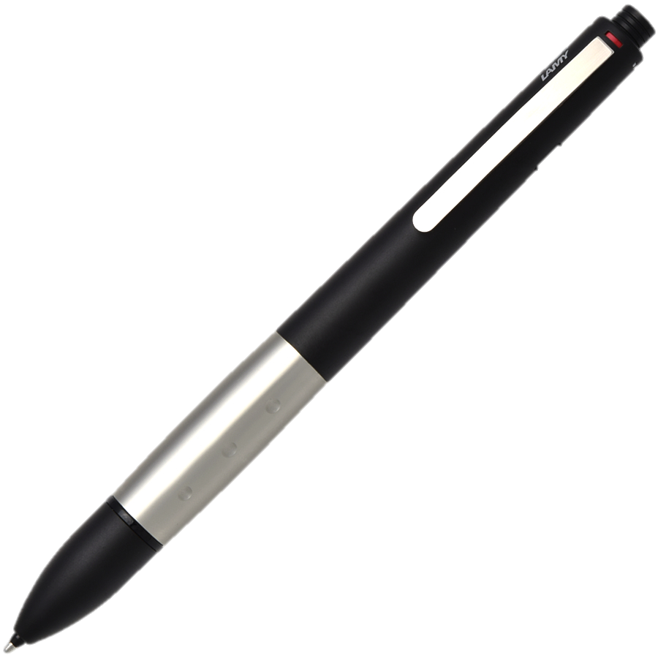
あ、それから、一つ心配していることがあるんです。友だちの話によると、そのお花見の時にみんな何か食べ物を持って行くそうなんです。でも、ぼくはどんな食べ物を持って行ったらいいのかぜんぜん分かりません。ホストマザーに聞いてみようと思っていますが、先生も何かいいアイデアがありますか。
それでは、先生、またお手紙を書きますね。お体に気をつけてください。
1月23日 ジェーソンより

What did Jason think was unfortunate?
___________________________________________________________________
___________________________________________________________________
___________________________________________________________________
(2 marks)

Describe the troubling situation Jason experienced.
___________________________________________________________________
___________________________________________________________________
___________________________________________________________________
___________________________________________________________________
(4 marks)

What is Jason looking forward to? Explain.
___________________________________________________________________

___________________________________________________________________

___________________________________________________________________
(3 marks)

Why does Jason need to buy a new camera? Why would it be good if it is a cheap camera?
___________________________________________________________________
___________________________________________________________________

___________________________________________________________________

___________________________________________________________________
(4 marks)

Describe Jason’s concern.
___________________________________________________________________
___________________________________________________________________
___________________________________________________________________
(3 marks)

Text 7 (14 marks)

Read the following ‘advertisement’, and respond to the questions in English.
日本でアルバイトをしてみたい人、あつまれ‼‼

こんな人におすすめ！
- 日本を旅行しようと思っているけど、お金がたりるかどうか心配している人
- 日本でアルバイトをしたいけど、どうやって仕事を見つけたらいいのか
よく分からない人
北海道プラン  （冬だけのアルバイト） | おきなわプラン
- スキーリゾートでの仕事  - キッチンハンド・ウェイトレス・  インフォーメーションセンター  - 外国から来たスキーヤーが日本語が分からない時、英語で お手伝い  - 休みの日には週に一回フリー  スキーレッスンがうけられるよ！  （スキーウェアやスキーぐつは  無料でかりられるから  だいじょうぶ！） | - ダイビングインストラクターの  アシスタント  - 最近、中国や韓国からの  おきゃくさんが多いので、  中国語や韓国語ができる人に  ピッタリ！  - 海に入ることが多いので、水泳が上手な人  - 休みの日にはスノーケリングや  サーフィンが楽しめるよ！

- 日本語のレベルや仕事のないようで、もらえるお金がかわる。
- 日本にいる間に住む場所は心配しないで！私たちがアパートをじゅんびします！
（昼食・夕食つき）

このアルバイトの前に自分でじゅんびしておくこと

自分の国から日本までのひこうきのおうふくチケット
日本語で、上手に会話ができること
日本でがんばりたい、という決心!!
クリック
きょうみがある人はこちらまでメールください！

Who is this advertisement suitable for?
___________________________________________________________________

___________________________________________________________________

___________________________________________________________________

___________________________________________________________________
(4 marks)

Which part-time job would suit somebody who can speak a language other than English? Explain.
___________________________________________________________________

___________________________________________________________________

___________________________________________________________________

___________________________________________________________________
(3 marks)

What is the benefit of working on the Hokkaido plan?
___________________________________________________________________

___________________________________________________________________

___________________________________________________________________
(2 marks)

Describe how your pay might change.
___________________________________________________________________

___________________________________________________________________

___________________________________________________________________
(2 marks)

List the things the advertisement recommends you prepare before coming to Japan.
___________________________________________________________________

___________________________________________________________________

___________________________________________________________________
(3 marks)
END OF SECTION TWO

Section Three: Written Communication (30%) (30 Marks)
This section has two (2) parts and three (3) questions. Answer two (2) questions in Japanese.

Part A: Stimulus and response
There is one (1) question. Answer the question in Japanese.
Write approximately 250-300ji using plain form on the squared paper following the question.

Part B: Extended writing
There are two (2) questions. Answer one (1) question in Japanese.
Write approximately 350-400ji using polite form on the squared paper following the question.

Spare pages are included at the end of this booklet. They can be used for planning your responses and/or as additional space if required to continue an answer.
- Planning: If you use the spare pages for planning, indicate this clearly at the top of the page.
- Continuing an answer: If you need to use the space to continue an answer, indicate in the original answer space where the answer is continued, i.e. give the page number. Fill in the number of the question that you are continuing to answer at the top of the page.

Suggested working time: 60 minutes.

Part A: Stimulus and response (10 marks)

Write your response to Question 30 on the squared paper following this section.

(10 marks)

You receive the following:

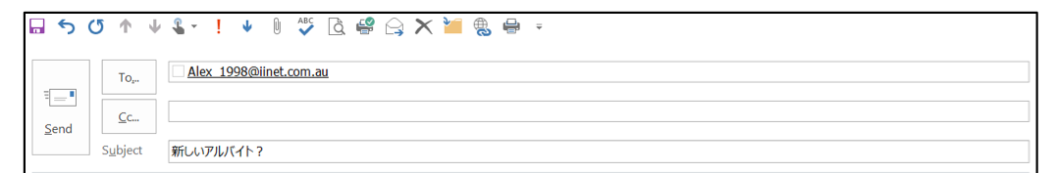
アレックス、元気？ 新しいアルバイトを始めたんだね！ どう？ 仕事でどんなことをしているの？ 時給はいくらぐらい？ そのお金を、どう使うの？ ねえ、色々教えて！

秋子より

You have just received this email from your friend. Write an ‘e-mail’ reply in 250–300 ji to your friend, addressing the points made and any questions asked. Use plain form.

Start your answer to Question 30 here

340ji
Continue your answer to Question 30 here.

340ji

THIS PAGE HAS BEEN LEFT BLANK INTENTIONALLY
Part B: Extended writing (20 marks)

Answer one (1) of the following questions in Japanese. Write approximately 350–400 ji using polite form endings in the squared paper following this section.

(20 marks)

You plan to enter an essay competition for the Hiragana Times to win a trip to Japan. The title of your essay is “Japan is the best place”. Write an essay/descriptive account explaining why Japan is the best place to go as well as what you can do there. Also describe two types of accommodation where you can stay in Japan. Talk about why Australians like Japan as a tourist destination in your account.

Include the following information:

- Explain why Japan is the best place to go and what you can do there
- Describe two types of accommodation where you can stay in Japan.
- Discuss what Australians like about Japan as a tourist destination

or

(20 marks)

Your sister school has asked you to write about how you spend the school summer holidays. Write an essay/descriptive account explaining where you go and what you do in the holidays. Also discuss where you stay when you travel in school holidays. Talk about what Australians like to do in the holidays and why.

Include the following information:

- Explain how you spend your school holidays, where you go and what you do
- Discuss where you stay when you travel in school holidays
- Discuss what Australians like to do in the holidays and why

Start your answer here for: Question () 31 or 32

340ji
Continue your answer to question 31 or 32 here
340ji

Additional working space

____________________________________________________________________________

____________________________________________________________________________

____________________________________________________________________________

____________________________________________________________________________

____________________________________________________________________________

____________________________________________________________________________

____________________________________________________________________________

____________________________________________________________________________

____________________________________________________________________________

____________________________________________________________________________

____________________________________________________________________________

____________________________________________________________________________

____________________________________________________________________________

____________________________________________________________________________

____________________________________________________________________________

____________________________________________________________________________

____________________________________________________________________________

____________________________________________________________________________

____________________________________________________________________________

____________________________________________________________________________

____________________________________________________________________________

____________________________________________________________________________

____________________________________________________________________________

____________________________________________________________________________

____________________________________________________________________________

____________________________________________________________________________

________________________________________________________________

END OF PAPER
Published by S.G. Ainsworth ABN 70218501911
Y. Haddrell ABN 97634237437
S.R. Haddrell ABN 27279332707

