Methodist Ladies’ College
Semester 1 Examination, 2017

Question/Answer Booklet

JAPANESE: SECOND LANGUAGE
ATAR Year 12

Student Name: ______________________________________________________

Teacher Name: ______________________________________________________

Time allowed for this paper
Reading time before commencing work: ten minutes
Working time for paper: two and a half hours

Materials required/recommended for this paper
To be provided by the supervisor
Number of additional
answer booklets used
(if applicable):
This Question/Answer Booklet
Sound recording

To be provided by the candidate
Standard items: pens (blue/black preferred), pencils (including coloured), sharpener, correction fluid/tape, eraser, ruler, highlighters
Special items: print dictionaries: one combined dictionary (Japanese/English and English/Japanese dictionary) or two separate dictionaries (one English/Japanese and one Japanese/English dictionary)
No electronic dictionaries are allowed
Notes: Dictionaries must not contain any notes or other marks

Important note to candidates
No other items may be taken into the examination room. It is your responsibility to ensure that you do not have any unauthorised material. If you have any unauthorised material with you, hand it to the supervisor before reading any further.
Structure of the examination
The Methodist Ladies' College Japanese: Second Language ATAR Year 12 examination consists of a written component and a practical(oral) component.

Structure of this paper
Section | Number of questions available | Number of questions to be answered | Suggested working time (minutes) | Marks available | Percentage of total exam | Your mark
Section One:  Response (listening) | 14 | 14 | 30 | 36 | 30 | /30
Section Two:  Response (viewing, reading) | 15 | 15 | 60 | 50 | 40 | /40
Section Three:  Written communication  Part A: Stimulus and Resonse | 1 | 1 | 60 | 10 | 12 | /30
Part B: Extended Response | 2 | 1 | 60 | 20 | 18 | /30
 |  |  |  | Total | 100 | /100

Instructions to candidates
- The rules for the conduct of ATAR course examinations are detailed in the 2017 Year 12 Information Handbook. Sitting this examination implies that you agree to abide by these rules.

- Write your answers in Standard Australian English or Japanese in this Question/Answer Booklet

- You must be careful to confine your answers to the specific questions asked and to follow any instructions that are specific to a particular question. You may not use SMS-style abbreviations in any section of the paper.

- Additional working space pages at the end of this Question/Answer booklet are for planning or continuing an answer. If you use these pages, indicate at the original answer, the page number it is planned/continued on and write the question number being planned/continued on the additional working space page.

Test Piece of Audio Text with Script

Listen to the short text that is printed below. This will help you to become accustomed to the speakers’ voices. There are no questions or marks associated with this text.

女： 今日の午後は何かよていがある？
男： うん、4時からクリケットのれんしゅうがあるんだ。
女： クリケットって、私ルールがよく分からないのよね。
男： えっ、日本にはクリケットはないの？
女： うん、ぜんぜんないよ。日本にいる時、私、いちどもクリケットのことを聞いた
ことがなかったわ。
男： へ～え、そう。じゃ、日本で人気があるスポーツは何？
女： そうねえ、やきゅうやサッカーかな。

Turn over and begin Section One.

Section One: Response: Listening 30% (36 marks)
This section contains fourteen (14) questions. Answer all questions in English in the spaces provided.

You will hear four (4) texts in Japanese. Each text will be played twice, with a short pause between the first and second readings. After the second reading, there will be time to answer the questions.

You may make notes at any time. Your notes will not be marked. You may come back to this section at any time during the working time for this paper.

Suggested working time: 30 minutes

TEXT 1 (4 marks)

Saeko is talking about her travel experience.
Space for Notes
Part (i)

Are the statements true or false? Circle the correct answer.

1. Saeko spent a year in Australia swimming at the beach, seeing rare animals she hasn’t seen before and becoming friends with various people from other countries. | True | False
2. Saeko still feels not being able to speak English well is a problem even though she studied English hard before coming to Australia. | True | False
3. Despite the fact that Saeko understands most of the things her teachers and friends say, she is disappointed that she can’t say the things she wants to say well. | True | False
4. Saeko had the chance to go to see a koala at the zoo last week and was surprised since they were bigger than she thought and they didn’t open their eyes at all even though there were lots of people there. | True | False

TEXT 1 (2 marks)

Saeko continues to talk about her travel experience.
Space for Notes
Part (ii)
- (1 mark)

Circle the most appropriate alternative from a, b, c, or d.

Since coming to Australia, Saeko

- found studying abroad in a school in the country side hard, since she hasn’t met anyone she can speak Japanese with yet.
- wants to try to go to a large city like Sydney and Melbourne because it will be very good for her English study.
- hasn’t met with anyone from Japan, and she thinks it’s very good for her English study that her lifestyle, must be conducted only in English.
- understands that the Social Studies class is going on an excursion to large cities like Sydney and Melbourne and so she also wants to go too, because her lifestyle in the country has only been about studying English.

- (1 mark)

Circle the most appropriate alternative from a, b, c, or d.

Saeko thinks she

- will enjoy being able to go shopping and look at town life with her host sister and friends on the excursion.
- can buy a nice present for her host mother when they go sightseeing with friends on the excursion.
- will buy a nice present for her host sister who cannot come on the excursion with Saeko because of a big hockey match.
- might enjoy shopping with friends and seeing the history of the town when she goes on the excursion.

TEXT 2 (10 marks)
Space for Notes
A mother and father are talking about trip preparations.

Why did the school phone this morning?
______________________________________________________
______________________________________________________
(1 mark)

Where and when is Kana going?
______________________________________________________

______________________________________________________
______________________________________________________
(3 marks)

Which item(s) does the mother want to purchase? Use a tick () or cross (X)
against each item.

Item | Tick () OR Cross (X)
1. Summer clothes
2. Winter clothes
3. Souvenir for host family
4. New suitcase

(4 marks)

What does the mother think would be embarrassing?
______________________________________________________

______________________________________________________
______________________________________________________
(2 marks)

TEXT 3 (11 marks)
Space for Notes
Mibuki and Adam are talking about part-time jobs.

Why does Adam believe working at a fast food outlet or supermarket is a popular job?
______________________________________________________
______________________________________________________
______________________________________________________
(3 marks)

What does Mibuki intend to do and why is she a little worried about it?
______________________________________________________
______________________________________________________
______________________________________________________
(3 marks)

Explain why Mibuki needs a part time job?
______________________________________________________
______________________________________________________

______________________________________________________

______________________________________________________

______________________________________________________
(5 marks)

TEXT 4 (9 marks)
Space for Notes
Haruka is talking with her father about pocket money.

What was wonderful about the concert?
______________________________________________________
______________________________________________________
______________________________________________________
(2 marks)

Why does Haruka need 3500 yen?
______________________________________________________
______________________________________________________

______________________________________________________
(2 marks)

Why does Haruka want 5000 yen?
______________________________________________________
______________________________________________________

______________________________________________________
(2 marks)

What will Haruka need to do to receive 5000 yen?
______________________________________________________
______________________________________________________
______________________________________________________
(3 marks)

End of Section One

THIS PAGE HAS BEEN LEFT BLANK INTENTIONALLY

Section Two: Response: Viewing and reading (40%) (50 Marks)
This section contains four (4) texts and 19 questions. Answer all questions in English in the spaces provided.
Suggested working time: 60 minutes.
_________________________________________________________________________

Text 5: Diaries (16 marks)

Read the following diary entries and answer Questions 15 to 19 in English.

５月２６日（金） 天気：くもり

あー、明日からいよいよ人生はじめてのアルバイトが始まる。だから、
すごくきんちょうしている！友だちがしょうかいしてくれた喫茶店でのアルバイトだ。毎週、土曜日の昼から夕方までだけ働くつもり。平日は学校の勉強とじゅくで いそがしいし、土曜日の朝はサッカーのトレーニングが あるし、日曜日は教会に行くから、土曜日の午後しか時間がないぼくには ぴったりの仕事だ。明日はいそがしくなりそうだから、今日ははやくねよう。

5月２７日（土） 天気：雨☀

今日はアルバイトのさいしょの日でいい一日になると思っていたけど、さいあくの日になってしまった。。。
まず、そうじ。店の中のそうじだけじゃなくて、外の駐車場までそうじしなければならなかった！しかも、大雨がふっていて、さむくてさむくてつらかった！それに、せっかく、今朝はやくおきて、かっこいいヘアスタイルにしたのに、雨にぬれて、めちゃくちゃになってしまったよ！
それから、そうじの後はキッチンで一人でずっと食器をあらわなければならなかった。だから、おきゃくさんと話すのを楽しみにしていたのに、だれとも話せなくて、がっかりした。。。
それに、アルバイトの間、ずっとたっていたから、あしもいたくなってこまった。お金をかせぐのはたいへんだ。。。
そして、時給はよさそうだと思ったのに、店長によると、その時給の中から、ユニフォーム代と店で毎日出る昼食代をはらわなけらばならないそうだ。しんじられないよ！

Why is the author nervous?

___________________________________________________________________

___________________________________________________________________

(2 marks)

List the reasons why the author believe this part-time job is perfect for him.

___________________________________________________________________

___________________________________________________________________

___________________________________________________________________

___________________________________________________________________
(4 marks)

Describe why the day was so bad for the author with regards to cleaning.

___________________________________________________________________

___________________________________________________________________

___________________________________________________________________

(3 marks)

Explain why the author was so disappointed.

___________________________________________________________________

___________________________________________________________________

___________________________________________________________________
(3 marks)

What can’t the author believe?

___________________________________________________________________

___________________________________________________________________

___________________________________________________________________

___________________________________________________________________
(4 marks)

Text 6: An Online Chat (18 marks)


Read this online chat between two Japanese teachers and answer Questions 20 to 24 in English.





そうですか。ジャック先生たちはどんな所に行ってみたいのですか？
できたら、富士山が見えて、おんせんにも入れて、おいしい名物料理が食べられる所がいいです。それから、私たちは日本にいる間は、しんかんせんで旅行をするよていなので、しんかんせんがとまる駅の近くだったらべんりで、いいですね。
あ、それなら、フジスキー場に行けるバスがしずおか駅から出ていますよ。でも、そこは少しお金がかかってしまうかもしれません。しかし、そのスキー場に行った友だちによると、もちろん雪が見られるし、スキーだけではなくて、そりもできるそうだから、楽しい一日がすごせると思いますよ。
高木先生、こんにちは。来年、日本語のクラスの学生と日本に行くのを楽しみにしています。でも、今、ちょっと、こまった事があるんです。じつは、京都の後、はこねに行くよていでしたが、はこねで安くていい旅館が見つけられないのです。だから、はこねには行かないで、どこか、ほかの所に行ってみようかと思っています。どこかいい所を
教えてくれませんか。
色々とありがとうございます。今から、さっそく、インターネットで見てみようと思います。
そうですか。それから、今回は冬にそちらに行こうと思っているので、まだ雪を見たことがない学生たちに雪を見せてあげたいのですが…
なるほど．．．じゃ、しずおかはどうですか？しずおかは冬でもそんなにさむくなくて、すごしやすい所だし、春だったら、さくらが楽しめますよ。おいしいお茶やみかんやわさびなどが有名で、おみやげも買えるし、とてもいい場所です。
+

What is the small problem for Mrs. Jack and her students?
___________________________________________________________________

___________________________________________________________________
(2 marks)

List FOUR preferences Mrs. Jack has with regards to the accommodation.
___________________________________________________________________

___________________________________________________________________

___________________________________________________________________

___________________________________________________________________
(4 marks)

Describe why Mrs. Takagi recommends Shizuoka to Mrs. Jack.
___________________________________________________________________

___________________________________________________________________

___________________________________________________________________

___________________________________________________________________

___________________________________________________________________
(5 marks)

Why did Mrs. Jack choose winter to travel?
___________________________________________________________________

___________________________________________________________________
(2 marks)

Explain why Mrs. Takagi suggest Fuji Ski Resort.
___________________________________________________________________

___________________________________________________________________

___________________________________________________________________

___________________________________________________________________

___________________________________________________________________

___________________________________________________________________
(5 marks)

Text 7: An Online Forum (16 marks)

Read this online forum and answer Questions 25 to 29 in English.


日本の事なら、何でも聞いて！
ホーム |  | ないよう | かんこう | りゅうがく | しつもん
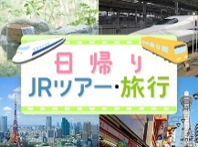    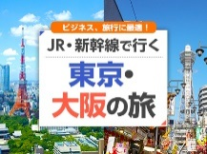  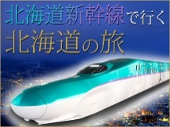  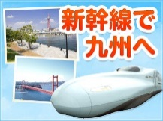  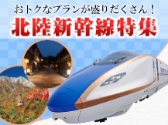  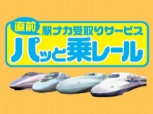    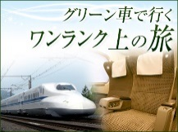 |   カリーナ 2017年03月15日 (20:31)  来年の夏休みに家族で日本を旅行するよていなんだけど、どんな所に泊まったらいいかな？日本ははじめてだから、何も分からない！だれか教えて～！

ゆたか 2017年03月15日 (21:12) 日本で何をしたいかによって、ちがうと思うけど、日本のでんとうてきなぶんかをたいけんしたかったら、ぜったいに旅館がおすすめだね。ぼくは去年、京都にある旅館に宿泊したん だけど、外にあるおんせんにも入れたし、夜は京都でしか食べられない名物料理も楽しめたし、ふとんでもねられたし、すごくよかった。だから、やっぱり、旅館がいいんじゃない？

なな 2017年03月15日 (23:16) 私は日本国内を旅行をする時は、どこへ行っても、あまりお金を使わないように安いビジネスホテルに泊まるようにしている。最近のビジネスホテルはおんせんみたいな大きなおふろもあるし、朝食も、和食でも洋食でも無料で食べられるし、サービスがいい所が多い。だから、旅館に泊まらないでビジネスホテルに泊まったほうがいいかな。

あさひ 2017年03月15日 (23:57) もし、日本語ができなくて心配だったら、ホテルに泊まったほうがいいかもしれないよ。この間、ぼくが泊まったスキーリゾートのホテルには英語や中国語が話せるスタッフがいて、日本語ができないおきゃくさんが来ても大丈夫だったみたい。それから、どこに泊まっても、インターネットが使える所だとべんりだね。ぼくが泊まったスキーリゾートはいなかにあったから、天気がすごくわるい時は、インターネットがほとんど使えなくなって本当にこまったよ！
それから、この間、すごく安いホテルをよやくしたんだ。そのホテルに着いたら、すごく小さくて古くて、しかもエレベーターがなかった！私の部屋は３かいにあったので、おもいスーツケースを持って３階まで上がらなければならなくて、本当にたいへんだった！だから、宿泊料金の安さだけで宿泊先をえらぶんじゃなくて、ほかの事もよくしらべてから、きめたほうがいいと思うよ。

List THREE reasons why the Japanese Inn was so good for Yutaka?
___________________________________________________________________

___________________________________________________________________

___________________________________________________________________
(3 marks)

Why does Nana prefer to stay in a business hotel rather than in a Japanese Inn?
___________________________________________________________________

___________________________________________________________________

___________________________________________________________________

___________________________________________________________________
(4 marks)

Explain why Asahi suggests staying in a business hotel, if you are worried about language.
___________________________________________________________________

___________________________________________________________________

___________________________________________________________________
(3 marks)

Describe why Asahi believe the internet is important in choosing a hotel.
___________________________________________________________________

___________________________________________________________________

___________________________________________________________________
(3 marks)

Why doesn’t Asahi recommend choosing a cheap hotel?
___________________________________________________________________

___________________________________________________________________

___________________________________________________________________
(3 marks)
End of Section Two

Section Three: Written Communication (30%) (30 marks)

This section contains two (2) parts and three (3) questions. Answer two (2) questions in Japanese.

Part A: Stimulus response
There is one (1) stimulus text and one (1) question. Answer the question in Japanese.
Write approximately 250-300ji using plain form, on the squared paper following the question.

Part B: Extended response
There are two (2) questions. Answer one (1) question in Japanese.
Write approximately 350-400ji using polite form, on the squared paper following the questions.

Additional working space pages at the end of this Question/Answer booklet are for planning or continuing an answer. If you use these pages, indicate at the original answer, the page number it is planned/continued on and write the question number being planned/continued on the additional working space page.

Suggested working time: 60 minutes.

Part A: Stimulus and response (12%) (10 marks)

Write your response to Question 30 on the squared paper following this section. Write approximately 250-300ji using plain form.

(10 marks)

You receive the following email:

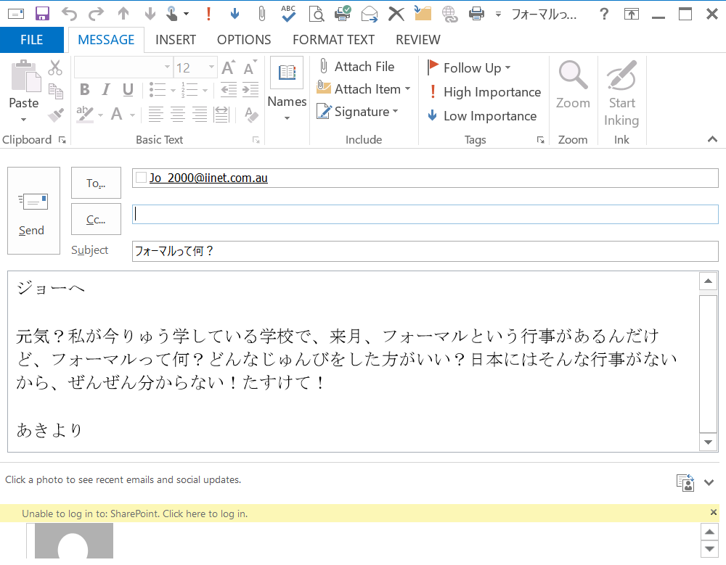
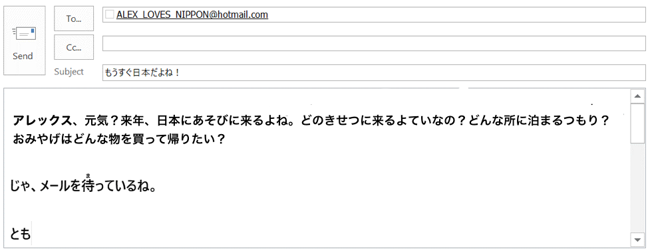

Start your answer to Question 30 here

340ji
Continue your answer to Question 30 here.

340ji

THIS PAGE HAS BEEN LEFT BLANK INTENTIONALLY
Part B: Extended response (18%) (20 marks)

Answer one (1) of the following questions in Japanese. Write approximately 350–400 ji using polite form endings in the squared paper following this section.

(20 marks)

Your sister/brother school in Japan has asked you to write an article for their annual publication titled ‘Popular Japan’.
- Discuss what aspect(s) of Japanese culture is popular among Australians at present
- Describe what interests you about Japan
- Mention your travel plans with regards to Japan.

or

(20 marks)

Your sister/brother school in Japan has requested you to write an article for their school magazine titled ‘Part-time jobs for Australian high school students’.
- Describe your part-time job
- Discuss what other part-time job are popular amongst Australian high school students
- Discuss the advantages and disadvantages of having a part-time job while still a high school student.

Start your answer here for: Question () 31 or 32

340ji
Continue your answer to question 31 or 32 here

340ji
Continue your answer to question 31 or 32 here

340ji
END OF PAPER

