Methodist Ladies’ College
ATAR course examination, Semester 2, 2018

Question Paper

ENGLISH
ATAR Year 12

Student Name: ______________________________________________________

Teacher Name: ______________________________________________________

Time allowed for this paper
Reading time before commencing work: 10 minutes
Working time for paper: 3 hours

Materials required/recommended for this paper
To be provided by the supervisor
Number of additional
answer booklets used
(if applicable):
This Question Booklet
MLC Answer Booklets x 3

To be provided by the candidate
Standard items: pens (blue/black preferred), pencils (including coloured), sharpener, correction fluid/tape, eraser, ruler, highlighters
Special items: nil

Important note to candidates
No other items may be taken into the examination room. It is your responsibility to ensure that you do not have any unauthorised material. If you have any unauthorised material with you, hand it to the supervisor before reading any further.
Structure of this paper
Section | Number of questions available | Number of questions to be answered | Suggested working time (minutes) | Marks available | Percentage of total exam
Section One:  Comprehension | 3 | 3 | 60 | 30 | 30
Section Two:  Responding | 6 | 1 | 60 | 40 | 40
Section Three:  Composing | 5 | 1 | 60 | 30 | 30
 |  |  |  | Total | 100

Instructions to candidates
- The rules for the conduct of the ATAR course examinations are detailed in the Year 12 Information Handbook 2018. Sitting this examination implies that you agree to abide by these rules.

- Write your answers in the MLC Answer booklets. Use a separate booklet for each question. Fill all the information asked for on the cover.

- You must be careful to confine your answers to the specific questions asked and to follow any instructions that are specific to a particular question. If you fail to comply you will be penalised.

- Use the MLC Answer Booklet or this Question Paper for all planning of responses. No extra loose pages will be provided for planning. Leave two lines after your planning to start your response.

See next page
Section One: Comprehending (30 marks)

In this section there are two (2) texts and three (3) questions. Answer all questions.

You are required to comprehend and analyse unseen written and visual texts and respond concisely in approximately 200-300 words for each question.

Suggested working time: 60 minutes

Question 1: (10 marks)

Explain how visual and written elements work together to appeal to a specific target audience in Text 1.

Question 2: (10 marks)

Explain how Text 2 uses stylistic devices to construct a sense of place.

Question 3: (10 marks)
Compare how Text 2 and Text 3 present different perspectives on living in institutions.

See next page for Text 1

Text 1
Text 1 is a black and white reproduction of the cover of May 2009 print edition of Dolly, an Australian magazine. It features Taylor Swift, an American singer.



Text 2
Text 2 is from the novel The Secret History, written by Donna Tartt (1992). The extract depicts the narrator, Richard Papen, arriving at his living quarters in college.
The dormitories weren’t even dorms – or at any rate not like the dorms I knew, with cinderblock walls and depressing, yellowish light – but white clapboard houses with green shutters, set back from the Common in groves of maples and ash. All the same it never occurred to me that my particular room, wherever it might be, would be anything but ugly and disappointing and it was with something of shock that I saw it for the first time – a white room with big north facing windows, monkish and bare, with scarred oak floors and a ceiling slanted like a garret’s. On my first night there, I sat on the bed during the twilight while the walls went slowly from grey to gold to black, listening to a soprano’s voice climb dizzily up and down somewhere at the other end of the hall until at last the light was completely gone, and the faraway soprano spiralled on and on in the darkness like some angel of death, and I can’t remember the air ever seeming as high and cold and rarefied as it was that night, or ever feeling farther away from the low-slung lines of dusty Plano*.
Those first days before classes started I spent alone in my white washed room, in the bright meadows of Hampden*. And I was happy in those first few days as really I’d never been before, roaming like a sleepwalker, stunned and drunk with beauty. A group of red-cheeked girls playing soccer, ponytails flying, their shouts and laughter carrying faintly over the velvety, twilit field. Trees creaking with apples, fallen apples red on the grass beneath, the heavy sweet smell of apples rotting on the ground and the steady thrumming of wasps around them. Commons clock tower: ivied brick, white spire, spellbound in the hazy distance. The shock of first seeing a birch tree at night, rising up in the dark as cool and slim as a ghost. And the nights, bigger than imagining: black and gusty and enormous, disordered and wild with stars.

*Plano is a small town is California, where the narrator is from.
*Hampden is where the college is located in the U.S.

Text 3

Text 3 is an extract from an article titled ‘Sisters of no mercy’. The article highlights the hardships faced by young people living in orphanages before and after the second world war. The article was published in The Guardian in 2003.

Fred Aitken is 70 years old and still he is haunted by sounds - the racket of children "banging their heads against the walls of the dormitories". The walls were in a gothic mansion called Nazareth House, an orphanage in Aberdeen* where Aitken was dispatched when he was six. There, he says, nuns regularly beat him and made him witness the violent degradation of other children. Sleep was routinely interrupted by their constant checks for children wetting their beds and the beating that followed. One bed-wetter was held out of the window by his ankles as punishment. "You woke up to this thrashing. Nuns with leather straps hanging from their waist beside their rosary beads. The strap was socially acceptable. The excuse is that it was normal in those days."
Aitken, who now lives near Chester*, was taken to Nazareth House after his mother died in the 1930s. He ran away constantly, and in his early teens one of his older sisters, then living in one room, took him in and tried to take care of him. He avoided school, sauntered around shops, cinemas, anywhere warm, until he was picked up and sent to an approved school for "delinquents". He joined the RAF* and although other young men lay in their beds weeping for their mothers, Aitken thrived: the military were "the first people who treated me as a human being. I was clothed, fed, paid a weekly wage. And they didn't beat me." Even then Aitken was shadowed by unhappiness. In the 1960s, when he was in his 30s, he sought help. "I told a doctor about the nuns. The man said he thought I was fantasising." It was only 30 years later, when other Nazareth House survivors began to speak out about their experiences, that his childhood and its bleak effects could no longer be dismissed as his imaginings.

* Aberdeen is a city Scotland
* Chester is a city in UK
* The RAF is The Royal Airforce

End of Section One

Section Two: Responding (40 marks)
In this section there are six (6) questions. Answer one (1) question.
Your response should demonstrate your understanding of form, purpose, context and audience.
You must make primary reference to any text or text type that you have studied.
Suggested working time: 60 minutes.

Question 4: (40 marks)
Explore how written, audio and/or visual effects work together to evoke a specific response in one multimodal text you have studied.

Question 5: (40 marks)
Compare the way in which a particular group, event, culture or idea is represented in two texts you have studied.

Question 6: (40 marks)
Discuss how your understanding of the context of production affects your interpretation of at least one text you have studied.

Question 7: (40 marks)
Using at least one text that you have studied, consider how character/s conveys ideas about social attitudes.

Question 8: (40 marks)
Explore how the use of a particular perspective in one text you have studied has encouraged you to support or reject a controversial idea.

Question 9: (40 marks)
Explain how generic conventions are used to create an empathetic response in at least one text you have studied.

End of Section Two

Section Three: Composing (30 marks)

In this section there are five (5) questions. Answer one (1) question.

You are required to demonstrate writing skills by choosing a form of writing appropriate to a specific audience, context and purpose.

Suggested working time: 60 minutes.

Question 10 (30 marks)

Compose a narrative that explores the idea of unrequited love.

Question 11: (30 marks)
In a form of your choice, compose a text where symbolism is used imaginatively.

Question 12: (30 marks)
Compose a narrative that uses the character and setting in the image below.

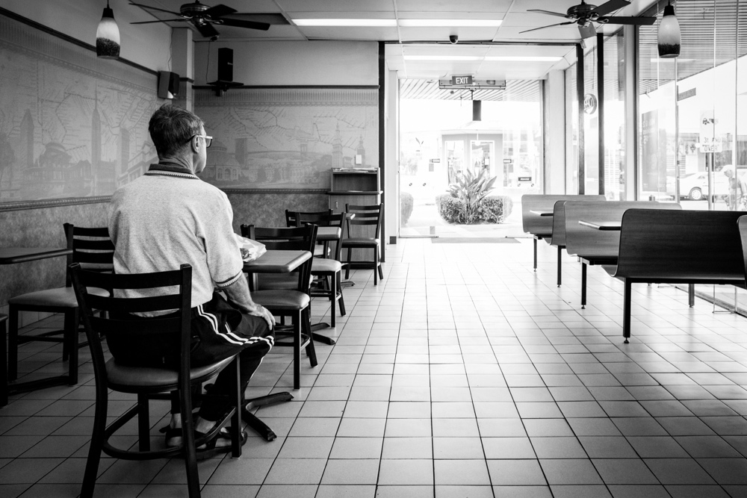

Question 13: (30 marks)
Create an interpretive text that aims to expose a particular truth of which the audience was previously unaware.

Question 14: (30 marks)
Write a persuasive text that uses emotive appeals to convince a resistant audience to be more empathetic to your cause.

End of Examination

ACKNOWLEDGEMENTS

For the construction of questions in the MLC exam paper, the ETAWA Year 12 English ATAR Examination, Semester Two 2018 has been consulted as a resource.

SECTION ONE
Text 1
Dolly (2009). Retrieved 4th of December, 2018, from http://www.dolly.com.au/celebrity/taylor-swift-best-magazine-covers-5855
Text 2
Tartt, D (1992). The Secret History. Alfred A. Knopf: U.S. pp11-12.
Text 3
The Guardian (2003). Sisters of No Mercy. Retrieved 24th of August, 2018, from https://www.theguardian.com/world/2003/apr/12/religion.childprotection

SECTION THREE
http://www.mlc.org.au/blog/2018/3/26/photo-exhibit-of-inner-wests-social-justice-heroes

End of Examination

