

Year 11 Modern History

Semester 1, 2018

Source Booklet

Name: _____________________________________

SOURCES FOR QUESTION 1

Source 1:

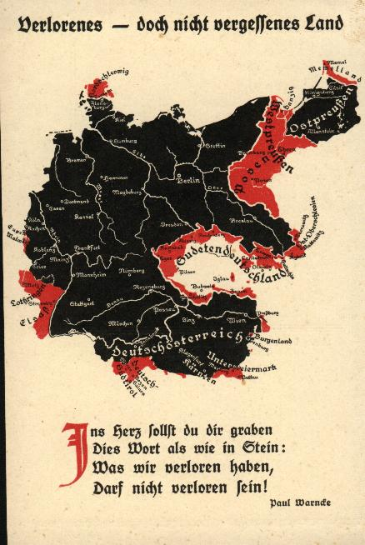

[A German postcard produced 1919. The title is “lost but not forgotten land’. The poem under the map reads: You must carve in your heart, These words as in stone, What we have lost, Will be regained!]

Source 2:

Germany’s chickens are coming home to roost (bad deeds return to the wrongdoers) and she is making no end of a song about it. That was expected, but it will not help her much. If Germany had her desserts, indeed there would be no Germany left to bear any burdern at all; she would be wiped off the map of Europe…Stern justice would demand for Germany a punishment ten times harder than she will have to bear.

[Extract from a British newspaper “The People” 25th May 1919. The title of article read “Terms of the Treaty Better than Germany Deserves”.]

Source 3:

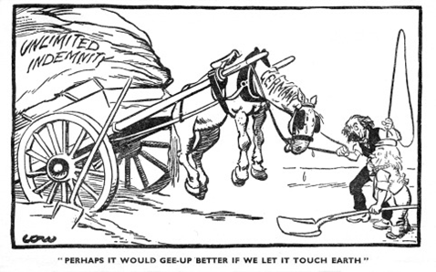

Note – “Unlimited indemnity” refers to war debt and reparations.

[A cartoon by David Low which appeared in the British newspaper The Star on 24th January 1921.]

Source 4:

The Peace of Paris – 1919

“One of the few safe comments to make about the Treaty of Versailles is that nobody ever loved it. The Germans denounced it as a fraud and a cheat which barely had a nodding acquaintance with the 14 points. The French cursed the treaty because they had been led to exchange solid advantages - particularly German territory – for British and US security guarantees which then fell through when the US did not ratify the treaty.

By the 1920s most Britons deplored the treaty fairly massively. US citizens saw it as a document which – particularly through the League of Nations, whose Charter was written right into the Treaty – tried to embroil them in the corrupt politics and quarrels of old Europe – which the USA had supposedly been designed as an escape from!

Once another great war broke out, only 20 years later, discredit of the Treaty of Versailles was complete. There are scholars who speak of the time between the wars as a 20 year armistice and nothing more…”

[An extract from a 2005 lecture by historian Donald G Wileman PhD from York Univeristy, Ontario Canda.]

SOURCES FOR QUESTION 2

Source 1:
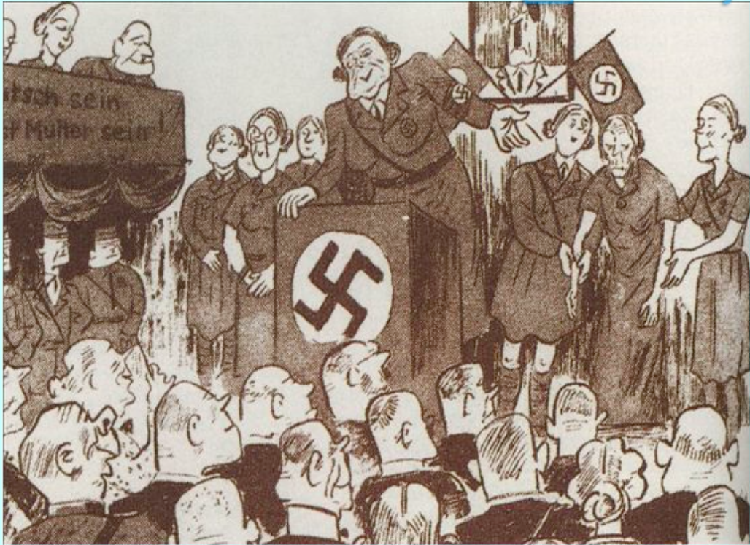

[A German cartoon from the 1930s. The caption reads “introducing Frau Muller who up to now has brought 12 children into the world.”]

Source 2:

At one meeting the team leader raised her voice. ‘There is no greater honour for a German woman than to bearchildren for the Führer and for the Fatherland! The Führer has ruled that no family will be complete without at least four children. A German woman does not use make-up! A German woman does not smoke! She has a duty to keep herself fit and healthy! Any questions?’ ‘Why isn’t the Führer married and a father himself?’ I asked.

[Marianne Gartner was a member of the League of German Maidens and remembers one of its meetings in 1936.]

Source 3:

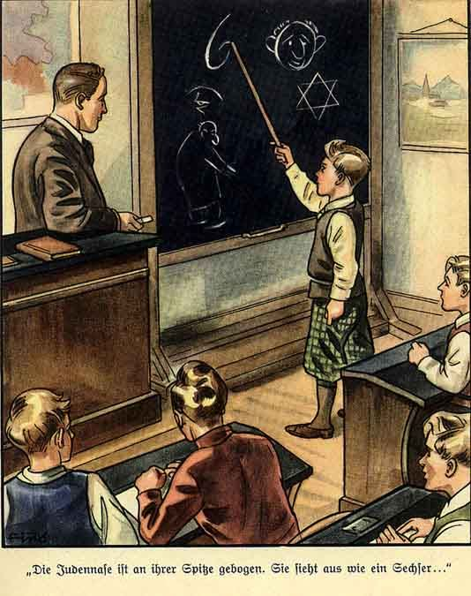

[An extract from The Poisonous Mushroom, published in 1938 by Ernst Hiemer]

Source 4:

I overcame chaos in Germany, restored order, enormously raised production in all fields of our national economy...I succeeded in completely resettling in useful production those 7 million unemployed who so touched our hearts...I have not only politically united the German nation but also rearmed it militarily, and I have further tried to liquidate that Treaty sheet by sheet whose 448 Articles contain the vilest rape that nations and human beings have ever been expected to submit to. I have restored to the Reich the provinces grabbed from us in 1919; I have led millions of deeply unhappy Germans, who have been snatched away from us, back into the Fatherland; I have restored the thousand-year-old historical unity of German living space; and I have attempted to accomplish all that without shedding blood and without inflicting the sufferings of war on my people or any other. I have accomplished all this, as one who 21 years ago was still an unknown worker and soldier of my people, by my own efforts...

[Hitler’s Reichstag Speech 28th April 1939]

