
Semester 2 Examination, 2015

Question/Answer Booklet

HUMAN BIOLOGY ATAR Year 11

Student Name: _______________________________________
Teacher: _______________________________________

Time allowed for this paper
Reading time before commencing work: ten minutes
Working time for paper: three hours

Materials required/recommended for this paper

To be provided by the supervisor
This Question/Answer Booklet
Multiple-choice Answer Sheet

To be provided by the candidate
Standard items: pens, pencils, eraser, correction fluid, ruler, highlighters
Special items: non-programmable calculators satisfying the conditions set by the Curriculum Council for this course

Important note to candidates
No other items may be taken into the examination room. It is your responsibility to ensure that you do not have any unauthorised notes or other items of a non-personal nature in the examination room. If you have any unauthorised material with you, hand it to the supervisor before reading any further.

Structure of this paper

Section | Number of questions available | Number of questions to be answered | Suggested working time  (minutes) | Marks available | Percentage of exam
Section One:  Multiple-choice | 30 | 30 | 40 | 60 | 20
Section Two:  Short answer | 8 | 8 | 90 | 100 | 60
Section Three:  Extended answer | 3 | 2 | 50 | 40 | 20
 |  |  |  |  | 100

Instructions to candidates

1. The rules for the conduct of Western Australian external examinations are detailed in the Year 12 Information Handbook 2010. Sitting this examination implies that you agree to abide by these rules.

2. Answer the questions according to the following instructions.

Section One: Answer all questions on the separate Multiple-choice Answer Sheet provided. For each question shade the box to indicate your answer. Use only a blue or black pen to shade the boxes. If you make a mistake, place a cross through that square, do not erase or use correction fluid, and shade your new answer. Marks will not be deducted for incorrect answers. No marks will be given if more than one answer is completed for any question.

Sections Two and Three: Write your answers in this Question/Answer Booklet.

3. You must be careful to confine your responses to the specific questions asked and to follow any instructions that are specific to a particular question.

4. Spare pages are included at the end of this booklet. They can be used for planning your responses and/or as additional space if required to continue an answer.
  - Planning: If you use the spare pages for planning, indicate this clearly at the top of the page.
  - Continuing an answer: If you need to use the space to continue an answer, indicate in the original answer space where the answer is continued, i.e. give the page number. Fill in the number of the question(s) that you are continuing to answer at the top of the page.

Section One: Multiple-choice 20% (60 Marks)

This section has 30 questions. Answer all questions on the separate Multiple-choice Answer Sheet provided. For each question shade the box to indicate your answer. Use only a blue or black pen to shade the boxes. If you make a mistake, place a cross through that square, do not erase or use correction fluid, and shade your new answer. Marks will not be deducted for incorrect answers. No marks will be given if more than one answer is completed for any question.

Suggested working time for this section is 40 minutes.

- Which one of the following generates the most adenosine triphosphate (ATP)?
a) ribosomes
b) mitochondria
c) nucleoli
d) chromosomes

The next question refers to the following diagram, which represents a ‘map’ of human chromosome number 1.

The labels show the abbreviations and names of medical conditions associated with the information coded for at four different places on the chromosome:

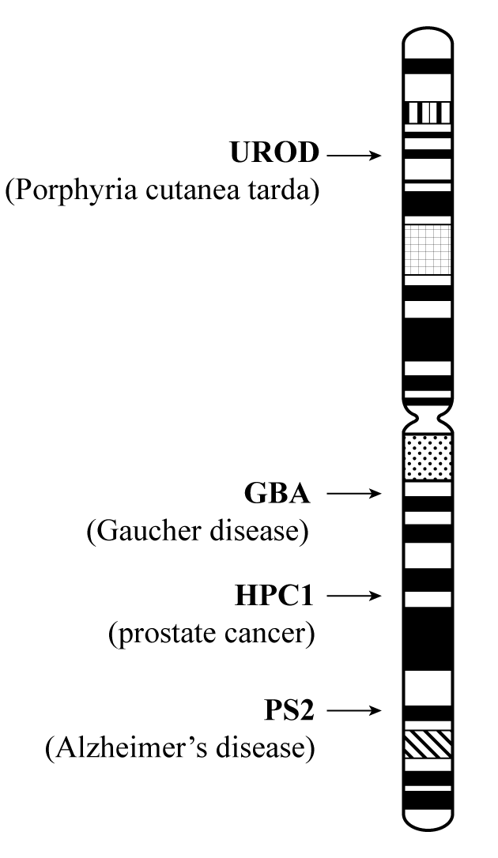

- The segment of human chromosome number 1 labelled GBA represents a:

a) disease
b) polypeptide
c) base triplet
d) gene

- Which of the following is a connective tissue?

a) bone
b) liver
c) heart muscle
d) endothelial cells in capillaries

4. Amylase is an enzyme that catalyses the breakdown of starch. As the temperature rises, the activity of this enzyme will:
- increase until the enzyme begins to denature.
- decrease until the substrate begins to denature.
- increase until the optimum pH level is reached.
- decrease until the substrate reaches a maximum concentration.

- Which of the following is the site for protein production?

- nucleus
- cytoplasm
- mitochondria
- ribosomes

6. A pedigree is shown
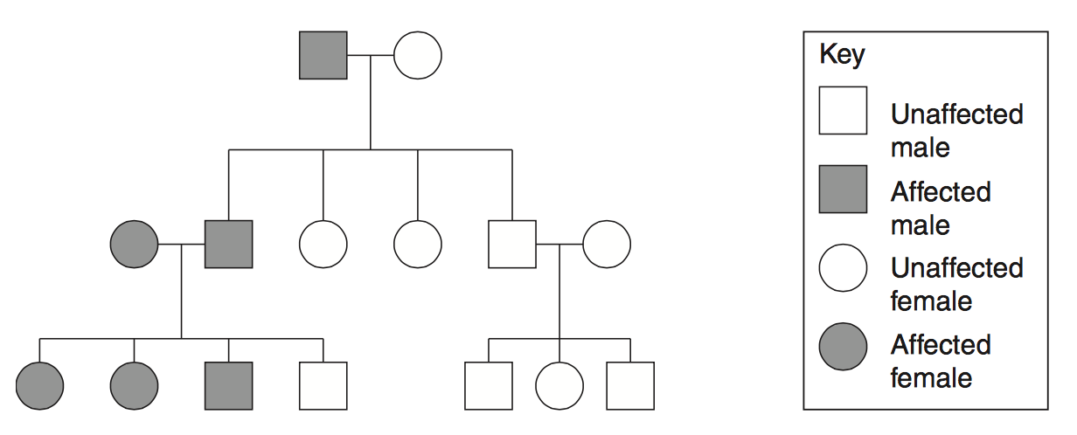

What type of inheritance is shown in the pedigree?
  - Sex-linked recessive
  - Sex-linked dominant
  - autosomal recessive
  - autosomal dominant
Question 7 refers to the electron micrographs below. B shows the same tissue as A but is greatly magnified.
A B
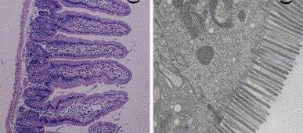

7. The picture above is most likely of a:

a) layer of epithelial cells in the intestinal lining
- layer of skeletal muscle cells
- section of bone cells
- layer of epithelial cells lining a gastric pit in the stomach

8. Oxygen debt occurs when:

a) the maximum rate of breathing takes place
- the supply of oxygen to cells is not enough to keep up with demand in aerobic respiration
- carbon dioxide production is greatly increased
- there is an excess supply of glucose to cells

9. William and Mary are brother and sister and they are twins.

Ignoring mutations, which one of the following cells is genetically identical to a liver cell from William?

a) a liver cell from Mary
b) a sperm cell from William
c) a muscle cell from William
d) all of the above

Questions 10 and 11 refer to the diagram below.
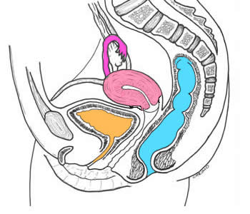
W
Z
Y
X

10. The site of fertilization marked in the diagram above is most likely to be:

a) W
b) X
c) Y
d) Z

11. The site of ovulation marked in the diagram above is:

- W
- X
- Y
- Z

12. Which statement about sperm transport in the female reproductive tract is INCORRECT?

a) Some sperm are destroyed by the acidic environment of the vagina.
b) Transport of sperm to the uterine tube is aided by contraction of smooth muscle in the uterine wall.
c) Some sperm swim up through the ureter.
d) Sperm movement through the cervix can be blocked by mucus.

13. Thirty percent (30%) of the nucleotide bases in human DNA are adenine (A). What is the percentage of guanine (G) bases in human DNA?
- 20%
- 30%
- 40%
- 70%

14. Which two substances are likely to be carried in greater concentration in the foetus’ umbilical vein rather than the umbilical artery:

- urea and carbon dioxide
- oxygen and glucose
- carbon dioxide and antibodies
- oxygen and proteins

15. The contractions of the uterus at birth are stimulated by increasing levels of the hormone:

a) luteinising hormone
b) chorionic gonadotrophin
c) prolactin
d) oxytocin

16. The correctly matched names of the endocrine glands and the hormones they secrete in the table below are:

 | Endocrine gland | Hormone | Endocrine gland | Hormone
a) | Ovary | Follicle stimulating hormone | Testis | Luteinising hormone
b) | Posterior Pituitary gland | Follicle stimulating hormone | Ovarian follicle | oestrogen
c) | Anterior Pituitary gland | Oestrogen | Anterior Pituitary gland | Luteinising hormone
d) | Corpus luteum | Progesterone | Interstitial cells | Testosterone

17. Ovulation is most likely to occur when:

  - oestrogen levels fall a little and luteinising hormones reach a monthly peak
  - progesterone levels fall to a monthly low and oestrogen levels rise
  - progesterone and oestrogen levels rise to a monthly high
  - human chorionic gonadotropohin is released

Question 18 refers to the graph below.

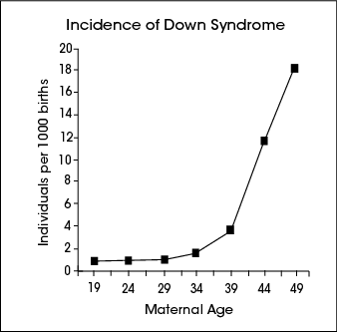

18. What conclusion is best supported by the data:

a) There is no risk of Down syndrome in children born to mothers under the age of 34 years.
b) The risk of Down syndrome increases dramatically in mothers after the age of 34 years.
c) The risk of Down syndrome doubles in children born in mothers for each year over the age of 34
d) There is no correlation between the number of Down syndrome births and the age of mothers

19. Which of the structures identified below is most likely to move through a nuclear pore?

a) chromosome
b) ribonucleic acid (a copy of a small segment of DNA)
c) a bacteria
d) mitochondria

Question 20 refers to the micrograph below.

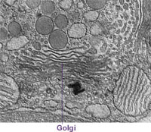
X

20. State the name and function of the organelle labelled X in the micrograph above?

- The endoplasmic reticulum, responsible for the manufacture and transport of proteins.
- A lyzosome carrying digestive enzymes.
- The endoplasmic reticulum, responsible for packaging proteins into vesicles.
- Golgi apparatus, responsible for the packaging and modification of proteins to be transported from the cell.

21. Haemophilia is a human disease in which the blood of an affected individual does not clot. The disease is known to be caused by a sex-linked recessive allele.
The family pedigree shows the pattern of inheritance of this disease in a family.
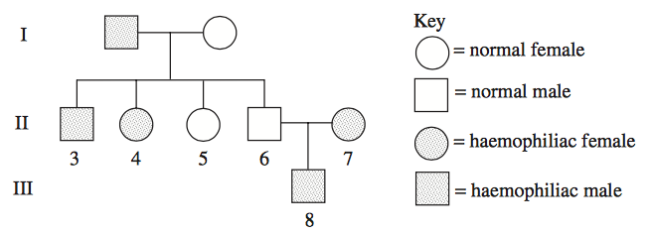
Which of the following shows the genotype for II5?
(a) X^{h}X^{h}
(b) X^{h}X^{n}
(c) X^{n}X^{n}
(d) X^{n} Y
22. Which of the following is not true for the breathing process in humans?

a) in inhalation, ribs are raised and in exhalation, ribs are lowered
b) in inhalation, the diaphragm flattens and in exhalation, the diaphragm arches upwards
c) in inhalation, the volume of the thorax decreases and in exhalation, the volume of the thorax increases
d) to inhale, air pressure in the lungs decreases and air moves in and to exhale, air pressure in the lungs increases and air moves out

23. Soluble food molecules absorbed through the wall of the small intestine will be transported around the body by:

a) plasma
b) red blood cells
c) platelets
d) fibrin

24. The circulation in humans is described as double because the blood:

a) passes through the heart twice in each circulation
b) passes through the heart twice to get to the lungs
c) has double the volume of most other vertebrates
d) has a ventricle and an atria to pass through

25. The renal artery is close to the top of the aorta. This is helpful in the functioning of the kidney as:

a) the blood flows very smoothly
b) there is a large volume of blood
c) the blood flow is under high pressure
d) the blood is well supplied with toxins at this point in its circulation

26. The diagram represents a model of DNA replication. The steps are NOT in the correct order.

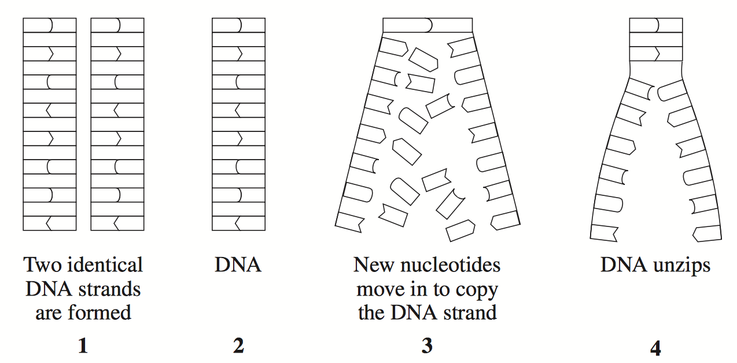

Which of the following is the correct order?
  - 1,2,3,4
  - 2,3,4,1
  - 2,4,3,1
  - 4,3,2,1

27. Muscle fibres within a skeletal muscle are surrounded by a thin membrane called the:

- sarcomere
- myofibril
- sarcolemma
- sacroplasm

28. In humans, brown eye colour is dominant and blue eye colour is recessive. A brown-eyed boy and a blue-eyed girl have a blue-eyed mother.
What eye colour does the father have and why?
  - Brown, because the gene for brown eye colour is sex linked.
  - Brown, because at least one of the parents must have brown eyes.
  - Blue, because at least two other members of the family have blue eyes.
  - Blue, because at least one of the parents must be heterozygous for eye colour.

29. The joint between two vertebrae is an example of a

- fixed joint
- slightly moveable joint
- hinge joint
- pivot joint

30. What happens to the concentrations of glucose, urea and protein as fluid moves from A to B in the nephron?

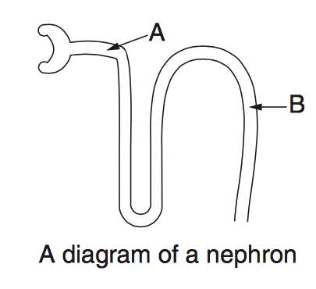

 | Glucose Concentration | Urea Concentration | Large Protein Concentration
a) | Unchanged | Decreases | Decreases
b) | Unchanged | Decreases | Increases
c) | Decreases | Increases | Increases
d) | Decreases | Increases | Unchanged

This page has been left blank intentionally
Section Two: Short answer 60% (100 Marks)

This section has eight (8) questions. Answer all questions. Write your answers in the space provided.

Spare pages are included at the end of this booklet. They can be used for planning your responses and/or as additional space if required to continue an answer.
  - Planning: If you use the spare pages for planning, indicate this clearly at the top of the page.
  - Continuing an answer: If you need to use the space to continue an answer, indicate in the original answer space where the answer is continued, i.e. give the page number. Fill in the number of the question(s) that you are continuing to answer at the top of the page.

Suggested working time for this section is 90 minutes.

Question 31 17 marks

The following questions refer to the diagrams below.
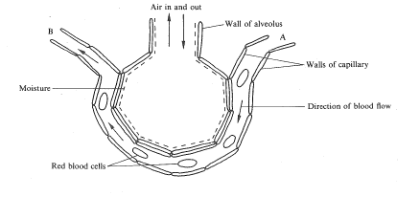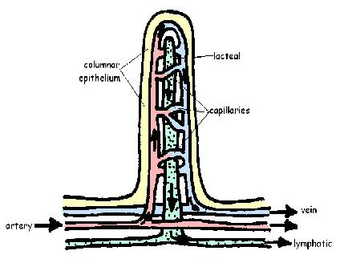
A B

a) i) Name each of the structures labelled above.
.
A_________________________________________________________________________

B_________________________________________________________________________
2 marks

ii) Name the body organ in which you would find each of the structures identified above.

A_________________________________________________________________________

B_________________________________________________________________________
2 marks

b) Describe four features that are common to structures A and B above due to their role in absorption.

___________________________________________________________________________

___________________________________________________________________________

___________________________________________________________________________

___________________________________________________________________________

___________________________________________________________________________

___________________________________________________________________________4 marks

c) Structure A relies on a concentration gradient for the diffusion of particles. Identify two processed that happen at A which make this possible.

___________________________________________________________________________

___________________________________________________________________________

___________________________________________________________________________
2 marks

d) Name two substances that are absorbed at B using an active process.
___________________________________________________________________________

___________________________________________________________________________
2 marks
e) Explain the differences between the processes of active and passive transport.

___________________________________________________________________________

___________________________________________________________________________

___________________________________________________________________________

___________________________________________________________________________
4 marks

f) Name one place in the body other than those identified in your answer to question 31a, where passive transport occurs.

___________________________________________________________________________
1 mark

Question 32 12 marks

The following photograph shows a group of cells, some of which are replicating by mitosis. The letters P, Q, R and S indicate cells that are at different points in the cell cycle.

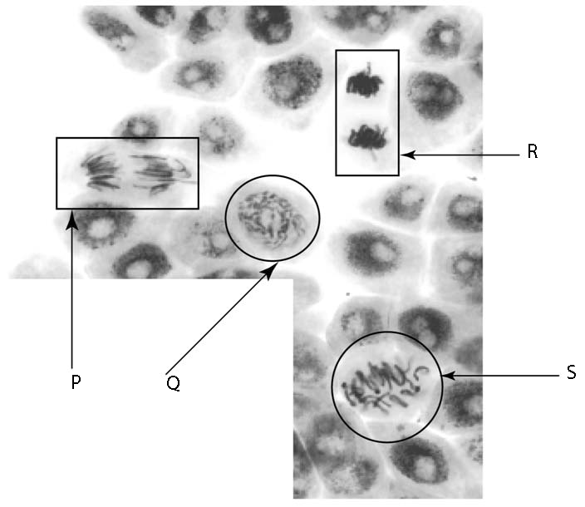X

a) Starting with the cell closest to the beginning of mitosis, arrange the letters P, Q, R and S in the order in which they would occur during the cell cycle.

___________________________________________________________________________
1 mark

b) Name the structure labelled X on the diagram.

___________________________________________________________________________
1 mark

c) Name two body processes that depend on mitosis.

___________________________________________________________________________

___________________________________________________________________________
2 marks

d) Explain what characterises cancer as a disease.

___________________________________________________________________________

___________________________________________________________________________
2 marks

e) Explain why treating cancers such as leukaemia, a cancer of the white blood cells, is so particularly difficult in contrast to treating a bacterial disease.

___________________________________________________________________________

___________________________________________________________________________

___________________________________________________________________________
2 marks

f) Compare and contrast mitosis and meiosis by completing the following table with TRUE or FALSE written in the available spaces:

 | Mitosis | Meiosis
Involves two nuclear divisions

Results in 4 cells each with half the original number of chromosomes
Produces diploid cells

Produces egg and sperm

4 marks

Question 33
18 marks

In an experiment, test tubes containing a particular enzyme and its substrate were placed in water baths at different temperatures. The reaction was stopped after a given time and the amount of product formed was measured. From the results, enzyme activities at temperatures between 15 and 45 degrees Celsius were calculated, and are shown in the table below.

Temperature  (degrees Celsius) | Enzyme Activity  (µm/mL)
15 | 12
20 | 18
25 | 28
27 | 35
31 | 42
34 | 77
37 | 95
39 | 90
41 | 76
45 | 25

a) State the independent variable for this experiment.

___________________________________________________________________________
1 mark

b) State a hypothesis which is being investigated in this experiment.

___________________________________________________________________________

___________________________________________________________________________
2 marks

c) List three factors which would be controlled variables in this experiment.

___________________________________________________________________________

___________________________________________________________________________

___________________________________________________________________________

___________________________________________________________________________

___________________________________________________________________________

___________________________________________________________________________
3 marks

d) Plot a suitable graph of the data in the space provided below.
5 marks
If you wish to have a second attempt at the graph, the grid is repeated at the end of this Question/Answer Booklet. Indicate clearly on this page if you have used the second grid and cancel the working on the grid on this page.



e) Explain why you have chosen your graph type.

___________________________________________________________________________

___________________________________________________________________________
1 mark

f) Describe how and why the activity of this enzyme varied between 15 and 45 degrees Celsius.

___________________________________________________________________________

___________________________________________________________________________

___________________________________________________________________________

___________________________________________________________________________

___________________________________________________________________________

___________________________________________________________________________

___________________________________________________________________________
4 marks

g) Another enzyme was isolated from a site along the human digestive tract and purified. It was identified as a protease. Given the fact that enzyme activity is dependent on the pH of solutions, state a hypothesis which would test whether the enzyme originated in the stomach or the small intestine.

___________________________________________________________________________

___________________________________________________________________________

___________________________________________________________________________
2 marks

Question 34 12 marks

The figure below shows sections through relaxed and contracted myofibrils of a skeletal muscle. The transverse sections are diagrams. The longitudinal sections are electron micrographs.

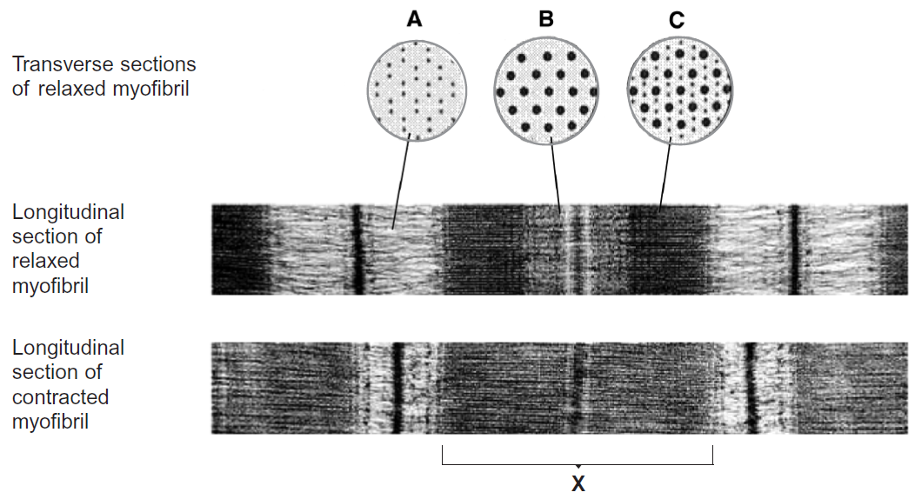

(a) The electron micrographs are magnified 40 000 times. Calculate the length of band X in micrometres. Show your working.

4 marks

(b) Explain the difference in appearance between transverse sections A and C in the figure.

_________________________________________________________________________

_________________________________________________________________________

_________________________________________________________________________
2 marks

(c) Describe in detail the events which lead to the differences in appearance between the relaxed myofibril and the contracted myofibril.

_________________________________________________________________________

_________________________________________________________________________

_________________________________________________________________________

_________________________________________________________________________

_________________________________________________________________________

_________________________________________________________________________

_________________________________________________________________________

_________________________________________________________________________

_________________________________________________________________________

_________________________________________________________________________

_________________________________________________________________________

_________________________________________________________________________
6 marks

Question 35
10 marks

Using a light microscope, a student looked at a prepared slide of human blood, and drew a scaled diagram.

The diagram shown is a representation of the student’s scaled diagram.

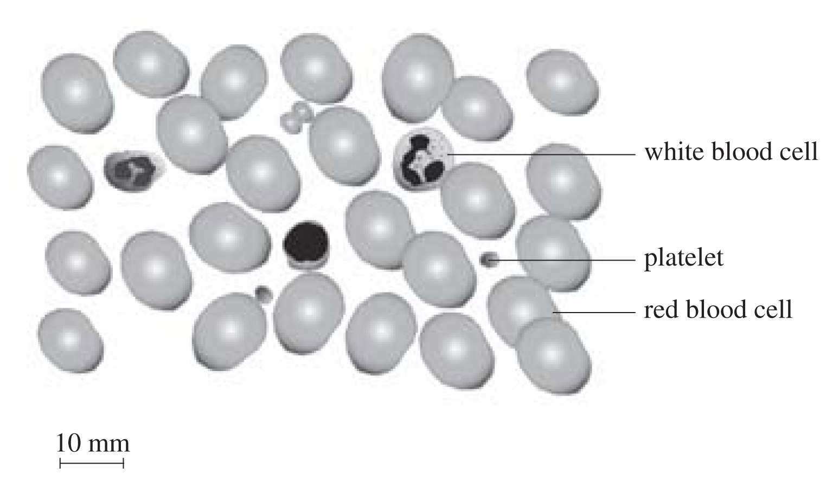

a) Assess the accuracy of the diagram

___________________________________________________________________________

___________________________________________________________________________

___________________________________________________________________________

___________________________________________________________________________
2 marks
Red blood cells were placed on top of a grid in three different solutions and left for a few minutes.
Refer to the original and final results shown in the diagram below to answer question 33b).

ORIGINAL:
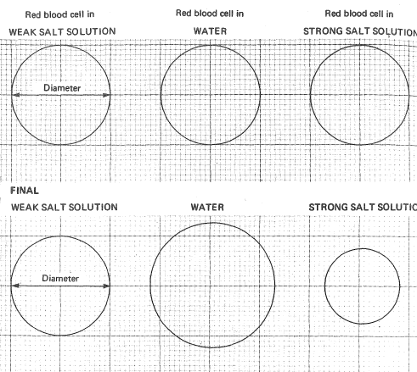

b) i) Describe the changes shown by red blood cells when placed into water and strong salt solution respectively.

In water: _______________________________________________________________

______________________________________________________________________

In strong salt solution: ____________________________________________________

______________________________________________________________________
2 marks

ii) Explain why these changes take place.

______________________________________________________________________

______________________________________________________________________

______________________________________________________________________
2 marks

c) Give two reasons why it is important for the body to regulate its water content.

___________________________________________________________________________

___________________________________________________________________________

___________________________________________________________________________

___________________________________________________________________________
2 marks

d) Where does the excess water that is returned by the lymph system to the circulatory system originally come from?

___________________________________________________________________________

___________________________________________________________________________

___________________________________________________________________________

___________________________________________________________________________
2 marks

Question 36 10 marks

The diagrams below show four different biological molecules. Molecule A is glucose, and molecules B, C and D are composed of units of glucose.

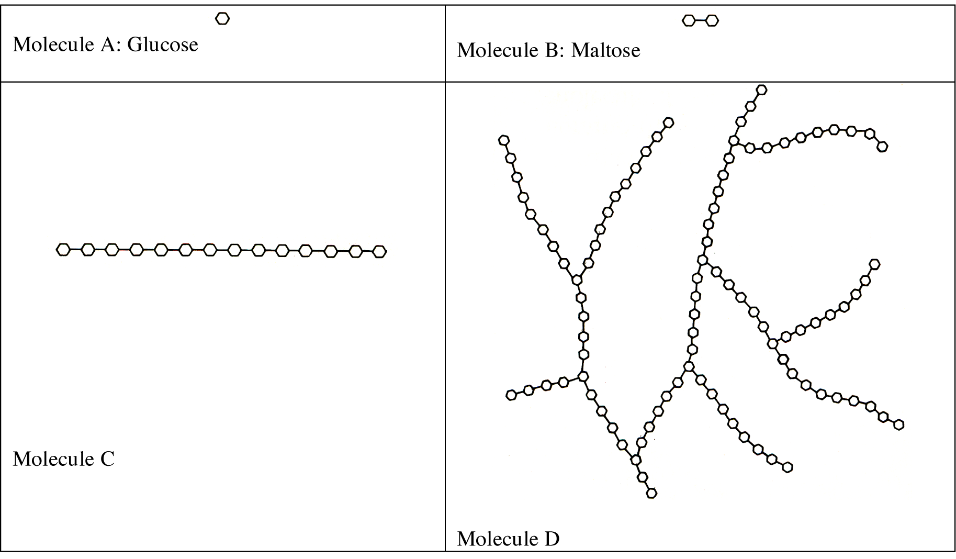

a) If glucose, A, is a monosaccharide, what type of carbohydrate molecules are C and D?

___________________________________________________________________________
1 mark

b) Name an example of a carbohydrate molecule that could be represented by C?

___________________________________________________________________________
1 mark
For a period of several hours after a meal, samples of food were taken from the parts of the digestive system labelled 1-6 in the diagram below.

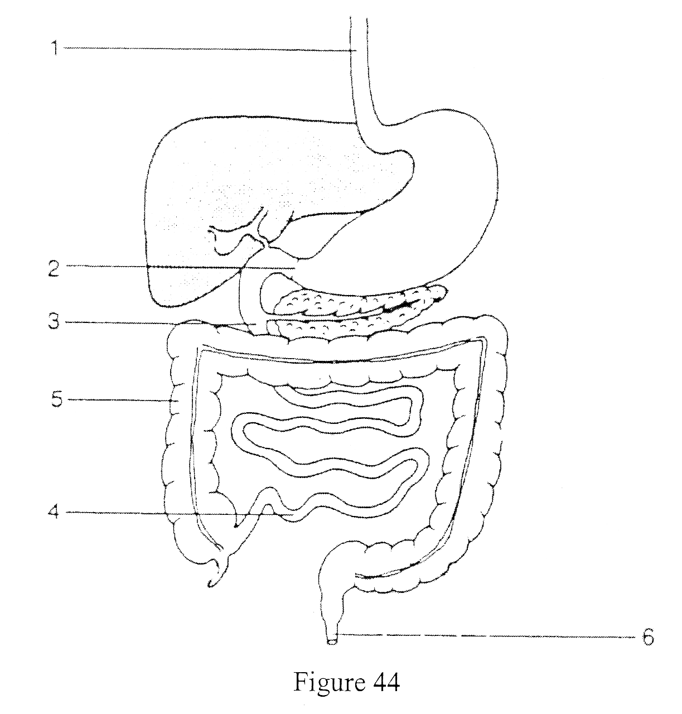

The samples were analysed and the results are shown in the table below:

 | Parts of the Digestive System Sampled
Substances | 1 | 2 | 3 | 4 | 5 | 6
% starch | 8 | 7 | 0 | 0 | 0 | 0
% sugars | 2 | 1 | 8 | 0 | 0 | 0
% proteins | 5 | 1 | 9 | 0 | 0 | 0
% amino acids | 0 | 2 | 3 | 0 | 0 | 0
% fats | 5 | 4 | 2 | 0 | 0 | 0
% water | 70 | 76 | 76 | 89 | 80 | 70
% fibre | 10 | 9 | 9 | 11 | 20 | 30
pH | 7 | 3 | 8 | 8 | 8 | 8

c) This data is taken from a person who was on a sugar-free diet. What evidence is there in the table to support the recorded observation that there must be amylase in the mouth?

___________________________________________________________________________

___________________________________________________________________________

___________________________________________________________________________

___________________________________________________________________________
3 marks

d) Suggest a reason why there are no amino acids in sampled part 1.

___________________________________________________________________________

___________________________________________________________________________

___________________________________________________________________________
1 mark

e) i) In what numbered part is the greatest variety of nutrients digested?

___________________________________________________________________________
1 mark

ii) Explain how the data in the table enabled you to determine your answer to the
previous question.

___________________________________________________________________________

___________________________________________________________________________

___________________________________________________________________________

___________________________________________________________________________
3 marks

Question 37 8 marks

The figure below represents a nephron, which is the functional unit of the kidney.

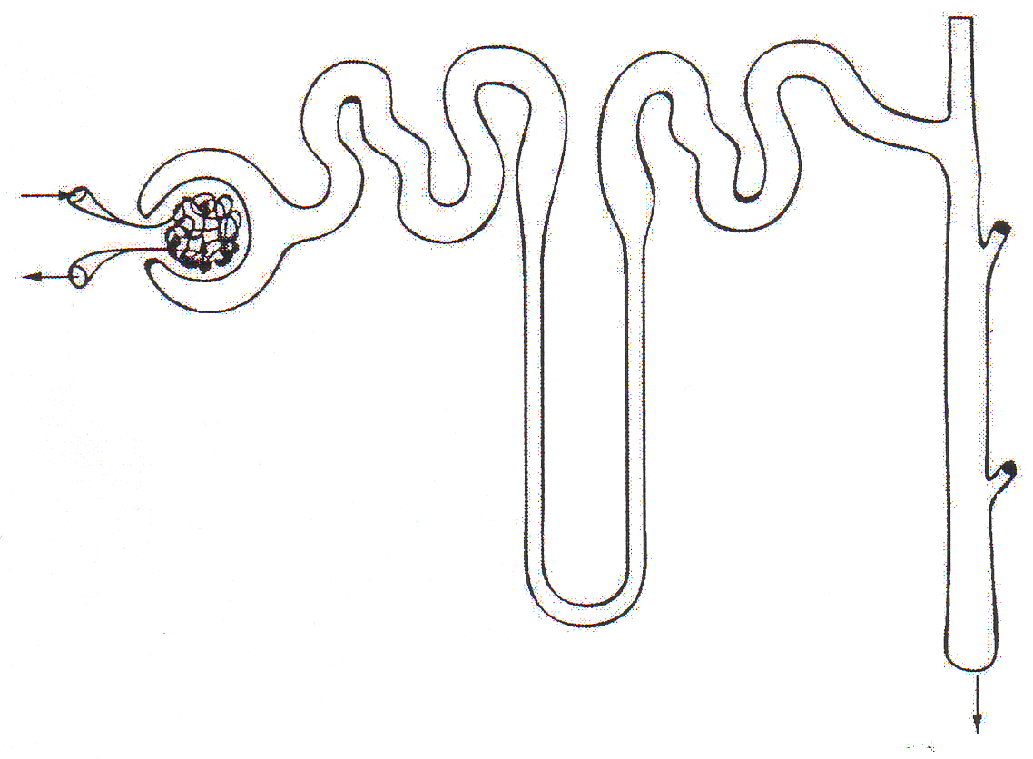
Figure 37a

a) i) Identify the area where filtration occurs, by marking it with an X on the diagram.
1 mark

ii) Identify the area where reabsorption occurs, by shading it in on the diagram.
1 mark

b) The lining of the kidney tubule is made up of cuboidal epithelial cells. Draw a diagram in the space below showing at least two features of this tissue, which suit it to its role in reabsorption.
3 marks
Table 37 below shows the amounts of certain substances found in various parts of the kidney, and in urine, over a 24-hour period for two individuals. One individual has normal kidney function, the other has a kidney disease. Both persons were given a dose of penicillin on the day in which the tests were carried out.

Table 37 |  | Substance | Filtered | Reabsorbed | Excreted in urine
 | Mr N | water (L)  protein (g)  glucose (g)  urea (g)  penicillin (g) | 185  0  185  44  2 | 183.5  0  185  14  0 | 1.5  0  0  30  3
 | Mr M | water (L)  protein (g)  glucose (g)  urea (g)  penicillin (g) | 185  15  185  44  2 | 183.5  0  185  14  0 | 1.5  15  0  30  3

From your knowledge of the functioning of the kidney, and these data:

c) Which individual has the diseased kidney? ________________ Explain.

_______________________________________________________________________

_______________________________________________________________________

_______________________________________________________________________

_______________________________________________________________________
3 marks

Question 38 13 marks

Question 38 refers to the diagram below. The diagram below shows a vertical cross section of the heart.

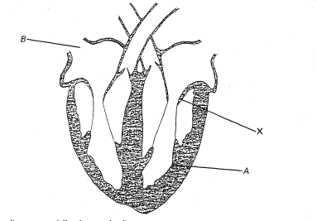
a) Name the parts labelled A and B in the diagram above:

A______________________________________

B______________________________________ 2 marks

b) On the diagram above, shade the blood vessels of the heart that will contain deoxygenated blood.
2 marks

c) Label on the diagram the exit and entry points of the systemic circulation, using the given names for the vessels concerned.
2 marks

d) In the diagram above, name, and explain the function of the structure that would be found at the position marked X.

___________________________________________________________________________

___________________________________________________________________________
2 marks

e) What is it that is felt as the “pulse” when pulse rate is taken?

___________________________________________________________________________

___________________________________________________________________________

___________________________________________________________________________
2 marks
f) Why can we feel the pulse rate more easily after exercise?

___________________________________________________________________________

___________________________________________________________________________
1 mark

g) Describe two features of veins that allow the easy flow of blood back to the heart.

___________________________________________________________________________

___________________________________________________________________________

___________________________________________________________________________
2 marks

Section Three: Extended answer 20% (40 Marks)

This section contains three (3) questions. You must answer two (2) questions. Write your answers in the space provided. Each question carries twenty (20) marks.

Spare pages are included at the end of this booklet. They can be used for planning your responses and/or as additional space if required to continue an answer.
  - Planning: If you use the spare pages for planning, indicate this clearly at the top of the page.
  - Continuing an answer: If you need to use the space to continue an answer, indicate in the original answer space where the answer is continued, i.e. give the page number. Fill in the number of the question(s) that you are continuing to answer at the top of the page.

Responses could include clearly labelled diagrams with explanatory notes; lists of points with linking sentences; clearly labelled tables and graphs; and annotated flow diagrams with introductory notes.

Suggested working time for this section is 50 minutes.

Answer any two questions from Questions 39 to 41.

Indicate the first question you will answer by ticking the box next to the question. Write your answer on pages 35-40. When you have answered your first question, turn to page 41 and indicate the second question you will answer on that page.

_________________________________________________________________________________

☐ Question 39

a) Compare the changes in the chemical composition of blood as it passes through the lungs, small intestine, liver and the kidney, giving a brief explanation for the change.
11 marks

b) Discuss the structure and function of the three main types of joints. Include examples in your answer.
9 marks

☐ Question 40

a) In the rhythm method it is suggested that four days before ovulation and two days after ovulation are unsafe periods in which to have coitus. Use your knowledge of the hormonal cycles and the development and survival of the egg and sperm to explain fully where these six days lie and why only these six days (allowing two days of error margin) are considered unsafe.
10 marks

b) DNA codes for the production of proteins in a cell through a series of processes.
Describe these processes in sequence from the coding by DNA to the production of a protein and explain why every protein is different in structure.
10 marks

☐ Question 41

a) Explain how diffusion can play a major role in the transport of adenosine triphosphate (ATP) and adenosine diphosphate (ADP) around the cell. Use specific examples, identifying the place in the cell where ATP is produced (and ADP consumed) and a place where ATP is consumed (and ADP produced).
10 marks

b) Draw a cross section of a capillary, artery and vein identifying at least three features that characterise each of these vessels.
10 marks

End of Questions
Question number:__________

Question number:__________

Question number:__________

Question number:__________

Question number:__________

Question number:__________

Section Three: Extended answer 20% (40 Marks)

This section contains three (3) questions. You must answer two (2) questions. Write your answers in the space provided. Each question carries twenty (20) marks.

Spare pages are included at the end of this booklet. They can be used for planning your responses and/or as additional space if required to continue an answer.
  - Planning: If you use the spare pages for planning, indicate this clearly at the top of the page.
  - Continuing an answer: If you need to use the space to continue an answer, indicate in the original answer space where the answer is continued, i.e. give the page number. Fill in the number of the question(s) that you are continuing to answer at the top of the page.

Responses could include clearly labelled diagrams with explanatory notes; lists of points with linking sentences; clearly labelled tables and graphs; and annotated flow diagrams with introductory notes.

Suggested working time for this section is 50 minutes.

Answer any two questions from Questions 39 to 41.

Indicate the first question you will answer by ticking the box next to the question. Write your answer on pages 35-40. When you have answered your first question, turn to page 41 and indicate the second question you will answer on that page.

_________________________________________________________________________________

☐ Question 39

a) Compare the changes in the chemical composition of blood as it passes through the lungs, small intestine, liver and the kidney, giving a brief explanation for the change.
11 marks

b) Discuss the structure and function of the three main types of joints. Include examples in your answer.
9 marks

☐ Question 40

a) In the rhythm method it is suggested that four days before ovulation and two days after ovulation are unsafe periods in which to have coitus. Use your knowledge of the hormonal cycles and the development and survival of the egg and sperm to explain fully where these six days lie and why only these six days (allowing two days of error margin) are considered unsafe.
10 marks

b) DNA codes for the production of proteins in a cell through a series of processes.
Describe these processes in sequence from the coding by DNA to the production of a protein and explain why every protein is different in structure.
10 marks

☐ Question 41

a) Explain how diffusion can play a major role in the transport of adenosine triphosphate (ATP) and adenosine diphosphate (ADP) around the cell. Use specific examples, identifying the place in the cell where ATP is produced (and ADP consumed) and a place where ATP is consumed (and ADP produced).
10 marks

b) Draw a cross section of a capillary, artery and vein identifying at least three features that characterise each of these vessels.
10 marks

End of Questions

Question number:__________

Question number:__________

Question number:__________

Question number:__________

Question number:__________

Additional Working Space


Methodist Ladies’ College

Multiple Choice Answer Sheet

Subject 2AB Human Biological Science
Name:
Teacher ______________________________

Directions
- Use a ballpoint pen or ink pen.
- Mark the boxes in the following way.
- Please enter your name, and teacher’s name as directed by your supervisor.
- Give only one answer for each question. If you change your mind,
place a cross over your mark and then mark your new answer.
- More than one answer will invalidate the answer.
- If you change your mind back to the original answer that has a cross through it, place a cross through your last answer and then circle the new answer.
- At the end of the examination, place this Multiple Choice Answer Sheet inside the front cover of your Examination Answer Booklet.
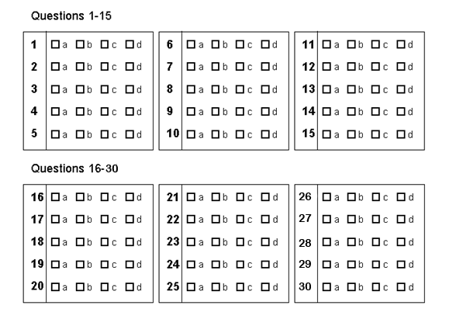
Score

Name:

 | QUESTION | MARKS AVAILABLE | MARK | PERCENTAGE  OF EXAM | TOTAL
 | QUESTION | TOTAL |  | 30%
PART I | 1 - 30 | 60
PART II | 31 | 17
 | 32 | 12
 | 33 | 10
 | 34 | 12
 | 35 | 18
 | 36 | 10
 | 37 | 8
 | 38 | 13 |  | 50%
TOTAL PART II |  | 100
 | 39 or 40 or 41 | 20
 | 39 or 40 or 41 | 20
SECTION III TOTAL |  | 40 |  | 20%

