MATERIALS DESIGN AND TECHNOLOGY
YR 11 ATAR

Student Number: In figures

Time allowed for this paper
Reading/planning time before commencing work: ten minutes
Working time for paper: two hours

Material required/recommended for this paper

To be provided by the supervisor

This Question/Answer Booklet
Multiple Choice Answer Sheet

To be provided by the candidate
Standard materials: pens, pencils, eraser, correction fluid, ruler, highlighters

Important note to candidates
No other materials may be taken into the examination room. It is your responsibility to ensure that you do not have any unauthorised notes or other material of a non-personal nature in the examination room. If you have any unauthorised material with you, hand it to the supervisor before reading any further.

Structure of this paper

Section | Number of questions available | Number of questions to be attempted | Suggested working time (minutes) | Marks available | Percentage of exam
One: Short-answer | 3 | 3 | 20 mins | 15 | 15%
Two: Extended answer | 3 | 3 | 20 mins | 20 | 20%
Three: Textiles specific content | 6 | 6 | 80 mins | 65 | 65%
 |  |  | Total | 100 | 100%

Instructions to candidates

- Answer the questions according to the following instructions

Sections One, Two, and Three: Answer all questions. Write your answers in this Question/Answer booklet.

- You must be careful to confine your responses to the specific questions asked and to follow any instructions that are specific to a particular question.

- Spare pages are included at the end of this booklet. They can be used for planning your responses and/or as additional space if required to continue an answer.
  - Planning: If you use the spare pages for planning, indicate this clearly at the top of the page.
  - Continuing an answer: If you need to use the space to continue an answer, indicate in the original answer space where the answer is continued, i.e. give the page number. Fill in the number of questions that you are continuing to answer at the top of the page.

Section One: Short Answer (15 marks)

This section has THREE (3) questions. Answer all questions. Write your answers in the spaces provided.

Spare pages are included at the end of this booklet. They can used for planning your responses and/or as additional space if required to continue and answer.
  - Planning: If you use the spare pages for planning, indicate this clearly at the top of the page.
  - Continuing an answer: If you need to use the space to continue an answer, indicate in the original answer space where the answer is continued, i.e. give the page number. Fill in the number of questions that you are continuing to answer at the top of the page.

Suggested working time: 15 minutes

Question One (4 marks)

- From the list below, select the two most important ‘fundamentals of design’ to consider when designing and manufacturing the Thurle Ride along Mini jogging stroller illustrated bellow. Explain why it is important to consider the selected ‘fundamental of design’ when manufacturing clothing for young children.
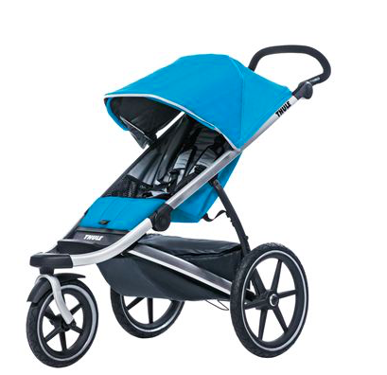

Place the numbers 1 and 2 in the boxes below to indicate your choice.
2
1
3

Function Aesthetics Ergonomics Environmental Safety

Fundamental of Design ______Ssfety__________________________ ( 2 marks)
Reason
- Safety straps - for safety of infant
- Moulded handle bar with soft covering to allow for good grip
- Wheels balanced, jogging, turning
- Shade and cover, leg rest – safety of infant
- Adjustable height handle for adults
- Brakes – safety when not mobile

Fundamental of Design ______Ergonomics__________________________ ( 2 marks)
Reason
- Moulded handle bar with soft covering to allow for good grip
- Wheels balanced for design and purpose
- Designed for shading baby and appears to have leg rest tht may open out
- Would be easily foldable
- Adjustable height handle for adults
- Large wheels for jogging – sand, turning circle

Fundamental of Design ____Function___________________ ( 2 marks)
Reason
      - baby carrier – would need to give comfort, support and shelter
      - allows functional storage bag that does not protrude from stroller - nappy bag etc
      - Wheels - Jogging pram – turning circle, balance, sand,
      - Handle – balance and control
Question Two (6 marks)

Finishes are often applied to enhance the appearance of a material.
Choose a finishing technique used in your context area to enhance the appearance of a material.
Explain how the finish is applied and how it enhances the performance of a chosen material.

Fabric Finish: Sanforising, Mercerising, Napping, bleaching, dyeing (1 mark)

Chosen Material: Cotton denim (1 mark)

Explanation of How Finish is Applied: (4 marks)
Sanforising: damp cotton fabric is stretched around rollers and heated, reversed to compress the fabrc and heated again. This results in cotton fabric with less than 1% shrinkage - permanant
Mercerising: Cotton fibres, yarns or fabrics are immersed in an alkali solution. This causes the fibres to swell and straighten, removing the convolutions and creating a fibre with a circular cross section. This increases lustre, strength and dyeability – end users sewing thread
Napping: fabric is passed over barbed rollers that raise the firbe ends resulting in a soft surface with better insulation – end uses fleecy, flanellette, blankets

See the next page

Question Three ( 5 marks)

- What does PPE stand for? (1 mark)
Personal Protective Equipment – any device or appliance designed to be worn or held by an individual for protection against one or more health and safety hazards

- What does MSDS stand for? (1 mark)

Material Safety Data Sheet – Document that contains information on the potential health effects of exposure and how to work safely with the material it is written about

- A small fire has broken out in the staff kitchen of a textile manufacturing warehouse, all personnel have been evacuated and the fire department has been called.

Identify one (1) section of the MSDS the fire department needs to know before proceeding into the property? Justify your answer. (3 marks)

Any of the following in priority order
Fire Fighting Measures-
describes safety risk and volatility of the product, fire fighting measures- equipment and extinguishing products, output of burning product- gases, smoke, soot etc.
Accidental Release Measures-
describes how to treat accidental release of the product, containment, clean-up, protective clothing and measures including environmental actions.
Exposure Controls and Personal Protection-
lists hazardous component data, exposure limits, engineering controls when used (ventilation etc.) and PPE to be used.

Hazards Identification-
describes the products classification as being hazardous or non-hazardous, its risk phase (flammability, vapours, toxicity, etc.) physical harm it can cause due to exposure, its safety phase- precautions, avoidances, actions (fire control, medical/first aid treatment, PPE, safe usage, etc.).
Composition/Information of Ingredients-
identifies chemical composition of the product, proportion of chemicals and their CAS number.
First Aid Measures-
description of actions to be taken if product is inhaled, swallowed, comes in contact with eyes, skin and treatment/action to be taken by a doctor.
Disposal Consideration-
describes waste disposal methods of the product and its container.
They would need to knpw before entering the premises
- are there any dangerous goods or hazardous substances stores inside and where they are stored
- all staff should have been briefed on any hazardous substances
- clear display of an MSDS sheet displaying ingredients, the chemical and physical porperties, first aid measures and precautions for the safe use of the substance including use of PPE

End of Section One

Section Two: Extended Answer (20 marks)

This section has THREE (3) questions. Answer all questions. Write your answers in the spaces provided.

Spare pages are included at the end of this booklet. They can be used for planning your responses and/or as additional space if required to continue and answer.
  - Planning: If you use the spare pages for planning, indicate this clearly at the top of the page.
  - Continuing an answer: If you need to use the space to continue an answer, indicate in the original answer space where the answer is continued, i.e. give the page number. Fill in the number of questions that you are continuing to answer at the top of the page.

Suggested working time: 15 minutes

Question Four ( 8 marks)
Design elements and principles are carefully considered when designing products.
- Using annotated diagrams, explain what is meant by line and shape in relation to fashion designing. (You may use the fashion template provided at the end of the question paper) ( 2 marks)
Line: 1 mark for a clearly annptated diagram explaining Line – vertical, horizontal, diagonal
defines the direction of a design. Can divide a space or outline an object. Can express emotion and movement and can communicate a feeling
Shape: 1 mark for a clearly annptated diagram explaining Shape – 2D or 3D, silhouette,Triangle, hourglass, inverted triangle , rectangle
is a closed line. There are 2 main types of recognisable shapes – organic, free form and geometric. When lines join to form a shape with no depth it is called 2 dimensional, when depth is applied to a shape it becomes 3 dimensional

See the next page

Question Four contiued
- Sketch and annotate a cocktail style dress for a special occasion. The garment must illustrate the use of balance, repetition, emphasis and proportion. (You may use the fashion template provided) ( 6 marks)
2 marks for correct drawing techniques for presentation drawing
- Use and trace the body shape in pencil
- Sketch drawing front and back view
- Colour the garment
Annotate the image: (1 mark for each aspect)
- Illustrate balance – symmetrical / radial or assymetrical
- Illustrate repetition – repetition of design element or principle eg lines, patternsa
- Illustrate emphasis – dominance, focal point
- Illustrate proportion – Golden mean 3.5.8

Question Five ( 8 marks)
This question is about trend forecasts and the use of recycled materials in textile products.
- Explain the term ‘trend forecast’ in the textile industry. ( 1 mark)
A fashion forecast predicts the colours, fabrics, textures, materials, prints, graphics, beauty/grooming, accessories, footwear, street wear and other styles that will be presented on the runway and in the stores for the upcoming seasons

- Explain the research that you can undertake to identify trend forecasts. ( 2 marks)
Look at past trends that might be repeated, Online Trend forecasting websites free and paid websites,other designers websites and runway collections especially in the UK & USA - ahead one season, magazines, look at what celebrities, socialites and entertainers are wearing to see what might begin a trend, llok at new fibres and fabrics, textile embellishments that are popular
A merchandiser plays a key role in the direction of upcoming trends. Different from developers they have much more experience in buying and are knowledgable in what consumers are looking for

- Explain how designers use the information from trend forecasts. (2 marks)
The designers take the particular trends and then determine the styles. Silhouettes and colours for the range of garments and also creates a theme for the particular season

- Trend forecasts show that there is a continued interest in a sustainable concept of the three R’s in recycling, reducing and reusing. Explain, giving an example of how one the three R’s, can be used in fashionable textile products. ( 3 marks)

Use an example to explain one of the 3Rs

Recycling: eg recycle / upcycle items of clothing into another item of clothing. Most clothing and textiles items are nearly 100% recyclable. The advantage is that by recycling we are cutting down the number of resources needed to produce new clothing. On garments besides fabric – buttons, zips, jewelry can all be recycled ono other garments
Reducing – minimsing waste and off cuts by buying only what you need, using patterns with minimal offcuts.
By Reducing you can save energy. You can help sustain the environment for future generations
Re-using: Re using components of a garment – for example reusing lace from a wedding dress, reusing fur from a fur coat, allows products to be used to their fullest extent. This works in remodelling a garment where the fabric is either used in part resized to form a new garment

Question Six (4 marks)

Claire is a designer who wants to set up a workshop to produce garments. She intends to employ staff and has the financial backing to achieve this aim. She is concerned about fulfilling her legal obligations regarding the safety of her employees.
Outline in detail the safety requirements for a textile workship / studio.

Employers must as so far is practical, provide and maintain a working environment where their employees are not exposed to hazards.
This includes:
  - Safe systems of work.
  - Information, instruction, training and supervision.
  - Consultation and co-operation.
  - Provision of personal protection equipment.
  - Safe plants and substances.
  - Reporting of fatalities. Injuries and disease.

GENERAL PRINCIPLES in TEXTILES STUDIOS
- Have good lighting in the workroom to reduce eye strain.
- Work in a well ventilated area to reduce fibre, dust and vapour inhalation.
- Have appropriate ergonomic furniture – correct height of desk and chair for comfort and to reduce strain on body.
- Keep power cords away from sewing and cutting areas.
- Wear appropriate dress – closed shoes, hair tied back, no loose clothing worn.
- Keep fingers away from moving parts of all machine and electrical appliances – blade in over locker, needle in sewing machine, iron face.
- Safety guards used where applicable on machines.
- Keep work areas clean and uncluttered to prevent items getting caught in machines.
- Avoid contact with wet areas to prevent electrocution.
- Use PPE where necessary.

End of Section Two

Section Three: Textiles Specific Context (65 marks)

This section has SIX (6) questions. Answer all questions. Write your answers in the spaces provided.

Spare pages are included at the end of this booklet. They can be used for planning your responses and/or as additional space if required to continue and answer.
  - Planning: If you use the spare pages for planning, indicate this clearly at the top of the page.
  - Continuing an answer: If you need to use the space to continue an answer, indicate in the original answer space where the answer is continued, i.e. give the page number. Fill in the number of questions that you are continuing to answer at the top of the page.

Suggested working time: 80 minutes

Question Seven (10 marks)

Peter Alexander sleepwear has engaged your services as a designer to design a range of sleepwear for the Summer 2016 range.
- Using your knowledge, and the information provided in the table below, evaluate the properties of each of the following fibres for the Summer 2016 sleepwear range.
(6 marks
- Cotton
- (ii) Silk
 | Warmth | Ease of Care | Durability | Elasticity | Crease Resistance
Cotton | ** | *** | **** | * | *
Silk | **** | * | ** | ** | **
Key: * poor ***** excellent
Evaluation:
Cotton
Good properties on chart – ease of care, durability and not too warm (good conductor of heat)
Due to the garments being sleepwear no real need to be concerned about elasticity or crease resistance
3 marks
Cotton sleepwear for summer
- needs to have good durability,
- be to be cool, comfortable to wear and breathable
- be easily laundered and cared for

Silk Evaluation: ( 3 marks)
Silk pyjamas
- have warmth – which in summer is not an important need
- more important that they are soft and comfortable.
- Silk requires care with care laundering
- the fibre’s durability is low.
- If the pyjamas are roomy there is not a requirement for elasticity to be a feature.
- warmth good but not necessary.
- Laudering and care will require wool cycle wash or hand wash in soft detergent.
- Comfort yes.
A textile item has the following care label.
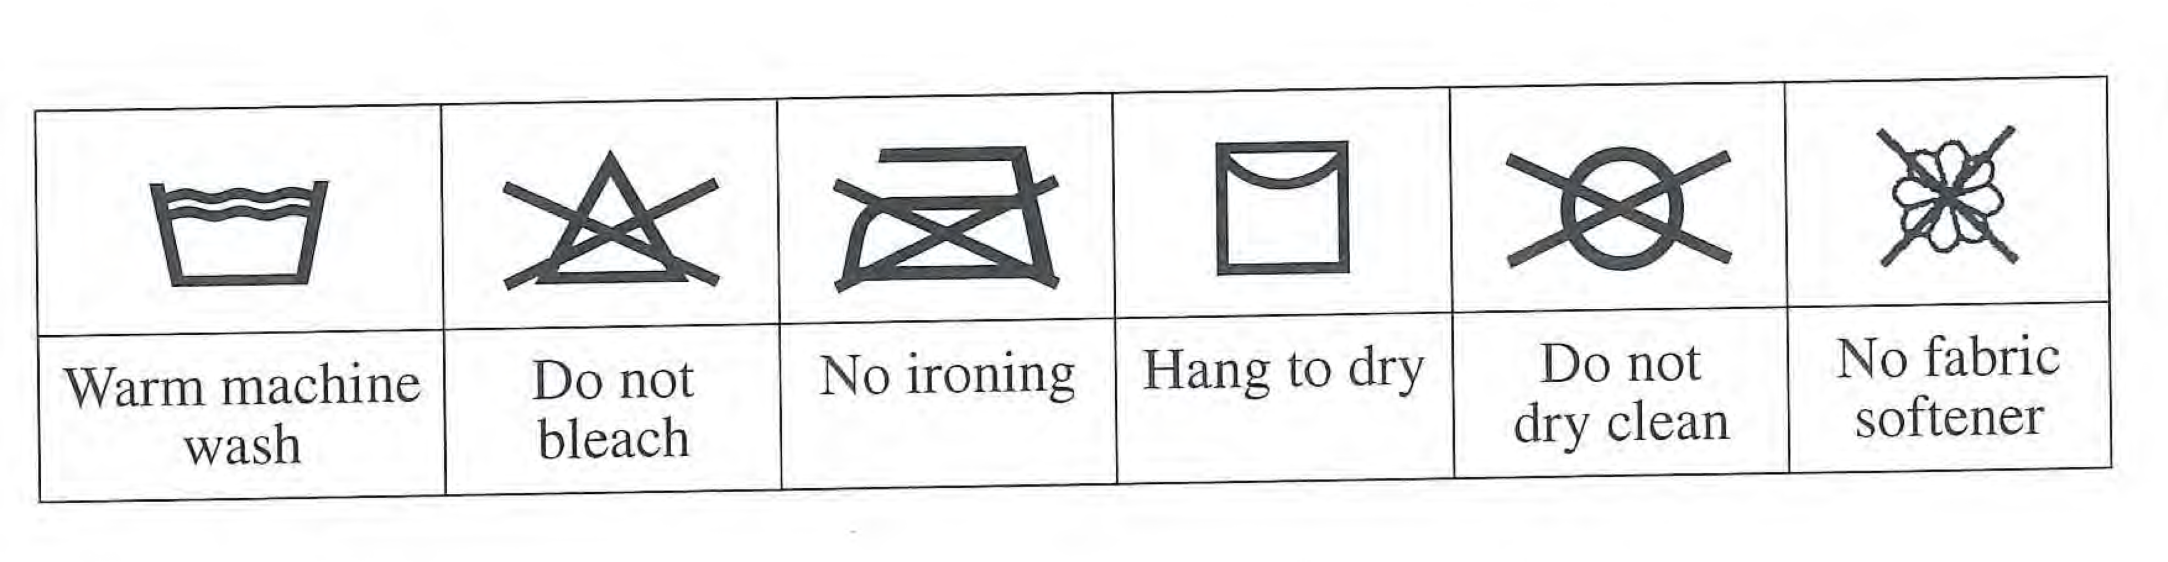
- In which of the following textile items is the care label shown above most likely to be found? (2 marks)
Circle the textile item below that would carry the care label shown above.
  - (i) A cotton bath towel
- Explain your answer (2 marks)
- Do not dry clean – cotton towelling is a fabric that can be laundered in hot water then is able to be hung out to dry as not easily damaged by sunlight – so no would never need to be dry cleaned
- No ironing – due to its excellent elastic recovery

- Rayon is attacked by bleaches – could also use warm machine wash due to chance of strength being lost when wet and tendency to go out of shape, and creases badly so would need ironing.
- Hang to dry and warm machine wash and warm rinse to support holding shape
- Tailored woollen jacket ( eg school blazer) are always dry cleaned.

See the next page

Question Eight ( 15 marks)
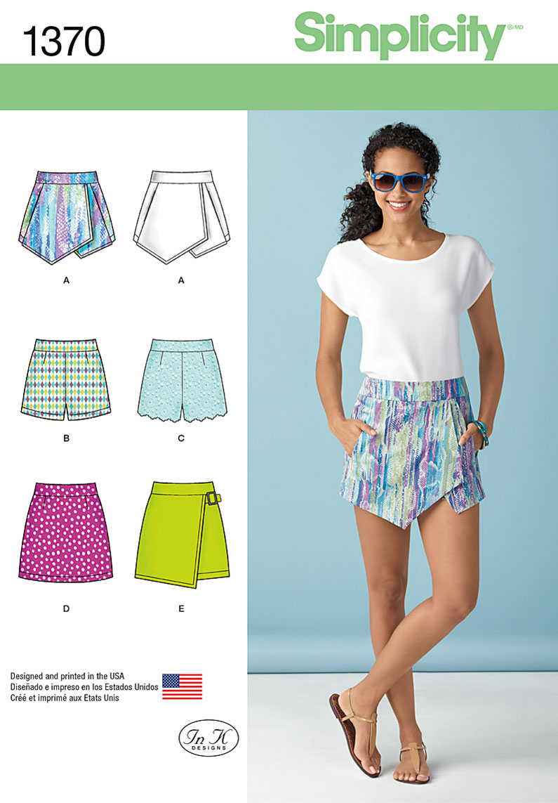

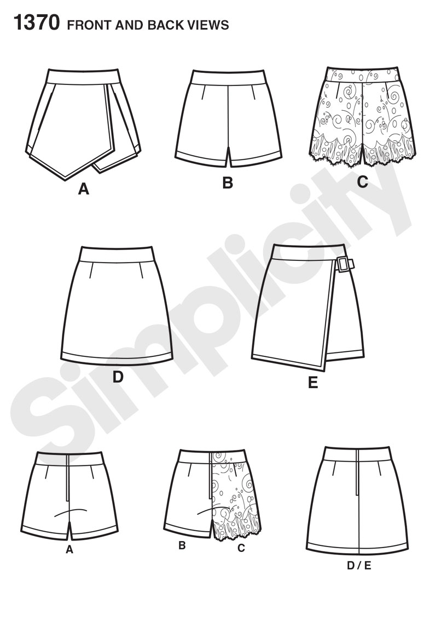

See next page

Question Eight continued
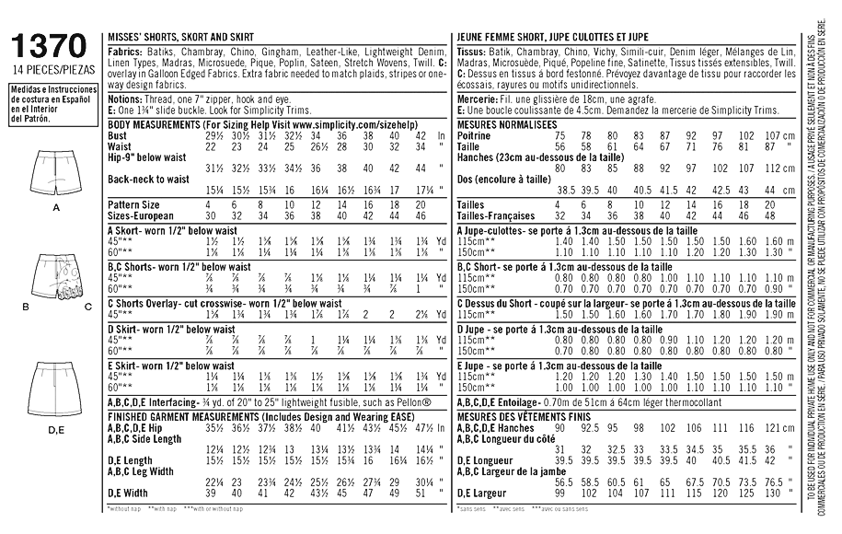

This question refers to Skort pattern View A from Simplicity pattern 1370 shown on the previous page and in the data table above.
The skorts will be made from a medium weight cotton- sateen and lycra fabric.

a) Using textiles specific terminology, describe the style of this Skort. ( 2 marks)
4 points described for 2 marks
assymetrical design
semi-fitted hipster style skorts
wrap style front front section to give the appearance of a skirt from the front and shorts from the back view.
Front wrap has triangular feature at centre front for aesthetic purpose.
The skirt also has a fitted waistband or yoke.
waist darts on shorts and an
18cm side zip.
In seam lined pockets.

b) The skorts View A requires a zip closure. Suggest the most appropriate place to insert it and justify your answer. ( 1 mark)
From the picture on the back of the pattern envelope, it appears tht the Centre backof the skort would be the most suitable as the waistband is showing on opening at Centre back.

See next page
Question Eight continued

c) Is there another appropriate place to insert the zip in the Skort View A? Justify your answer. ( 1 mark)

Ideally no - the centre back is the best

the left hand side front where the pocket seam joins the back pieces in the pocket seam, however this would move the opening with zipper and button closure to the left front in a wrap style.
As there is bulk on this seam caused by the pocket and lining it is not as easy to insert the zipper here.

d) Suggest a type of hem finish that would be appropriate for the leg hems and justify your answer. (1 mark)

as the fabric appears to be lightweight - a machine hem finish – this hem finish could then follow through to the right side of the garment as a feature, could also be topstitched.
Other options would be – a machine blind hem, hand sewn blind hem, Twin needle hem

View A and describe where it would be used.

- Supporting Fabric Name: (1 mark)
Vilene – fusible light to medium weight interfacing

- Describe where the supporting fabric would be used: ( 1 mark)
Waistband . Yoke pieces

- Describe the function of the supporting fabric when used in this location.
(1 mark)
in the waistband to give body / support to the fabric being used for the
waistband so it does not crease too much

f) Suggest a process by which you could reduce the bulk of the waistband seam where the band (Yoke) meets the overlay and the skort. (1 marks)
trimming, clipping and grading – explained
grade the turning allowance and then ‘V’ nick the allowance

g) A ‘napped’ fabric could be used for the skorts in View A.

i. Give a definition of “with nap” ( 1 mark)
a fabric with a one way design eg. stripes, checks or a one way pattern or and fabric with high lustre eg satin or surface pile eg velvet, velveteen, corduroy
fabrics that have a sheen, one way print and plaid fabric

ii. Give one (1) disadvantage or difficulty involved with using napped fabrics.
(1 mark)
This will require extra fabric to lay pattern pieces out facing one direction
Or extra fabric to match stripes, checks or the patterns on the fabric.

iii. How will nap affect the pattern layout or construction of Skort View A?
(1 mark)
you must lay all pattern pieces in the one (same) direction ie is the top of all patterns facing one end - (grain lines parallel to selvedge edge) when cutting out

See next page

Question Eight continued

h) Calculating material requirements:

- Calculate the amount of fabric required to make the Skort View A in a size 10 using 115cms width cotton / lycra sateen blend fabric (1 mark) __1.50m________________________________________________

- How much interfacing is needed for the Skort View A in a size 10? (1 mark) ___70cm_____________

- What other notions will be needed to make the Skort View A in a size 10?
(1 mark)
___thread. 18cm zip, hook and eye ___________________________

Question Nine (8 marks)

Outline how an embellishment or decorative technique could be incorporated into a contemporary textile item. Include a simple sketch to support your answer.
Correct name of technique – 1 mark
Description of technique – aesthetic appearance improved - 1 mark
Description and sketch of garment / item with embellishment – 2 marks
Annotation describing embellishment – 2 marks
Suitability of embellishment technique to garment / item chosen – 2 marks

Question Ten (10 marks)

- Identify TWO (2) fabric structures. (2 marks)

Structure 1: Woven
Structure 2: Knitted

- Describe using text and diagrams how these TWO (2) structures are different.
(8 marks)

Structure 1: to create woven fabric, two or more sets of yarns are interlaced at right angles. The warp runs (which are strongest) the length of the fabric and the weft yarns run across the width of the fabric. The design of a fabric depends on the order in which the warp and weft yarns are interlaced
Structure 2: most popular method of fabric construction. Knitted fabrics are made up of interlocking loops of yarns. A course is a horizontal row of loops and a wale is a vertical row of loops. All knit fabrics stretch due to their loop formation

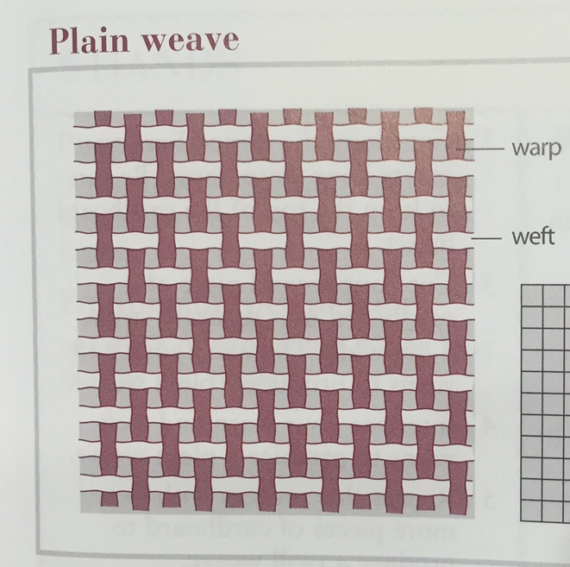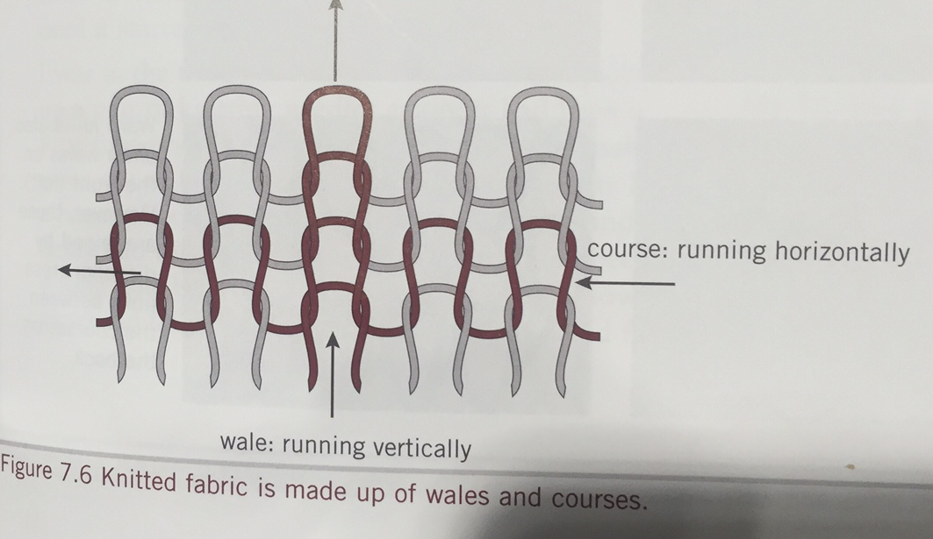

Question Eleven (10 marks)

Natural Fibres are used for a wide range of clothing products.

- Identify two (2) protein fibres. (2 marks)
Wool and silk

- Describe how regenerated fibres differ from protein fibres? (2 marks)

Regenerated fibres are made from wood pulp which is cellulosic in nature – however the cellulose is chemically modified to create the fibre. Wool and silk are natural fibres - wool from sheep - silk from silk worm

- Indentify two (2) characteristics you would expect from a crystalline cellulosic fibre and justify your choice using the microscopic structure and/or the classification of the fibre? (4 marks)
High strength and high durability, low absorbency, no easily dyed, less elasticity, poor abrasion resistance
Crystalline structure occurs when the polymers are packed closely together and in a parallel arrangement allowing many binding forces and resulting in a stronger fibre

- List two (2) amorphous fibres. (2 marks)

Fibre 1: wool
Fibre 2: rayon

Question Twelve ( 12 marks)
The Tanzanian company BioSustain was established with the aim to revive
cotton production using organic farming methods and to provide markets for organic cotton products - with an emphasis on quality.
The Singida region of Tanzania has ideal conditons for cotton production. It is also one of the poorest regions of Tanzania and one third of the region is a game reserve. Sustainable land use is necessary to conserve the area whilst strengthening the economy. BioSustain was established in 2012 with the aim to revive cotton production using organic farming and to provide markets for quality organic cotton products.
Bio Sustain provides farmers with other resources on credit, provide training and technical assistance to farmers as well as support on Fair Trade. Farmers are paid an organic premium for their cotton by BioSustain. To date, more than 3800 small holder producers have entered into contract with BioSustain and this number is expected to significantly increase in the future as BioSustain has acquired a cotton ginnery and oil mill in Singida Town.
Prior to the establishment of this company, cotton manufacture was a cottage industry in Tanzania.

Describe the environmental impacts you would expect to occur as a result of this development.
Environmental Impacts: 6 ideas explained = 6 marks
There are high environmental and social impacts associated with cotton famring, including:
Soil erosion and degradation - organic cotton farming should rescue / improve soil health and farm land
Cropping is more efficient using organic farming techniques – more cotton produced with less environmental impact
Water loss – improved management of water resources
Water and land pollution minimized and reduced
Non renewable resource depletion is minimized or more carefully managed
Air pollution and greenhouse gas emissions reduced
Biodiversity loss reduced, especially insects that are natural predators of cotton pests
Environmental impacts by exposure to hazardous pesticides and herbicides is reduced and or better managed
Social Impacts: 6 ideas explained = 6 marks
Income vulnerability - improved level of income reliability for cotton farmers and communities dependent on cotton farming
Empowering farmers and Improving quality of life for farming reliant families
Debate on Food/ Fuel/ Fibre - managing the increasing demand for food, fuel as well as fibre
Land available for food production is considered for communities
Child, bonded and forced labour is reduced
Fair trade principles considered ie. a fair wage for a fair days work, fair payments for cotton fibres.
Ethical treatment of cotoon growing farmers and communities
human health impacts by exposure to hazardous pesticides and herbicides minimized – keeping people safer

