

Methodist Ladies’ College

Examination

Semester One, 2017

Question/Answer Booklet

MATERIALS

DESIGN AND TECHNOLOGY

Units 1 and 2

Sections One, Two, and Three
Student Name:
 | Marks available | Your marks
Section One: Short Answer - General | 15
Section Two: Extended Answer – General | 20
Section Two: Extended Answer – Context | 65
 | 100 | / 100

Time allowed for this paper

Reading time before commencing work: ten minutes
Working time for paper: two hours

Materials required/ recommended for this paper

To be provided by the supervisor:

This Question/ Answer Booklet

To be provided by the candidate:
Standard items: pens (blue/black preferred), pencils (including coloured), sharpener,
correction fluid/tape, eraser, ruler, highlighters

Special items: non-programmable calculators approved for use in the WACE examinations

Important note to candidates
No other items may be taken into the examination room. It is your responsibility to ensure that you do not have any unauthorised notes or other items of a non-personal nature in the examination room. If you have any unauthorised material with you, hand it to the supervisor before reading any further.

Structure of this examination

This Unit 1 & 2 examination is worth 5% of your final course mark for
Materials Design & Technology

Structure of this paper

Section | Number of questions available | Number of questions to be answered |  | Suggested working time (minutes) | Marks available | Percentage of total exam
Section One:  Short answer | 3 | 3 |  | 15 | 15 | 15
Section Two:  Extended answer | 2 | 2 |  | 20 | 20 | 20
Section Three:  Textiles specific context | 7 | 7 |  | 85 | 65 | 65
 |  |  | Total |  | 100 | 100

Instructions to candidates

- Answer the questions according to the following instructions

Sections One, Two, and Three: Answer all questions. Write your answers in this Question/Answer booklet.

- You must be careful to confine your responses to the specific questions asked and to follow any instructions that are specific to a particular question.

- Spare pages are included at the end of this booklet. They can be used for planning your responses and/or as additional space if required to continue an answer.
  - Planning: If you use the spare pages for planning, indicate this clearly at the top of the page.
  - Continuing an answer: If you need to use the space to continue an answer, indicate in the original answer space where the answer is continued, i.e. give the page number. Fill in the number of questions that you are continuing to answer at the top of the page.

Section One: Short Answer (15 marks)

This section has THREE (3) questions. Answer all questions. Write your answers in the spaces provided.

Spare pages are included at the end of this booklet. They can used for planning your responses and/or as additional space if required to continue and answer.
  - Planning: If you use the spare pages for planning, indicate this clearly at the top of the page.
  - Continuing an answer: If you need to use the space to continue an answer, indicate in the original answer space where the answer is continued, i.e. give the page number. Fill in the number of questions that you are continuing to answer at the top of the page.

Suggested working time: 15 minutes

Question One (5 marks)

Select ONE (1) of the items below, by drawing a circle around it, and then answer the following questions relating to that item.

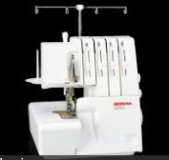

- Name the item you have selected and describe what is it used for? (1 mark)

- To neaten and cut seam allowances.
- To cut and roll hems for Rolled hems

- Explain TWO (2) safety precautions that should be taken when using the selected item.
(2 marks)
- keep the front hatch closed while sewing to prevent threads getting caught in work
- keep fingers away from blades (there is a finger guard on the front of the over-locker to facilate this.
- turn power off while threading the machine
- do not not turn power on until the 3 point plug has been insterted ito the power point

- Explain how this item has replaced a previous method of completing the same process (2 marks)
The previous method for neatening was done on the sewing machine. Prior to stitching, the seam allowances were cut to the correct width. The machine was then set up for zig zag stitch. The stitch width was set on 4 and the length on 2 and the stitch had to be positioned so it enclosed the edges of the fabric. ( Zig zag scissors, pinking shears, turned seam allowances were straight stitched)

Question Two (4 marks)

Art deco is the predominant architectural style of the period 1920s and 1930s.

Study the Art deco mood board on the previous page and describe FOUR (4) features of Art Deco style
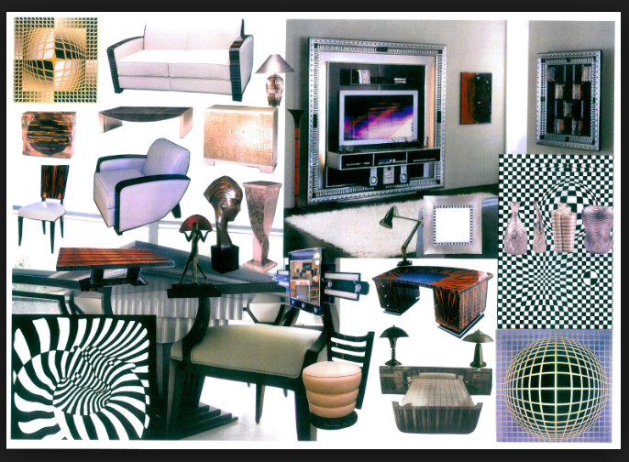
Features and descriptions:
- Feature 1: colour
colours: predominant use of neutrals- black and white. Dark polished timber is repeated in the desk, table top, chair back. Ebony (black) is used for the arms of the setee and chair as well as the chair back. Pastels are used as a contrast. Gold is evident in the top left pattern and in the statue of the head.
- Feature 2: pattern
diagonal pattern and checker board pattern predominate. Black and white predominate in the pattern; geometric patterns;
- Feature 3: materials: ebony, polished wood and luxury materials like leather and suede are evident
- Feature 4: shape:
The use of geometric shapes in the top right hand picture and also in the TV cabinet. Rectangular shapes are constrasted with curves. Rectangular furniture, circular furniture, symmetrical shapes
- Feature 5: Simplicity: simple but strong lines are used with constrasts. diagonal and straight lines and contrasted with the use of curves

Question Three (6 marks)

Products are designed with a specific target user in mind.

Describe a target market for each of the watches shown below and on the next page. Give THREE (3) reasons for your answer for each watch.

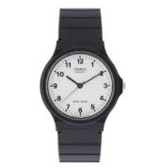

Watch A

Target user:
The target market is happy to purchase a mass marketed product with a low price point and low fashion content that performs basic functions,

Reason 1:
Low fashion Content: A target market that prefers this watch is one that desires a traditional looking watch and nothing that is overly fashionable. This watch is a basic style that will not date easily.It has been around for at least 30 years.
Reason 2:
function : this watch appeals to the consumer who only wants to watch as a traditional time device. This watch will tell the time in hours, minutes and seconds. It wil not give the date, such a market will prefer function and proce point over fashion content.

Reason 3:
Low price point low
The target market that prefers this watch is after a product that has a low price point. In order to achieve this such a watch will have traditional styling and wil be mass produced.

See the next page

Watch B



Target user:

High income, likes high tech, stylish and up to the minute goods, Likes to be seen with the lastest up to the minute items.

Reason 1:
High income- Apple I watches start at around $700. The target market will need to have a higher income.

Reason 2:
Like high tech: Members of this market want a product that performs a multitude of functions. time telling is the most basic of all. This watch will link with your phone and emails. It will count your footsteps, link with facebook and other social media and act as a mini comuter. It is for the peson who likes technological gadgets

Reason 3:
style: the apple I watch was developed with style in mind. The target group demand items that not only look stylish but give the message of being up to the minute, upwardly mobile- a trend setter.

End of Section One
Section Two: Extended Answer (20 marks)

Suggested working time: 20 minutes

Question Four (10 marks)

Select a contemporary designer who you have studied.
Answer the questions a) and b) in relation to the contemporary designer chosen below.

Contemporary designer studied: _________________________________________

- Identify a source of inspiration you have taken from this designer and using text
and graphics with annotations explain how you intend to use this source of
inspiration in your garment design and manufacture throughout this year.
(3 marks)

Graphics with annotations:

Source of inspiration | 1 mark
graphics | 1 mark
annotations | 1 mark

- Analyse the influence this designer has on current design trends in society.
(2 marks)
The student must examine the influence of the designer has on a current design trend methodically and in detail, in order to explain and interpret it.
For example: Christian Dior created The New Look. This is evident in currect fashions in the form of the skater skirt worn with a fitted top outfit. The effect of this trend is to create an hourglass silhouette just as Dior created the same look with his New-look designs which used a small corset to draw the waist in and a wide skirt to emphasise and extend the hips.

- Designers use inspirations from a variety of sources when generating ideas for their collections and in designing individual garments within a collection or range.
Describe other inspiration sources that you have used and explain how you have used these sources in designing an item of clothing this year. (5 marks)

Inspiration can come from a wide range of sources: these include pictures of fashions In magazines, history books which look at eras of fashion, pieces of art, song lyrics, films (clothing worn by actors) nature (sea creatures, leaves, patterns, wave movements), fashion forecasts, costumes for stage play, fantasy, science fiction, the future,

Garment description and with explanations as to how they used at least 3 sources in the design of an item of clothing | 5 marks
Garment description and with explanations as to how they used at least 2 sources in the design of an item of clothing | 3/4 marks
Garment description and with explanations as to how they used at least 1 sources in the design of an item of clothing | 1/2marks

Question Five (10 marks)
The elements and principles of design are used by designers to achieve good design and best practise in their various design contexts: textiles, wood and metal.

- Use text and diagrams to explain TWO (2) Elements of Design (4 marks)

Any two of the following can be described using text and diagrams
- colour
- line
- texture
- shape and form

2 Design elements described in text and diagrams | 4 marks
1 design element described in text and diagrams | 2 marks
2 design elements described in text | 2 marks
2 design elements described in diagrams | 2 marks
1 design element described in text | 1 mark
1 design element described in diagrams | 1 mark
Other combinations marks as allocated

- Use text and diagrams to explain THREE (3) Principles of Design (6 marks)

Principle of Design 1: _______________________________________

Any three of the following can be described using text and diagrams
- balance
- contrast
- focal point
- dominance
- proportion
- rhythm/ repetition

3 Design principles described in text and diagrams | 6 marks
2 Design principles described in text and diagrams | 4 marks
1 design principle described in text and diagrams | 1 marks
3 Design principles described in text | 3 marks
2 design principles described in text | 2 marks
1 design principle described in text | 1 mark
3 Design principles described in diagrams | 3 marks
2 design principles described in diagrams | 2 marks
1 design principle described in diagrams | 1 mark
Other combinations marks as allocated

End of Section Two

Section Three: Textiles Specific Context (65 marks)

Suggested working time: 85 minutes

Question Six (15 marks)

- Anthropometric data is used when making and using patterns to construct garments. Name the three key body measurements used to determine pattern size. Outline the process used to take each measurement. (3 marks)

- Name of body measurement Bust (1 mark)
How to take measurement: Measurements should be taken over your customary undergarments. Pull the measuring tape snug, but not too tight, always around the fullest part of each body area and keep the tape parallel to the floor.
Bust—take this measurement over the fullest part of the bust and across the widest part of the back.

- Name of body measurement Waist (1 mark)
How to take measurement: Measurements should be taken over your customary undergarments. Pull the measuring tape snug, but not too tight, always around the fullest part of each body area and keep the tape parallel to the floor.
Waist—To locate your waistline, tie a narrow string around the waist and let it settle into the natural waistline as you bend. Take the measurement along the stringline.

- Name of body measurement Hip (1 mark)
How to take measurement: Measurements should be taken over your customary undergarments. Pull the measuring tape snug, but not too tight, always around the fullest part of each body area and keep the tape parallel to the floor.
Hips—Take the measurement around the fullest part, which is usually 18cms to 23 cms below the waist.

- When working with commercial patterns, what are “notches” used for? (1 mark)

Notches are used as matchng points to ensure the correct fabric pieces are aligned with each other in the correct positions.

Question 7 continued
- In the space provided draw the symbol used on commercial patterns to indicate that the pattern piece must be placed on the fold of the fabric. (1 mark)

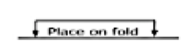

- Use text and / or diagrams to explain the process used to pin a pattern piece onto a piece of fabric so that it is “on the grain line” and ready to cut out. (1 mark)

- First fold the fabric in the apporriate manner following the layout chart.
- Take the pattern piece so the printed side s uppermost and place it on the fabric so the grain line is parallel to the selvedge and on the fabric (and not encroaching on the selvedge).
- Measure the distance from one end of the arrow to the selvedge, make a mental note of the measurement) and place a pin on the grainline to secure the pattern piece.
- Repeat the same procedure on the other end of the grainline. Pin in between on the grainline, in the same manner.
- Now the grainline is in position, pin diagonally into each corner and parallel to the edges leaving a handspan of 4 fingers in between each pin.

Diagrams:

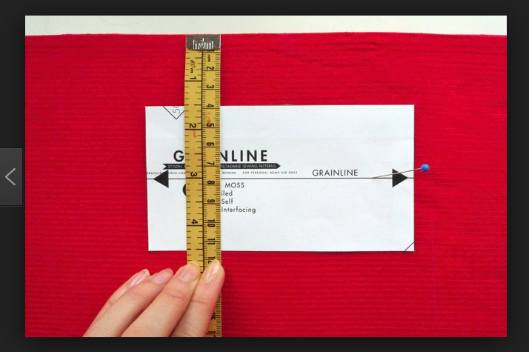

- Explain using text and diagrams the meaning of the term ‘bias grain”. (2 marks)

The bias runs at an angle to the straight and crossgrains, with the true bias running at an exact 45-degree angle

DIAGRAM

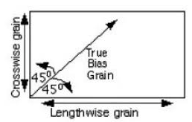

- When using a commercial pattern to determine materials required to manufacture a garment, notions are listed. What are ‘notions”? (1 mark)

Notions can include items that are sewn or otherwise attached to a finished article, such as buttons, snaps, and collar stays, but the term also includes thread.

g) When using a commercial pattern, what THREE (3) items of information are required to determine the amount of fabric you will need to purchase to make a garment? (3 marks)

- The view of the garment - you are intending to make identified on the pattern
- The width of the fabric – 115cms wide or 150cms wide
- Your size based on your body measurements

- List THREE (3) items of information that you will find on the front of a pattern envelope
(3 marks)
- The name of the pattern company
- The number of the pattern
- A diagram or picture of the finished item
- The views of the pattern you can make

Question Seven (10 marks)

- Describe THREE (3) factors that need to be considered when selecting materials to complete an embellishment technique on a garment. (3 marks)

- fibre content of the embellishment (fabrics, threads, in so much as whether it can be laundered and handled in the same manner as the garment. Silk embroidery threads on cotton fabric may be a problem when laundering and drycleaning may be required
- the weight of the materials- for example when appliquing one fabric onto another the weights of both fabrics must be considered in relation to each other.
- the cost-whether the cost of the embellishment will be within the budgetary expectaions. Silk embroidery threads and photographic transfer mediums can be expensive.
- the availability- threads for embroidery may not be readily available,

- Describe TWO (2) changes that may be needed in the care of the garment after an embellishment or decorative technique has been applied to the garment. (2 marks)

- The wash powder type may need to be altered. A cotton garment embroidered with silk embroidery thread would not be able to be laundered using the same laundry powder as prefiously used as the detergernt for cotton would break down the silk.
- the temperature of the wash water would need to be altered to suit the weaker fibre.
- the wash action may need to be altered- again the suit the weaker component.
- May no longer be washable – but may need dry cleaning or spot cleaning only

- Describe in detail using text and diagrams the steps,equipment and materials required to apply one (1) decorative technique to a garment. (5 marks)

Name of technique: any technique learned in class- for example applique, photo transfer, hand embroidery, beading

equipment | 1 mark
materails | 1 mark
Method with diagrams | 3 marks
______________________________________________________________________________________________________________________________________________________
___________________________________________________________________________

See the next page

Question Nine (14 marks)

The following questions refer to the information for Vogue pattern 9137 given below

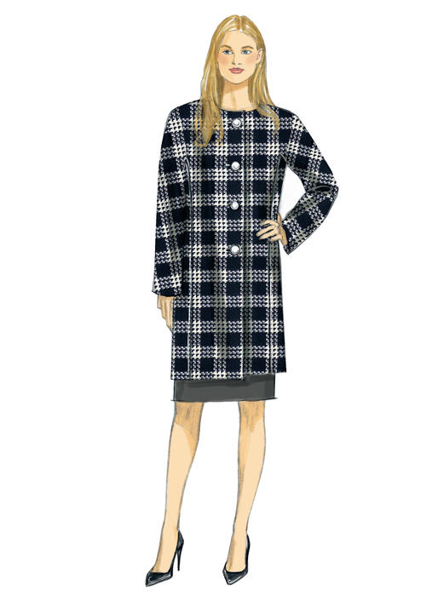
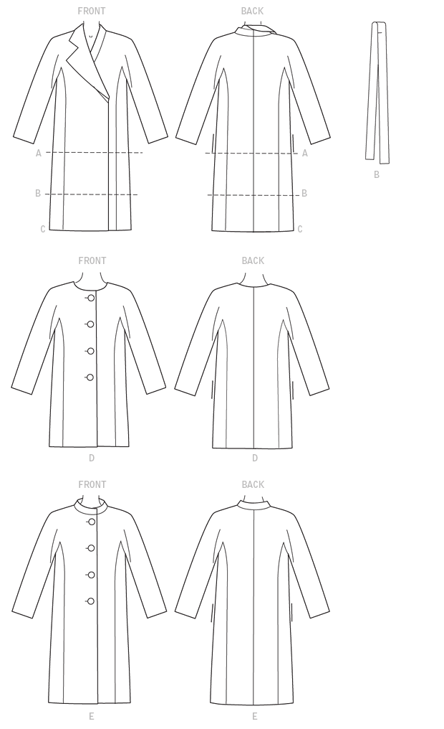

FABRICS: Lightweight Woolens, Wool blend, Tartan, Melton, Fleece, Acrylics, Corduroy,
Unsuitable for obvious diagonals. Check fabrics may require extra fabric to match
Checks.

NOTIONS: Optional: 1.5ms Shoulder Pads. A, B, C: Two Large Snaps. D, E: Four 3cms Buttons.

See the next page

Question 9 continued

Fabric widths given in centimeters.
 | X-Small |  | Small |  | Medium |  | Large |  | X-Large | XX-Large
 | (4-6) |  | (8-10) |  | (12-14) |  | (16-18) |  | (20-22) | (24-26)
A
115 cm*/** |  | 3.4 |  | 3.7 |  | 3.8 |  | 4.0 | 4.2 | 4.5 |  | m
150 cm*/** |  | 2.6 |  | 2.7 |  | 2.9 |  | 3.2 | 3.3 | 3.3 |  | m
LINING A
115 cm |  | 2.2 |  | 2.3 |  | 2.4 |  | 2.5 | 2.6 | 2.9 |  | m
FUSIBLE INTERFACING A
46 cm, 51 cm |  | 1.7 |  | 1.7 |  | 1.8 |  | 1.9 | 1.9 | 2.1 |  | m
B
115 cm*/** |  | 4.1 |  | 4.2 |  | 4.3 |  | 4.9 | 5.1 | 5.4 |  | m
150 cm*/** |  | 3.4 |  | 3.5 |  | 3.7 |  | 3.9 | 4.1 | 4.3 |  | m
FUSIBLE INTERFACING B
46 cm, 51 cm |  | 1.9 |  | 1.9 |  | 2.1 |  | 2.1 | 2.1 | 2.2 |  | m
C
115 cm*/** |  | 4.5 |  | 4.6 |  | 4.7 |  | 5.0 | 5.1 | 5.3 |  | m
150 cm*/** |  | 3.3 |  | 3.4 |  | 3.7 |  | 4.2 | 4.3 | 4.6 |  | m
FUSIBLE INTERFACING C
46 cm, 51 cm |  | 2.2 |  | 2.2 |  | 2.2 |  | 2.3 | 2.3 | 2.4 |  | m
D
115 cm*/** |  | 3.1 |  | 3.3 |  | 3.4 |  | 3.5 | 4.0 | 4.2 |  | m
150 cm*/** |  | 2.4 |  | 2.4 |  | 2.5 |  | 2.7 | 3.0 | 3.1 |  | m
FUSIBLE INTERFACING D
46 cm, 51 cm |  | 1.1 |  | 1.1 |  | 1.1 |  | 1.3 | 1.3 | 1.4 |  | m
E
115 cm*/** |  | 3.8 |  | 3.8 |  | 3.9 |  | 4.0 | 4.5 | 4.6 |  | m
150 cm*/** |  | 2.9 |  | 2.9 |  | 3.0 |  | 3.1 | 3.4 | 3.4 |  | m
FUSIBLE INTERFACING E
46 cm, 51 cm |  | 1.3 |  | 1.3 |  | 1.3 |  | 1.4 | 1.4 | 1.5 |  | m
LINING B, D
115 cm |  | 2.6 |  | 2.7 |  | 2.9 |  | 2.9 | 3.3 | 3.4 |  | m
LINING C, E
115 cm |  | 3.0 |  | 3.1 |  | 3.2 |  | 3.3 | 3.4 | 3.9 |  | m
FINISHED GARMENT MEASUREMENTS
Measurement at bustline
A B C D E |  | 103 |  | 108 |  | 117 |  | 127 | 137 | 147 |  | cm
Measurement at hipline
A B C D E |  | 103 |  | 108 |  | 117 |  | 127 | 137 | 147 |  | cm
Width, lower edge
A B C D E |  | 103 |  | 108 |  | 117 |  | 127 | 137 | 147 |  | cm
Back length from base of neck
A |  | 67 |  | 69 |  | 70 |  | 71 | 72 | 74 |  | cm
B D |  | 88 |  | 89 |  | 90 |  | 91 | 93 | 94 |  | cm
C E |  | 103 |  | 104 |  | 105 |  | 107 | 108 | 109 |  | cm

- How much fabric would you need to purchase to make the coat View D in a size 10.
(2 marks)
Fabric 150 cm width: 2.40 metres

Lining 115cms width: 2.70 metres

See the next page
Question 9 continued

b) A wool blend is one of the listed suitable fabrics. Describe the type of wool blend that you think is desirable for the coat and give TWO (2) reasons why this fabric is a good choice for this coat. (3 marks)

Type of blend: WOOL / NYLON BLEND
Other possible blends: ( Wool / Polyester blend) (Wool Lycra blend)

Reasons:
- Wool is naturally anti microbial – so it will not retain perspiration odours
- Wool Nylon blend adds a more easy care factor – more crease resistant / resilient - does not need pressing
- Nylon blend would make the fabric cheaper to purchase
- Nylon makes a lighter weight warm woollen fabric for the jacket
- Wool less likely to be attacked by moths when blended with Nylon
- Nylon adds moisture wicking capacity to wool, also adds a little elasticity, durability and and makes the wool more shrink resistant
c) The coat is lined. Suggest ONE (1) suitable fabric for the lining and give ONE (1) reason why this fabric is a good choice. ( 2 marks)

Lining Fabric: Taffeta Lining ( Nylon, Polyester or acetate) Bemsilk Lining ( Polyester )

Reason:
Light weight, soft handle, has lustre and good drape, slippery satin finish is comfortable against the body

d) Interfacing is desirable in the construction of this coat.

Where is interfacing used and why is it required? ( 1 mark)
Interfacing is used on the front opening and back neck facings – for maintain good shape, give support and body – to support buttonholes, buttons other closure
e) What type of interfacing would be used and explain why? ( 1 mark)

Medium weight – fusible Vilene or Pellon
- medium weight as a heavier weight fabric in the coat construction needs support – match weight to the fabric being used.
- fusible is easier to use and stays in place, would not wash off because jacket will not be laundered.
f) Describe the application process for this interfacing. ( 1 mark)

Fusible interfacing – so it is ironed onto the wrong side of the coat front and back facings using a hot iron until it is fused in place.

See the next page

Question 9 continued

g) Suggest and justify your choice of seams and seam finishes for the coat and the lining. Explain why this is the best choice of seam.

Coat Seams and Finishes: ( 2 marks)

Open seams on all seams except those joining the facings, collar, sleeves. – open seams will not fray – coat will not be laundered and will be drycleaned.
Finish to seams - Left raw – not overlocked – do not want to add bulk by overlocking
Lining Seams and Finishes: ( 2 marks)
Open seams on all seams except those joining the facings, collar, sleeves. – open seams will not fray – coat will not be laundered and will be drycleaned.
Finish to seams - Left raw – not overlocked – do not want to add bulk by overlocking If the fabric used frays badly – open seams could be overlock neatened as open seams.
h) A ‘napped’ fabric could be used for the coat.

i. Give a definition of “with nap” ( 1 mark)
Primarily, nap is the raised (fuzzy) surface on certain kinds of cloth, such as velvet or corduroy. These fabric can change colour when turned upside down.
Nap can refer additionally to other surfaces that look like the surface of a napped cloth. Additionally one way design fabrics like striped fabrics, one way patterns ( rabbits, teddy bears or floral fabrics), unbalanced checks like tartan are referred to as napped fabrics.

ii. How will nap affect the pattern layout or construction of the coat? (1 mark)

All pattern pieces must be laid on the fabric facing one direction.
Patterns on fabrics may require pattern matching eg. matching tartans, checks or floral patterns – this means more fabric metrage is required to pattern match.

- The print and pile must all be cut going one way. The fabric cannot be folded in half horizontally – this makes the process more lengthy and tedious as constant checking must be done to ensure the pattern pieces are all going in the right direction. (top to tail)
- more fabric is needed as the pattern pieces cannot be cut in the most economical manner thereby increasing the cost

See the next page

Question Ten (8 marks)

Knitted fabric is used for a wide range of clothing products.
- Identify the 2 structures of knitted fabrics. (2 marks

- weft knit
- warp knit
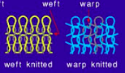
- Describe using text and diagrams how the 2 knit structures are different.
Any two of the following responses for (2 marks)
weft | warp
horizontal courses on back of fabric. front presents as vertical rows of wales. | No uniform presentation- Back and front can present as wales.
One thread travels across the fabric in rows formsing loops that inlock with each other to form a cloth. | many threads travel diagonally and vertically up the fabic interlocking with each other in an intricate pathway.
Can be achieved by hand knitting methods | Cannot be achieved by hand knitting methods
Will run if snagged | Will not run if snagged

- Identify TWO (2) different woven fabric structures. (2 marks)

  - _____________________________
  - _____________________________

Identify any two of the following - plain weave, twill weave, satin weave, jacquard weave, pile weave

- Describe using diagrams and text, how these TWO (2) woven fabric structures are different.
( 2 marks)
Describes difference between any 2 of the weaves using diagrams and text ( 1 mark each)

Question ten (18 marks)

1a) Complete the Fibre Classification chart below. (7 marks)

Fibres
Natural |  |  | Manufactured
Cellulose | Protein | Mineral | Synthetic | Regenerated
Cotton | Wool | Asbestos | Nylon | Cellulose Based | Protein Based
Linen | Silk |  | Polyester | Acetate | Casein
Hemp | Mohair |  | Acrylic | Viscose Rayon
Bamboo | Leather |  | Elastomeric | Lyocell

- Select a fabric that you have studied during your course and write its name below.
(1 mark)
Example: calico

- State the fibre content of this fabric. (1 mark)

Example-cotton

- Describe the structure of your chosen fabric (1 mark)

Example-plain weave

- State one use for this fabric. (1 mark)

Example-quilts, toiles, cushions

- Explain why this fabric is a suitable choice for this use. (1 mark)

Example-Explanation: it is the most basic of woven cotton cloths and of a medium weight. It is suitable for quilt linings and other goods that do not demand the use of a higher quality fabric.

Question 11 continued

g) Identify ONE (1) fibre that you have studied.

Fibre: _________________________________________________

Discuss in detail the environmental impact of this fibre during all stages of production.

- Fibre Growth / Production Stage: (2 marks)

- Manufacturing Stage: (2 marks)

- Garment Use, Care and Disposal Stage: (2 marks)

Example: cotton
production
this consists of the growth and manufacture of the cloth
growth- discuss water requirement, land availability, pesticides , herbicides, fertilisers, fossil fuels- petroleum etc
Land. Water and air pollution impacts on the environment.
manufacture: noise pollution, dust pollution, use of fossil fuels- coal, oli, petroleum, electricity - high energy use, high water use
Land, Water and air pollution impacts on the environment.
disposal:cotton is biodegradable but the finishes that are applied and the dyes may not be. Although the cotton will form landfill in the short time it will break down. The chemical finishes will however have a much more long lasting and often detrimental affect on the environment.
Land. water and air pollution impacts on the environment.

End of Section Three

