

Methodist Ladies’ College

Examination

Semester One, 2017

Question/Answer Booklet

MATERIALS

DESIGN AND TECHNOLOGY

Units 1 and 2

Sections One, Two, and Three
Student Name:
 | Marks available | Your marks
Section One: Short Answer - General | 15
Section Two: Extended Answer – General | 20
Section Two: Extended Answer – Context | 65
 | 100 | / 100

Time allowed for this paper

Reading time before commencing work: ten minutes
Working time for paper: two hours

Materials required/ recommended for this paper

To be provided by the supervisor:

This Question/ Answer Booklet

To be provided by the candidate:
Standard items: pens (blue/black preferred), pencils (including coloured), sharpener,
correction fluid/tape, eraser, ruler, highlighters

Special items: non-programmable calculators approved for use in the WACE examinations

Important note to candidates
No other items may be taken into the examination room. It is your responsibility to ensure that you do not have any unauthorised notes or other items of a non-personal nature in the examination room. If you have any unauthorised material with you, hand it to the supervisor before reading any further.

Structure of this examination

This Unit 1 & 2 examination is worth 5% of your final course mark for
Materials Design & Technology

Structure of this paper

Section | Number of questions available | Number of questions to be answered |  | Suggested working time (minutes) | Marks available | Percentage of total exam
Section One:  Short answer | 3 | 3 |  | 15 | 15 | 15
Section Two:  Extended answer | 2 | 2 |  | 20 | 20 | 20
Section Three:  Textiles specific context | 7 | 7 |  | 85 | 65 | 65
 |  |  | Total |  | 100 | 100

Instructions to candidates

- Answer the questions according to the following instructions

Sections One, Two, and Three: Answer all questions. Write your answers in this Question/Answer booklet.

- You must be careful to confine your responses to the specific questions asked and to follow any instructions that are specific to a particular question.

- Spare pages are included at the end of this booklet. They can be used for planning your responses and/or as additional space if required to continue an answer.
  - Planning: If you use the spare pages for planning, indicate this clearly at the top of the page.
  - Continuing an answer: If you need to use the space to continue an answer, indicate in the original answer space where the answer is continued, i.e. give the page number. Fill in the number of questions that you are continuing to answer at the top of the page.

Section One: Short Answer (15 marks)

This section has THREE (3) questions. Answer all questions. Write your answers in the spaces provided.

Spare pages are included at the end of this booklet. They can used for planning your responses and/or as additional space if required to continue and answer.
  - Planning: If you use the spare pages for planning, indicate this clearly at the top of the page.
  - Continuing an answer: If you need to use the space to continue an answer, indicate in the original answer space where the answer is continued, i.e. give the page number. Fill in the number of questions that you are continuing to answer at the top of the page.

Suggested working time: 15 minutes

Question One (5 marks)

Select ONE (1) of the items below, by drawing a circle around it, and then answer the following questions relating to that item.

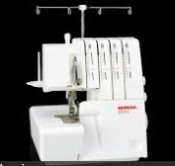
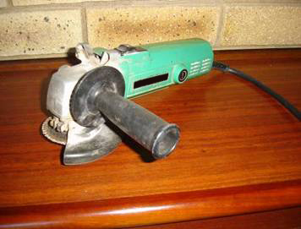

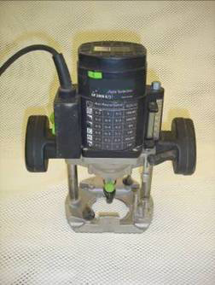

- Name the item you have selected and describe what is it used for? (1 mark)

_________________________________________________________________________________________________________________________________________________________________________________________________________________________________

- Explain TWO (2) safety precautions that should be taken when using the selected item.
(2 marks)

Safety precaution 1:

See the next page

Question 1 continued

Safety precaution 2:

- Explain how this item has replaced a previous method of completing the same process (2 marks)

Question Two (4 marks)

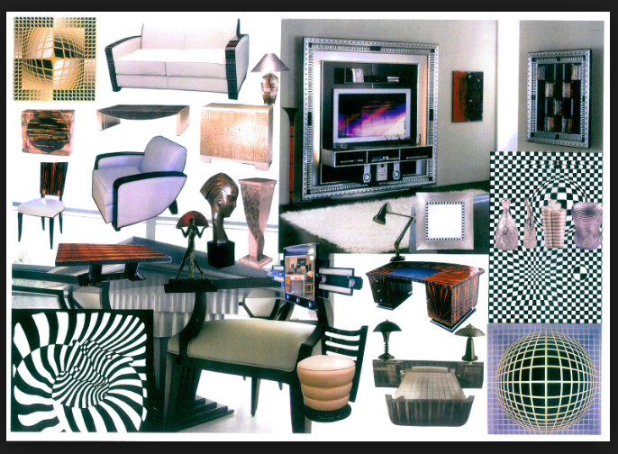
Art deco is the predominant architectural style of the period 1920s and 1930s.

See the next page

Question 2 continued

Study the Art deco mood board on the previous page and describe FOUR (4) features of Art Deco style

(4 marks)

Feature 1 Description:

Feature 2 Description:

Feature 3 Description:

Feature 4 Description:

See the next page

Question Three (6 marks)

Products are designed with a specific target user in mind.

Describe a target market for each of the watches shown below and on the next page. Give THREE (3) reasons for your answer for each watch.
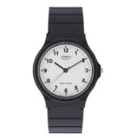

Watch A

Target user:

______________________________________________________________________________________________________________________________________________________

Reason 1:
______________________________________________________________________________________________________________________________________________________
______________________________________________________________________________________________________________________________________________________

Reason 2:
______________________________________________________________________________________________________________________________________________________
______________________________________________________________________________________________________________________________________________________

Reason 3:
______________________________________________________________________________________________________________________________________________________
______________________________________________________________________________________________________________________________________________________

See the next page
Question 3 continued


Watch B

Target user:

______________________________________________________________________________________________________________________________________________________

Reason 1:
______________________________________________________________________________________________________________________________________________________
______________________________________________________________________________________________________________________________________________________

Reason 2:
______________________________________________________________________________________________________________________________________________________
______________________________________________________________________________________________________________________________________________________

Reason 3:
____________________________________________________________________________________________________________________________________________________
____________________________________________________________________________________________________________________________________________________

End of Section One
Section Two: Extended Answer (20 marks)

This section has THREE (3) questions. Answer all questions. Write your answers in the spaces provided.

Spare pages are included at the end of this booklet. They can be used for planning your responses and/or as additional space if required to continue and answer.
  - Planning: If you use the spare pages for planning, indicate this clearly at the top of the page.
  - Continuing an answer: If you need to use the space to continue an answer, indicate in the original answer space where the answer is continued, i.e. give the page number. Fill in the number of questions that you are continuing to answer at the top of the page.

Suggested working time: 20 minutes

Question Four (10 marks)

Select a designer who you have studied.
Answer the questions a) and b) in relation to the designer chosen below.

Designer studied: _________________________________________

- Analyse and explain the influence this designer has on current design trends in society.
(2 marks)

___________________________________________________________________
___________________________________________________________________
___________________________________________________________________
___________________________________________________________________
___________________________________________________________________
___________________________________________________________________
___________________________________________________________________
___________________________________________________________________
___________________________________________________________________
___________________________________________________________________
___________________________________________________________________
___________________________________________________________________
___________________________________________________________________
___________________________________________________________________

see the next page
Question 4 continued

- Identify a source of inspiration you have taken from this designer and using text
and graphics with annotations explain how you intend to use this source of
inspiration in your garment design and manufacture throughout this year.
(3 marks)
_____________________________________________________________________
_____________________________________________________________________
_____________________________________________________________________
_____________________________________________________________________
_____________________________________________________________________
_____________________________________________________________________
_____________________________________________________________________
_____________________________________________________________________
_____________________________________________________________________
_____________________________________________________________________
Graphics with annotations:

see the next page

Question 4 continued

- Designers use inspirations from a variety of sources when generating ideas for their collections and in designing individual garments within a collection or range.
Describe other inspiration sources that you have used and explain how you have used these sources in designing an item of clothing this year. (5 marks)

_________________________________________________________________________________________________________________________________________________________________________________________________________________________________________________________________________________________________________________________________________________________
____________________________________________________________________________________________________________________________________________________________________________________________________________________________________________________________________________________
_____________________________________________________________________
_____________________________________________________________________
____________________________________________________________________________________________________________________________________________________________________________________________________________________________________________________________________________________
_____________________________________________________________________
_____________________________________________________________________
_____________________________________________________________________
____________________________________________________________________________________________________________________________________________________________________________________________________________________________________________________________________________________
_____________________________________________________________________
____________________________________________________________________________________________________________________________________________________________________________________________________________________________________________________________________________________

See the next page

Question Five (10 marks)
The elements and principles of design are used by designers to achieve good design and best practise in their various design contexts: textiles, wood and metal.

- Use text and diagrams to explain TWO (2) Elements of Design (4 marks)

Element of Design 1: _______________________________________

]

__________________________________________________________________________________________________________________________________________________________________________________________________________________________________________________________________________________________________________________________________________________________________________________________________________________________________________________________________

Element of Design 2: _______________________________________

__________________________________________________________________________________________________________________________________________________________________________________________________________________________________________________________________________________________________________________________________________________________________________________________________________________________________________________________________

See the next page
Question 5 continued

- Use text and diagrams to explain THREE (3) Principles of Design (6 marks)

Principle of Design 1: _______________________________________

__________________________________________________________________________________________________________________________________________________________________________________________________________________________________________________________________________________________________________________________________________________________________________________________________________________________________________________________________

Principle of Design 2: _______________________________________

_________________________________________________________________________________________________________________________________________________________________________________________________________________________________________________________________________________________________________________________________________________________________________________________________________________________________________________________________
See the next page
Question 5 continued

Principle of Design 3: _______________________________________

__________________________________________________________________________________________________________________________________________________________________________________________________________________________________________________________________________________________________________________________________________________________________________________________________________________________________________________________________
_________________________________________________________________________________________________________________________________________________________________________________________________________________________________

End of Section Two

Section Three: Textiles Specific Context (65 marks)

This section has Five (5) questions. Answer all questions. Write your answers in the spaces provided.

Spare pages are included at the end of this booklet. They can be used for planning your responses and/or as additional space if required to continue and answer.
  - Planning: If you use the spare pages for planning, indicate this clearly at the top of the page.
  - Continuing an answer: If you need to use the space to continue an answer, indicate in the original answer space where the answer is continued, i.e. give the page number. Fill in the number of questions that you are continuing to answer at the top of the page.

Suggested working time: 85 minutes

Question Seven (15 marks)

- Anthropometric data is used when making and using patterns to construct garments. Name the three key body measurements used to determine pattern size. Outline the process used to take each measurement. (3 marks)

- Name of body measurement ____________________________
How to take measurement: _______________________________________________________________________________________________________________________________________________________________________________________________________________

- Name of body measurement ____________________________
How to take measurement: _______________________________________________________________________________________________________________________________________________________________________________________________________________

- Name of body measurement _____________________________________________
How to take measurement: _______________________________________________________________________________________________________________________________________________________________________________________________________________

- When working with commercial patterns, what are “notches” used for? (1 mark)
_________________________________________________________________________________________________________________________________________________________________________________________________________________________________
See the next page

Question 7 continued
- In the space provided draw the symbol used on commercial patterns to indicate that the pattern piece must be placed on the fold of the fabric. (1 mark)

- Use text and / or diagrams to explain the process used to pin a pattern piece onto a piece of fabric so that it is “on the grain line” and ready to cut out. (1 mark)

________________________________________________________________________________________________________________________________________________________________________________________________________________________
________________________________________________________________________________________________________________________________________________________________________________________________________________________

See the next page
Question 7 continued

- Explain using text and diagrams the meaning of the term ‘true bias”. (2 marks)

________________________________________________________________________________________________________________________________________________________________________________________________________________________
Diagrams:

- When using a commercial pattern to determine materials required to manufacture a garment, notions are listed. Explain what ‘notions’ are and list some examples? (1 mark)
________________________________________________________________________________________________________________________________________________

g) When using a commercial pattern, what THREE (3) items of information are required to determine the amount of fabric you will need to purchase to make a garment? (3 marks)

- ___________________________________________________________________
- ___________________________________________________________________
- ___________________________________________________________________

- List THREE (3) items of information that you will find on the front of a pattern envelope
(3 marks)

- __________________________________________________________________
b. __________________________________________________________________
c. __________________________________________________________________

See the next page

Question Eight (10 marks)

- Describe THREE (3) factors that need to be considered when selecting materials to complete an embellishment technique on a garment. (3 marks)

- _____________________________________________________________________
__________________________________________________________________________________________________________________________________________
- __________________________________________________________________________________________________________________________________________
_____________________________________________________________________
- _______________________________________________________________________________________________________________________________________________________________________________________________________________

- Describe TWO (2) changes that may be needed in the care of the garment after an embellishment or decorative technique has been applied to the garment. (2 marks)

- _______________________________________________________________________________________________________________________________________________________________________________________________________________
- _______________________________________________________________________________________________________________________________________________________________________________________________________________

- Describe in detail using text and diagrams the equipment, materials and steps required to apply ONE (1) decorative technique to a garment. (5 marks)

Name of technique: ____________________

___________________________________________________________________________
______________________________________________________________________________________________________________________________________________________
___________________________________________________________________________
______________________________________________________________________________________________________________________________________________________
___________________________________________________________________________
______________________________________________________________________________________________________________________________________________________
___________________________________________________________________________
Question 8 continued ______________________________________________________________________________________________________________________________________________________
___________________________________________________________________________
___________________________________________________________________________
______________________________________________________________________________________________________________________________________________________
___________________________________________________________________________
______________________________________________________________________________________________________________________________________________________
___________________________________________________________________________

Diagrams:

See the next page

Question Nine (14 marks)

The following questions refer to the information for Vogue pattern 9137 given below

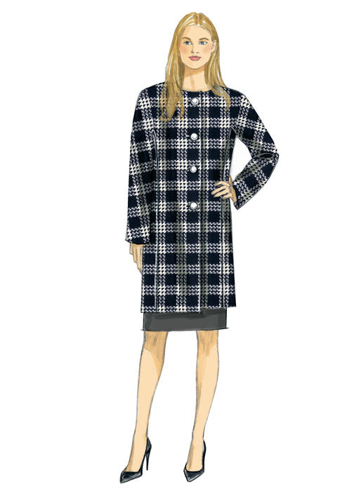
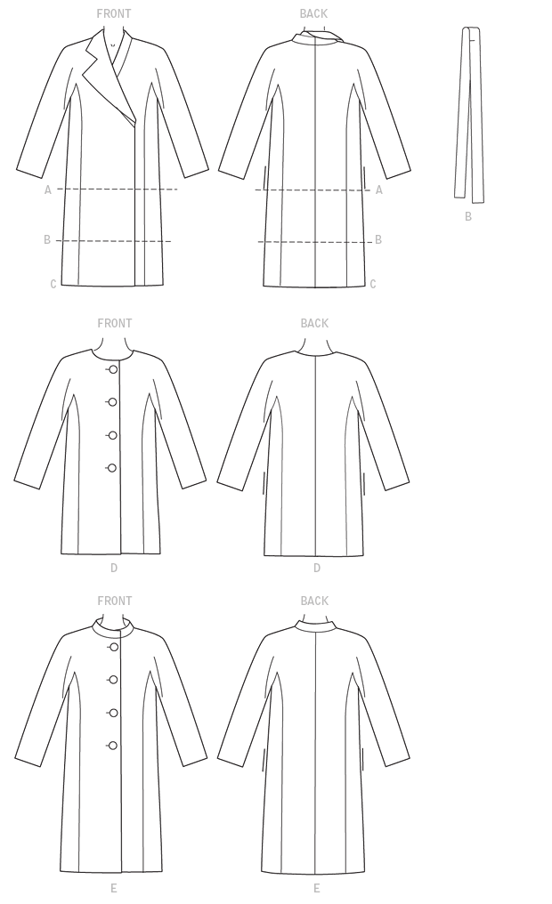

FABRICS: Lightweight Woolens, Wool blend, Tartan, Melton, Fleece, Acrylics, Corduroy,
Unsuitable for obvious diagonals. Check fabrics may require extra fabric to match
Checks.

NOTIONS: Optional: 1.5ms Shoulder Pads. A, B, C: Two Large Snaps. D, E: Four 3cms Buttons.

See the next page

Question 9 continued

Fabric widths given in centimeters.
 | X-Small |  | Small |  | Medium |  | Large |  | X-Large | XX-Large
 | (4-6) |  | (8-10) |  | (12-14) |  | (16-18) |  | (20-22) | (24-26)
A
115 cm*/** |  | 3.4 |  | 3.7 |  | 3.8 |  | 4.0 | 4.2 | 4.5 |  | m
150 cm*/** |  | 2.6 |  | 2.7 |  | 2.9 |  | 3.2 | 3.3 | 3.3 |  | m
LINING A
115 cm |  | 2.2 |  | 2.3 |  | 2.4 |  | 2.5 | 2.6 | 2.9 |  | m
FUSIBLE INTERFACING A
46 cm, 51 cm |  | 1.7 |  | 1.7 |  | 1.8 |  | 1.9 | 1.9 | 2.1 |  | m
B
115 cm*/** |  | 4.1 |  | 4.2 |  | 4.3 |  | 4.9 | 5.1 | 5.4 |  | m
150 cm*/** |  | 3.4 |  | 3.5 |  | 3.7 |  | 3.9 | 4.1 | 4.3 |  | m
FUSIBLE INTERFACING B
46 cm, 51 cm |  | 1.9 |  | 1.9 |  | 2.1 |  | 2.1 | 2.1 | 2.2 |  | m
C
115 cm*/** |  | 4.5 |  | 4.6 |  | 4.7 |  | 5.0 | 5.1 | 5.3 |  | m
150 cm*/** |  | 3.3 |  | 3.4 |  | 3.7 |  | 4.2 | 4.3 | 4.6 |  | m
FUSIBLE INTERFACING C
46 cm, 51 cm |  | 2.2 |  | 2.2 |  | 2.2 |  | 2.3 | 2.3 | 2.4 |  | m
D
115 cm*/** |  | 3.1 |  | 3.3 |  | 3.4 |  | 3.5 | 4.0 | 4.2 |  | m
150 cm*/** |  | 2.4 |  | 2.4 |  | 2.5 |  | 2.7 | 3.0 | 3.1 |  | m
FUSIBLE INTERFACING D
46 cm, 51 cm |  | 1.1 |  | 1.1 |  | 1.1 |  | 1.3 | 1.3 | 1.4 |  | m
E
115 cm*/** |  | 3.8 |  | 3.8 |  | 3.9 |  | 4.0 | 4.5 | 4.6 |  | m
150 cm*/** |  | 2.9 |  | 2.9 |  | 3.0 |  | 3.1 | 3.4 | 3.4 |  | m
FUSIBLE INTERFACING E
46 cm, 51 cm |  | 1.3 |  | 1.3 |  | 1.3 |  | 1.4 | 1.4 | 1.5 |  | m
LINING B, D
115 cm |  | 2.6 |  | 2.7 |  | 2.9 |  | 2.9 | 3.3 | 3.4 |  | m
LINING C, E
115 cm |  | 3.0 |  | 3.1 |  | 3.2 |  | 3.3 | 3.4 | 3.9 |  | m
FINISHED GARMENT MEASUREMENTS
Measurement at bustline
A B C D E |  | 103 |  | 108 |  | 117 |  | 127 | 137 | 147 |  | cm
Measurement at hipline
A B C D E |  | 103 |  | 108 |  | 117 |  | 127 | 137 | 147 |  | cm
Width, lower edge
A B C D E |  | 103 |  | 108 |  | 117 |  | 127 | 137 | 147 |  | cm
Back length from base of neck
A |  | 67 |  | 69 |  | 70 |  | 71 | 72 | 74 |  | cm
B D |  | 88 |  | 89 |  | 90 |  | 91 | 93 | 94 |  | cm
C E |  | 103 |  | 104 |  | 105 |  | 107 | 108 | 109 |  | cm

- How much fabric would you need to purchase to make the coat View D in a size 10.
(2 marks)

Fabric 150 cms width: _____________________________

Lining 115cms width: ______________________________

See the next page
Question 9 continued

b) A wool blend is one of the listed suitable fabrics. Describe the type of wool blend that you think is desirable for the coat and give TWO (2) reasons why this fabric is a good choice for this coat. (3 marks)

Type of blend:______________________________________________________________

Reasons: ___________________________________________________________________________
___________________________________________________________________________
___________________________________________________________________________
___________________________________________________________________________

c) The coat is lined. Suggest ONE (1) suitable fabric for the lining and give ONE (1) reason why this fabric is a good choice. ( 2 marks)

Lining Fabric:______________________________________________________________

Reason: ___________________________________________________________________________
___________________________________________________________________________
___________________________________________________________________________

d) Interfacing is desirable in the construction of this coat.

Where is interfacing used and why is it required? ( 1 mark)
___________________________________________________________________________
___________________________________________________________________________
___________________________________________________________________________
___________________________________________________________________________

e) What type of interfacing would be used and explain why? ( 1 mark)

___________________________________________________________________________
___________________________________________________________________________
___________________________________________________________________________
___________________________________________________________________________

f) Describe the application process for this interfacing. ( 1 mark)

___________________________________________________________________________
___________________________________________________________________________
___________________________________________________________________________
___________________________________________________________________________

See the next page

Question 9 continued

g) Suggest and justify your choice of seams and seam finishes for the coat and the lining. Explain why this is the best choice of seam.

Coat Seams and Finishes: ( 2 marks)

Lining Seams and Finishes: ( 2 marks)

h) A ‘napped’ fabric could be used for the coat.

i. Give a definition of “with nap” ( 1 mark)

ii. How will nap affect the pattern layout or construction of the coat? (1 mark)

See the next page

Question Ten (8 marks)

Knitted fabric is used for a wide range of clothing products.
- Identify the TWO (2) knit fabric structures (2 marks)

- _____________________________
- _____________________________

- Describe using text and diagrams how the TWO (2) knit fabric structures are different. (2 marks)

Diagrams:

See the next page

Question 10 continued

- Identify TWO (2) different woven fabric structures. (2 marks)

  - _____________________________
  - _____________________________

- Describe using diagrams and text, how these TWO (2) woven fabric structures are different.
( 2 marks)

Diagrams:

See the next page

Question Eleven (18 marks)

a) Complete the Fibre Classification Table below. (6 marks)

List TWO (2) fibres under each classification.
Fibres
Natural |  | Manufactured
Cellulose | Protein | Synthetic | Regenerated

b) Select a fabric that you are familiar with and have used. Write its fabric name below.
(1 mark)
__________________________________________

c) State the fibre content of this fabric. (1 mark)

__________________________________________

- Identify the fabric structure of your chosen fabric (1 mark)

__________________________________________

e) State ONE (1) use for this fabric. (1 mark)

__________________________________________

f) Explain why this fabric is a suitable choice for the use identified in the previous question. (1 mark)

_________________________________________________________________________________________________________________________________________________________________________________________________________________________________

See the next page

Question 11 continued

g) Identify ONE (1) fibre that you have studied.

Fibre: _________________________________________________

Discuss in detail the environmental impact of this fibre during all stages of production.

- Fibre Growth / Production Stage: (2 marks)

_________________________________________________________________________________________________________________________________________________________________________________________________________________________________
_________________________________________________________________________________________________________________________________________________________________________________________________________________________________
_________________________________________________________________________________________________________________________________________________________________________________________________________________________________

- Manufacturing Stage: (2 marks)
_________________________________________________________________________________________________________________________________________________________________________________________________________________________________
_________________________________________________________________________________________________________________________________________________________________________________________________________________________________
_________________________________________________________________________________________________________________________________________________________________________________________________________________________________
___________________________________________________________________________

- Garment Use, Care and Disposal Stage: (2 marks)

_________________________________________________________________________________________________________________________________________________________________________________________________________________________________
_________________________________________________________________________________________________________________________________________________________________________________________________________________________________
_________________________________________________________________________________________________________________________________________________________________________________________________________________________________End of Section Three

Spare Page
Question Number:

Spare Page
Question Number:

Spare Page
Question Number:

Spare Page
Question Number:

