

Methodist Ladies’ College
Examination
Semester One, 2016

Question/Answer Booklet
MATERIALS
DESIGN AND TECHNOLOGY
Units 1 and 2 SOLUTIONS
Sections One, Two, and Three
Student Name:
 | Marks available | Your marks
Section One: Short Answer - General | 15
Section Two: Extended Answer – General | 15
Section Two: Extended Answer – Context | 70
 | 100 | / 100

Time allowed for this paper
Reading time before commencing work: ten minutes
Working time for paper: two hours

Materials required/ recommended for this paper
To be provided by the supervisor:
This Question/ Answer Booklet

To be provided by the candidate:
Standard items: pens (blue/black preferred), pencils (including coloured), sharpener,
correction fluid/tape, eraser, ruler, highlighters

Special items: non-programmable calculators approved for use in the WACE examinations

Important note to candidates
No other items may be taken into the examination room. It is your responsibility to ensure that you do not have any unauthorised notes or other items of a non-personal nature in the examination room. If you have any unauthorised material with you, hand it to the supervisor before reading any further.

Structure of this examination

This Unit 1 & 2 examination is worth 5% of your final course mark for
Materials Design & Technology

Structure of this paper

Section | Number of questions available | Number of questions to be answered |  | Suggested working time (minutes) | Marks available | Percentage of total exam
Section One:  Short answer | 3 | 3 |  | 15 | 15 | 15
Section Two:  Extended answer | 3 | 3 |  | 15 | 15 | 15
Section Three:  Textiles specific context | 7 | 7 |  | 90 | 70 | 70
 |  |  | Total |  | 100 | 100

Instructions to candidates

- Answer the questions according to the following instructions

Sections One, Two, and Three: Answer all questions. Write your answers in this Question/Answer booklet.

- You must be careful to confine your responses to the specific questions asked and to follow any instructions that are specific to a particular question.

- Spare pages are included at the end of this booklet. They can be used for planning your responses and/or as additional space if required to continue an answer.
  - Planning: If you use the spare pages for planning, indicate this clearly at the top of the page.
  - Continuing an answer: If you need to use the space to continue an answer, indicate in the original answer space where the answer is continued, i.e. give the page number. Fill in the number of questions that you are continuing to answer at the top of the page.

Section One: Short Answer (15 marks)

This section has THREE (3) questions. Answer all questions. Write your answers in the spaces provided.

Spare pages are included at the end of this booklet. They can used for planning your responses and/or as additional space if required to continue and answer.
  - Planning: If you use the spare pages for planning, indicate this clearly at the top of the page.
  - Continuing an answer: If you need to use the space to continue an answer, indicate in the original answer space where the answer is continued, i.e. give the page number. Fill in the number of questions that you are continuing to answer at the top of the page.

Suggested working time: 15 minutes

Question One (5 marks)

Select ONE (1) of the items below, by drawing a circle around it, and then answer the following questions relating to that item.

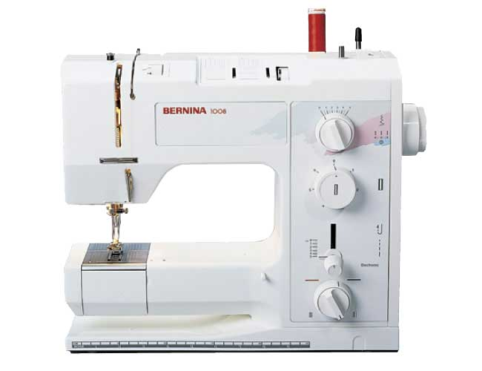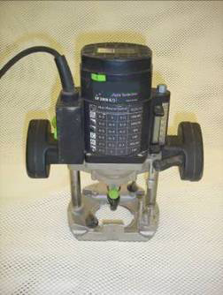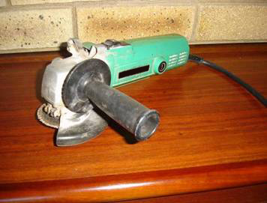

- Name the item you have selected and describe what is it used for? (1 mark)

Sewing machine – joining textile materials and constructing garments and acessories

- Explain TWO (2) safety precautions that should be taken when using the selected item.
(2 marks)
- Have good lighting in the workroom to reduce eye strain.
- Work in a well ventilated area to reduce fibre, dust and vapour inhalation.
- Have appropriate ergonomic furniture – correct height of desk and chair for comfort and to reduce strain on body.
- Keep power cords away from sewing and cutting areas.
- Wear appropriate dress – closed shoes, hair tied back, no loose clothing worn.
- Keep fingers away from moving parts of all machine and electrical appliances – blade in over locker, needle in sewing machine, iron face.
- Safety guards used where applicable on machines.
- Keep work areas clean and uncluttered to prevent items getting caught in machines.
- Avoid contact with wet areas to prevent electrocution.

Question 1 continued
- Explain how this item has replaced a previous manual method of completing the same process (2 marks)

Hand sewing using a hand sewing needle and thread
Treadle machine – using manual treadling to drive the needle - rather than electric machine

Question Two (4 marks)

Retro is a decorative and architectural style of the period 1960s – 1970s

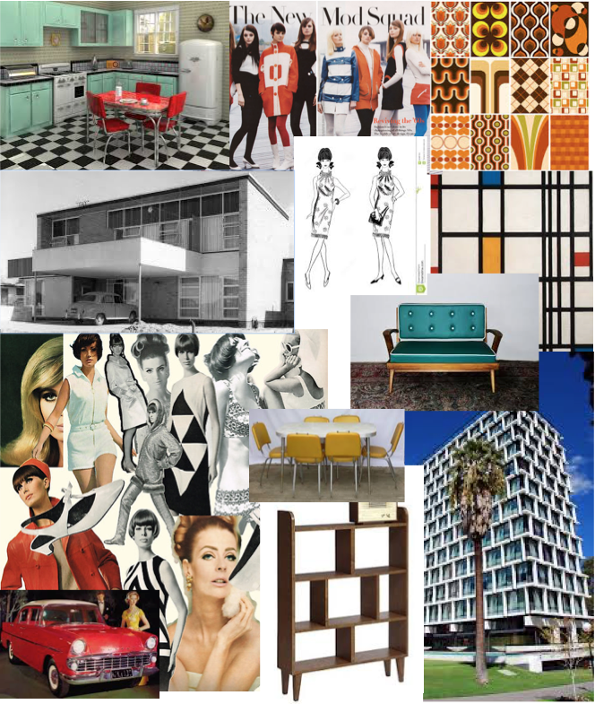
see the next page

Question 2 continued

- Study the Retro mood board above on the previous page and describe FOUR (4) features of Retro style

(4 marks)
Four features identified and a short description
Example: Use of geometric shapes – strong squares and rectangular shapes in architecture, furniture and textile fabric design.

Use of shiny fabrics and materials
Use of plastics and synthetic materials
Use of simplistic styles and shapes
Mod styles – mini skirts
Geometric shapes
Bold and Bright colours – orange and brow, red black and white
Repetition of patterns - Checks, stripes
Black and white

Question Three (6 marks)

Products are designed with a specific target user in mind.

- Describe a target user for each of the product pairs shown below. Give THREE (3) reasons for your answer. (3 marks)
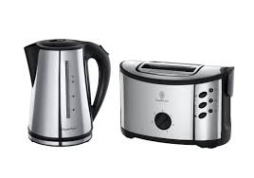
Product Pair A

Kettle A ($40.00) Toaster A ($35.00)

Target User:
economy driven – cheaper priced products,
simplistic design products
uncomplicated functional products – with minimal features
maybe students in a flat, apartment, or elderly people, or a staff room at work
Reasons:
cheaper price for each product
unsophisticated design – easy to understand and use
less features so easy to understand and use
easy to use
Question 3 continued

Product Pair B (3 marks)
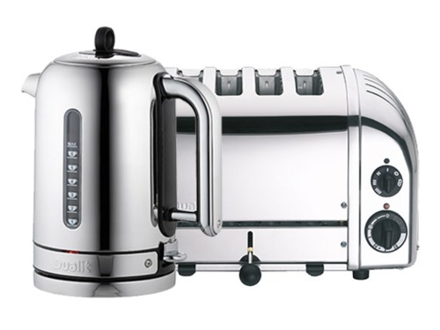

Dualit Kettle B ($249.00) Dualit Toaster B ($238.00)

Target User:
Clients interested in design – perhaps Vintage styles or modern designs
Clients have more $’s at disposal for purchase of goods DINKS & wealthier families
Larger families – four toast at once
Prepared to pay more for a more stylish product ( as well as functional) –
Interested in using more features
Reasons:
Stylish design features
Functional desing – four toast at once
More expensive prices
Has more features

End of Section One

Section Two: Extended Answer (15 marks)

This section has THREE (3) questions. Answer all questions. Write your answers in the spaces provided.

Spare pages are included at the end of this booklet. They can be used for planning your responses and/or as additional space if required to continue and answer.
  - Planning: If you use the spare pages for planning, indicate this clearly at the top of the page.
  - Continuing an answer: If you need to use the space to continue an answer, indicate in the original answer space where the answer is continued, i.e. give the page number. Fill in the number of questions that you are continuing to answer at the top of the page.

Suggested working time: 15 minutes

Question Four (5 marks)

All parts of Question 4 refer to the images below.

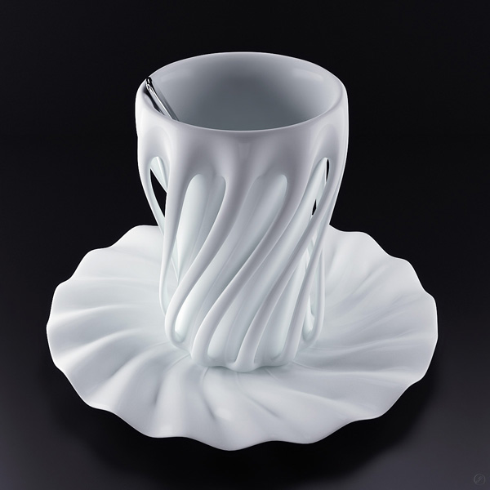

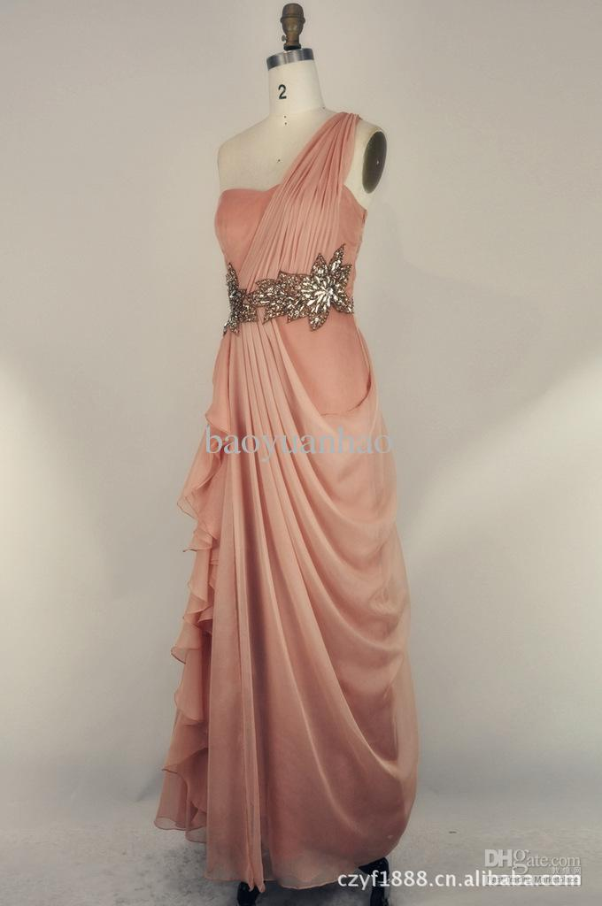

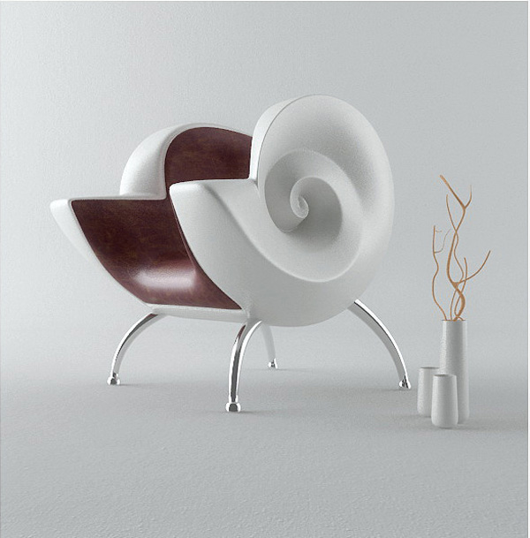
Cup & Saucer
Evening Gown

Shell Chair

See the next page

Question 4 continued

- The products on the previous page have all been made out of materials selected for their aesthetic value. What material property do all these products have in common? Explain.
(1 mark)
Drape of the materials used – ability to flow and fold in curvaceous shapes

- Select ONE (1) of the products shown above and suggest a material that would address the functional and aesthetic properties required for the successful end-use of the product. Justify your answer by referring to the specific properties of the proposed material. (4 marks)

Product chosen: Apricot evening gown

Material chosen:
Base of the dress – duchess satin or silk dupion
Silk Chiffon to be used for the draped gown overlay

Justify your answer with the specific properties of this material:
Chiffon overlay
- Silk chiffon drapes in the most beautiful way – and can form the circular style frill on the edge of the draped overlay
- Silk chiffon handles beautifully
- soft and floaty fabric – falls in folds especially when cut on the bias as this has been
- can be folded tightly to create and area of tightly rouched fabric that opens out into wide piece of fabric
- not bulky when rouched
- can be layered without too much bulk
- See through fabric – transparent / transluscent
- Silk can be dyed a variety of colours – therefore the colour would be available

Silk Dupion Main garment –
- Silk drapes in the most beautiful way – would have a nice crisp finish that holds its shape well
- Silk dupion handles beautifully with a lovely crisp texture but comfortable to wear
- Relatively strong - Would make a great strapless dress – will hold up properly
- Silk can be dyed a variety of colours – therefore the colour would be available

Question Five (6 marks)

- Explain THREE (3) ways in which a designer of your choice has influenced a decade of fashion. (3 marks)
Three ( 3) distinct design features / ideas related to the designer or the period of fashion history
Example – Silhouettes designed and used - 1960s / 70s – retro styles – shift dress styles, bra tops, skorts, flares,
Mini skirts or styles specific to the era
Use of bold fabrics, specific fabric types
Geometric fabrics
Decorative techniques used eg. applique, lace overlays

- Explain the use of inspiration / mood boards by a designer. (3 marks)

Gathering a wide range of ideas to consider to use in design development – garments, fabrics, notions, silhouettes, embellishments, styles, current fashion trends, etc
These ideas are then used to create initial rapid concept designs – a wide range of possible sketched ideas

Question Six (4 marks)

In creating new products and items, designers use the technology process to solve problems. Explain the following steps used in this process.

Investigation / Research (1 mark)

RESEARCH COMPONENT – establishes the breadth of the design brief and research is undertaken to determine the problem to be solved.
The designer will research the following:
Client research – interview the client to gather information about the clients needs, wants, expectations, purpose / use of the garment, anthropometric data, pattern size, figure type
Survey target audience to determine their needs, wants, expectations in terms of the design fundamentals – eg aesthetics, function, economics, environment, etc.
Look at current fashion trends and at other designers, designs that are popular, trends that are popular eg. colour palettes,
Brainstorming ideas, inspiration pages – to gather a wide range of design ideas

Planning / Devising (1 mark)
Design component – design development – The designer will commence sketching ideas working from a wide range of possible ideas to a final design concept that will be implemented.
The design sketching might include:
rapid concept designs
design development – bringing possible ideas together
design a collection / range
design a storyboard
design specification sheets
Planning – Materials list and budget
Production planning using a pattern

The influence of evaluation upon the design of a product. (2 marks)
Evaluating can be undertaken at any stage of the process and throughout the process – designers determine what has been successful in their design and production and look for further fine tuning / improvement in design ideas.
Ongoing evaluation – keeping a journal / notes recording success / problems and solutions to problems
Evaluating a proptotype / sample / toiles before creating the final design enables design improvements to be made
Final evaluation – determines success of the product - marketablilty

Section Three: Textiles Specific Context (70 marks)

This section has SEVEN (7) questions. Answer all questions. Write your answers in the spaces provided.

Spare pages are included at the end of this booklet. They can be used for planning your responses and/or as additional space if required to continue and answer.
  - Planning: If you use the spare pages for planning, indicate this clearly at the top of the page.
  - Continuing an answer: If you need to use the space to continue an answer, indicate in the original answer space where the answer is continued, i.e. give the page number. Fill in the number of questions that you are continuing to answer at the top of the page.

Suggested working time: 90 minutes

Question Seven (15 marks)

The following pattern envelope refers directly to all parts of Question 7
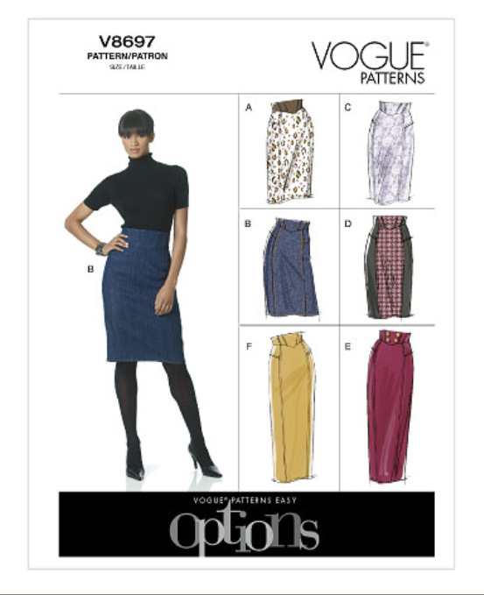
see the next page
Question 7 continued

The following pattern envelope refers directly to all parts of Question 7

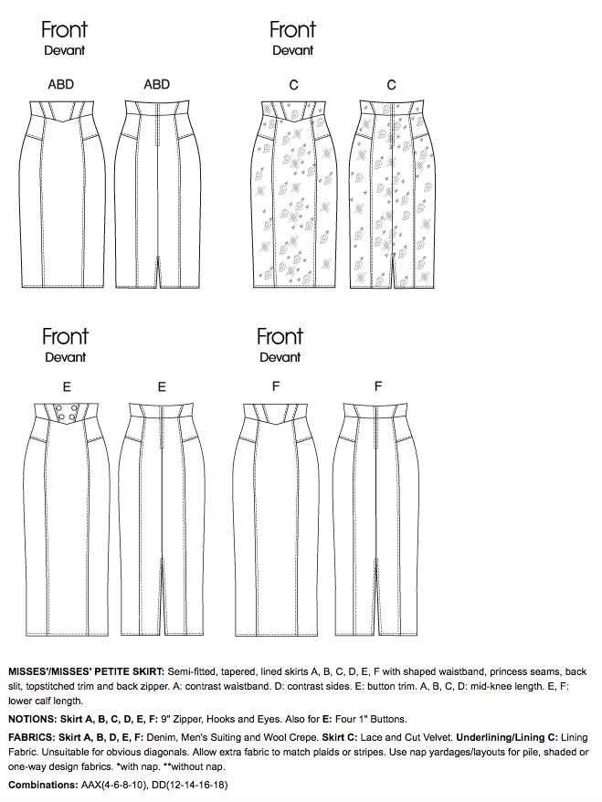

see next page

Question 7 continued

The following pattern envelope refers directly to all parts of Question 7

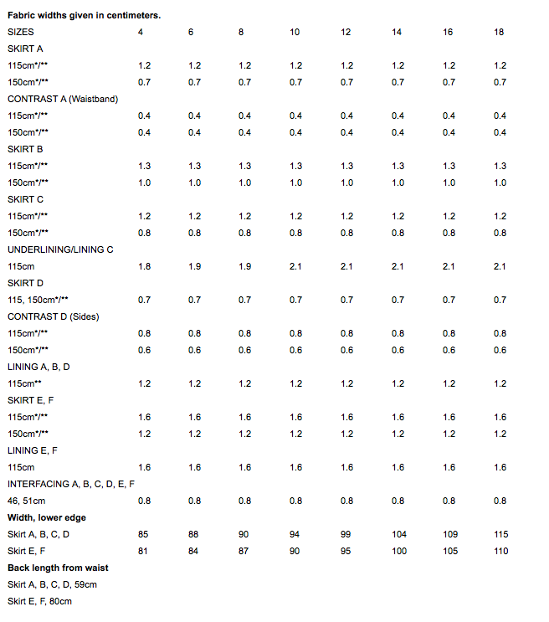

see next page

Question 7 continued

Using the pattern envelope on the previous page answer the following questions

- Name TWO (2) fabrics which would be suitable for the skirt view E (2 marks)
Fabrics: Denim mens suiting wool crepe

  - Which skirt view requires buttons?

skirt view View E (1 mark)

  - How many buttons would be required to complete the skirt design and what size should the buttons be? (2 marks)

Number of buttons: FOUR buttons

Size of buttons: 1” buttons

- How much fabric would you need to purchase for skirt view E, if you chose 150cm wide Velvet and your size was 12. Explain your answer. (2 marks)

1.20 metres
Question 7 continued

  - Does the skirt recommend a lining?

Yes (1 mark)

  - If you answers part (i) as Yes, what is the width of lining fabric and the amount that would be required for skirt view E? (2 marks)

115cm width – 1.60 metres

- Pattern pieces are printed on large pieces of tissue paper and marked with appropriate information. Each pattern piece will have pattern markings that need to be followed and sometimes transferred to the fabric you are using.

Draw the symbol for each named pattern marking in the table provided
(5 marks)

Name of symbol | Draw the symbol
Seam allowance

Cutting line

Shorten or lengthen lines

Straight grain of fabric line

Notches numbered in sequence of matching

Question Eight (12 marks)

Annotate the following images using each the following
- Elements of Design
- Principles of Design
- Silhouette

- Image 1 (3 marks)
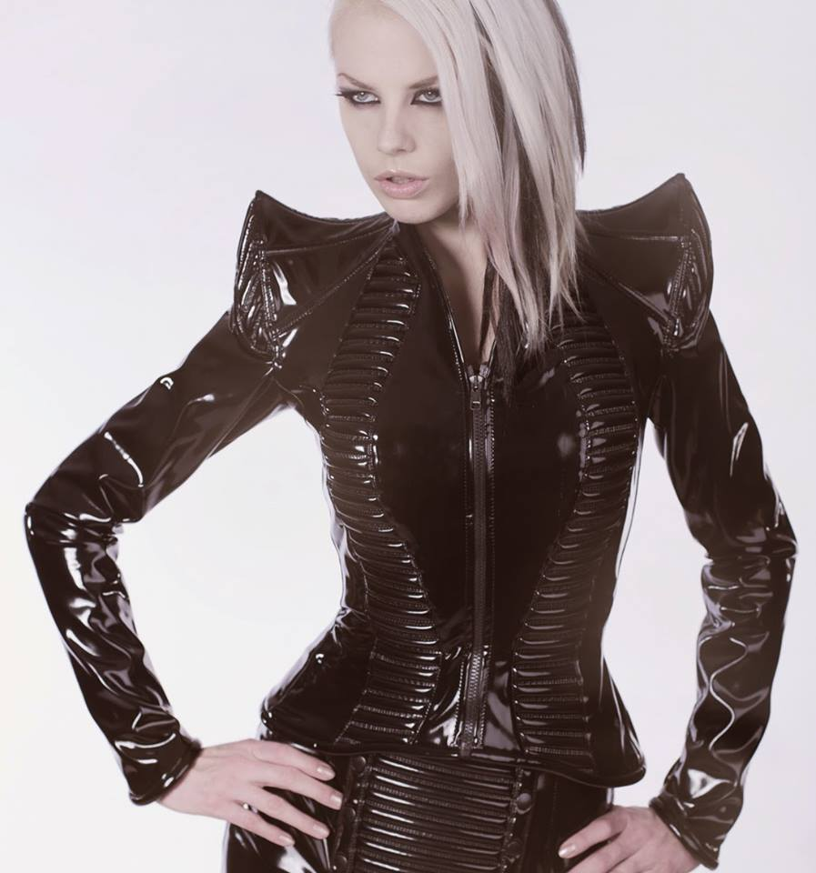
Element:
Colour – black – perception is the body appears smaller / thinner
Line – Vertical line of centre front zipper – vertical lines of the metallic trim - perception is the body appears taller
Texture – smooth, shiny texture - perception is the body appears larger
Shape – Sharp, pointy shoulder shape attracts attention – dominance, focal point

Principle:
Repetition – shapes in metallic trim
Rhythm – metallic trim repeated
Balance – symmetrcial balance – mirror image
Dominance – shoulder points attract attention
Silhouette:
Hourglass – nipped in at the wiast - outside shape of the garment / jacket

- Image 2 (3 marks)
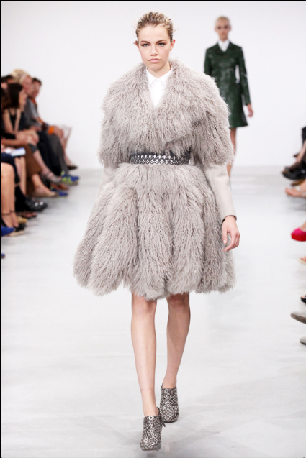

Element:
Colour – Grey – neutrals, monochromatic, shades & tints of grey
Line – fur lines – height , waistband – adds width
Shape – rectangle / hourglass
Texture – fluffy / rough = larger
Principle:
Repetition – fur pieces – fur panels
Rhythm - fur panels
Proportion – ½ - not so flattering to figure
Dominance – v neck leading to belt
Silhouette
Rectangle / Hourglass

- Image 3 (3 marks)
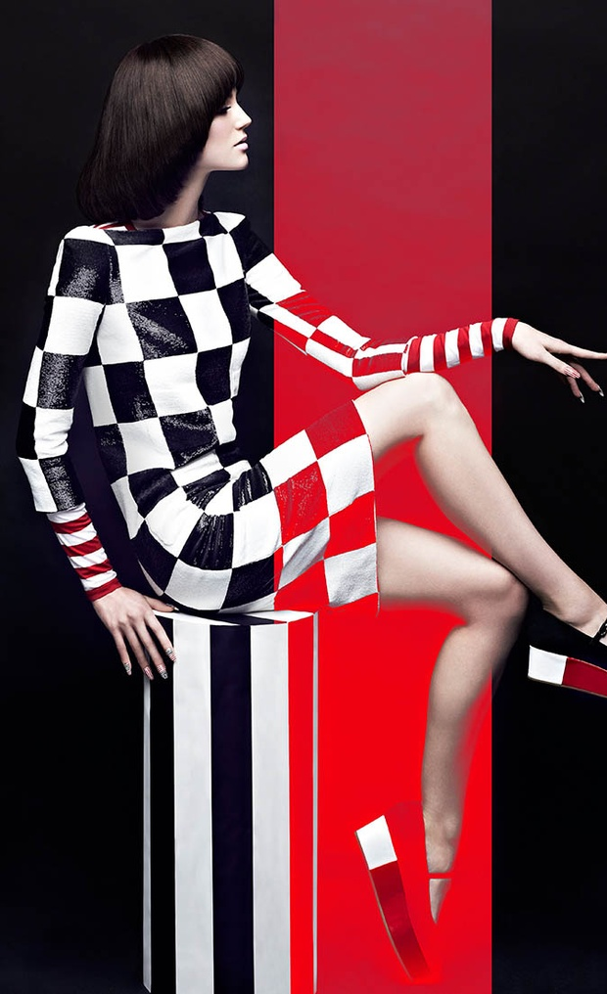
Element:
Colour – black and white – neutrals, Red – bold, primary colour
Line – checks create lines – both vertical and horizontal that lead the eye, striped trim around arm/ hand
Shape – rectangle shift – square shapes in the checked print used – tend to make figure appear larger
Texture – shiny – tends to attract attention and make figure appear larger
Principle:
Repetition checked fabric – repeated squares in three different colours
Rhythm – repetition of checked fabric, striped fabric
Proportion – 5/8s black and white checked fabric 3/8s – red and white checked fabric = golden mean - pleasing design
Balance – symmertrical – mirror image
Dominance – red hem panel
Silhouette
Rectangle

- Image 4 (3 marks)
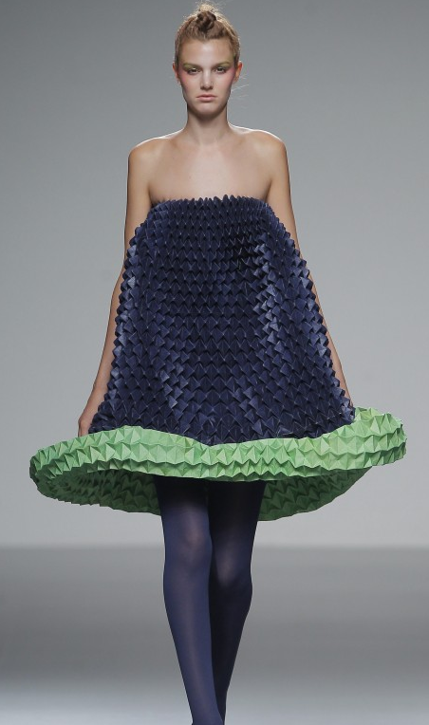
Element:
Colour – harmonious colour scheme – blue / green
Lines – patterns / stripes across the fabric, green line at hem – adds width
Shape – triangle silhouette, , shapes in the fabric
Textures – highly textures, shiny and lumpy/ knotty – adds width
Principle:
Repetition- lines in fabric
Rhythm-
Proportion - oversized
Balance - symmetrical
Dominance – green hem panel

Silhouette: triangle

Question Nine (12 marks)

A number of Design Fundamentals are listed below.

- Aesthetic
- Function
- Time Limitation
- Economic
- Safety
- Anthropometric
- Ergonomics
- Social
- Environmental

Name FOUR (4) Design Fundamentals from the list that you have worked with this year and explain how they relate to the following design.

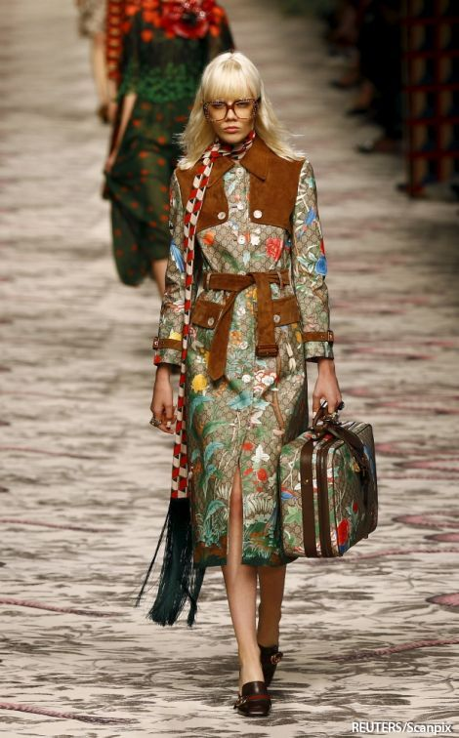
see next page

Question 9 continued

Design Fundamental 1: (3 marks)
Aesthetic:

Colours used - autumn – lighter fabric – change of season
Floral pattern – contrast to suede fabric
Suede fabric used for focal areas – attention and dark colour – winter climate
Burberry style - jacket
Proportions used – taller appearance with a longer coat

Design Fundamental 2 : (3 marks)
Function:
Between season coat – lighter weight printed fabric
Pockets
Belt and belt tabs on sleeves to tighten
Button front – closure

Design Fundamental 3: (3 marks)
Anthropometric
Data used – bust, waist and hip measurements used to achieve good fit for the average sized 8,10,12, 14, 16 etc

Ergonomics –
Sleeve length
Coat length
Button front – closure – button sizes in relation to button hole size

Social
Target audience – younger age group – preferred styles – trench coat , fabrics – prints and use of suede / leather – type of youthful prints etc

Environmental
Climate – lighter fabric to suit between season climate
Possibly – upcycled off cuts of larger suede jackets used to trim this jacket. suede fabrics, or using imitation suede fabrics

Safety – weather conditions, functional button closure

See next page

Question Ten (10 marks)

- Label the TWO (2) sets of threads on the diagram of the woven fabric below
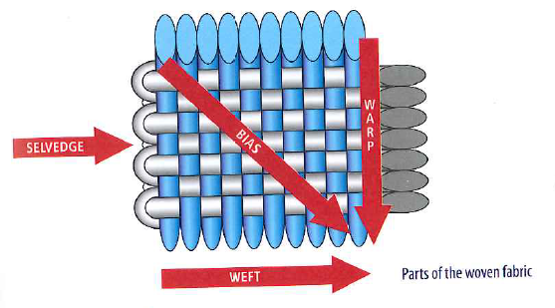
(2 marks)

Thread A:

__WARP_________
A
Thread B:

__WEFT_________

B
B

- Name TWO (2) other fabric structures
(2 marks)

Structure 1: KNIT FABRIC

Structure 2: NON WOVEN FABRIC ( BONDED, FELTED)

See next page

Question 10 continued

- Name each of the fabric weaves in the table and provide a typical use for this weave in the space provided
(6 marks)

 |  | Name Weave | Typical use of weave
1 | 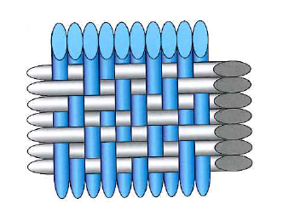 | CREPE WEAVE | DRESS FABRIC  APPAREL  HOME FURNISHINGS
2 | 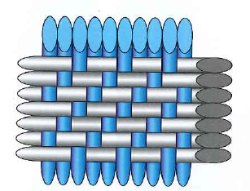 | TWILL WEAVE | UNIFORMS  DENIM  WORK CLOTHES  HOME FURNISHINGS  INDUSTRIAL FABRICS
3 | 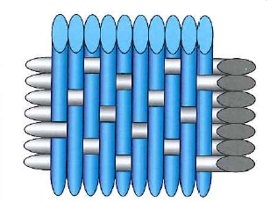 | SATIN WEAVE | FORMAL WEAR  EVENING GOWNS  LINGERIE  SLEEPWEAR  SATIN CURTAINS

Question Eleven (4 marks)

The following two garments were worn at the 2014/15 Australian Open.

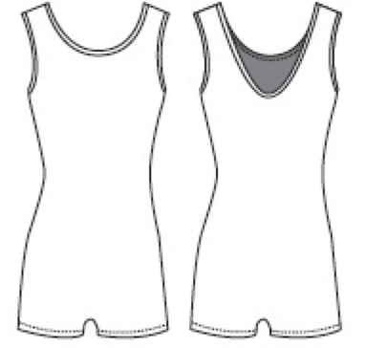
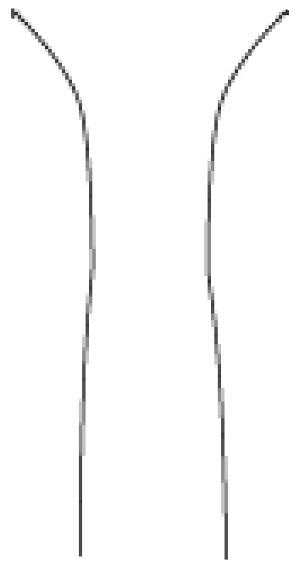
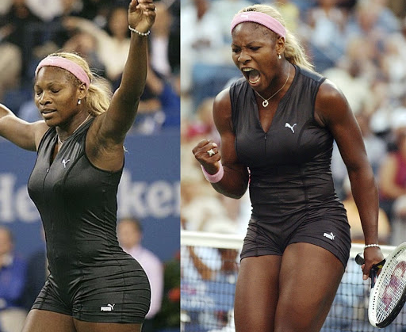

Puma ‘Catsuit’ worn by Serena Williams

Fabric: Polyester and Lycra blend

Features: Centred zip
Body length darts
See next page

Question 11 continued

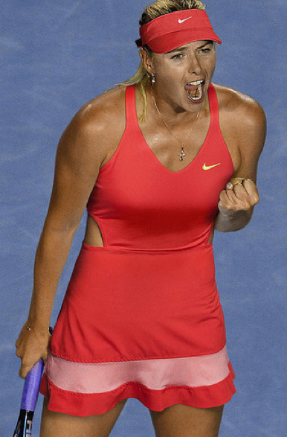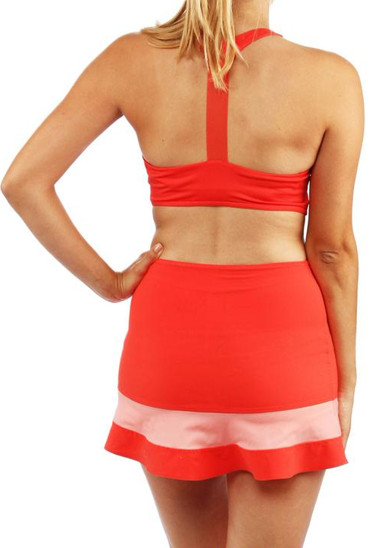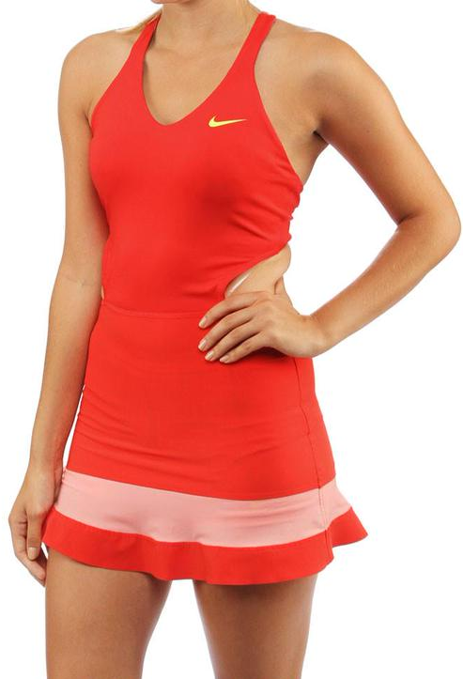

Nike tennis dress worn by Maria Sharapova

Fabric: High technology wicking fabric

Features: Cut away back feature
Halter neck and T-shaped bra

- Select and justify your choice of which of the two garments would be better to wear in a competitive sports context.

This is the best garment due to:
High technology wicking fabric – style is cool to wear – body open to environment, cool body and not sweaty to wear as fabric conducts perspiration wetness away from the body.
Excellent movement capacity due elasticity in high tech fabric
Excellent movement capacity due to style / design – halter T back, open shoulder area – no restriction to mevement
T back bra – good support for the bustline through use of bra style and high tech elastic fabric
Although not good cover for sun – mostly worn on indoor courts
Pull on feature – no zipper closure visble – fits more sizes easily – stretch nature
Matching hat
Logo featured

Question Twelve (6 marks)

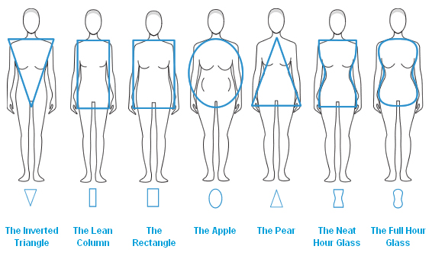

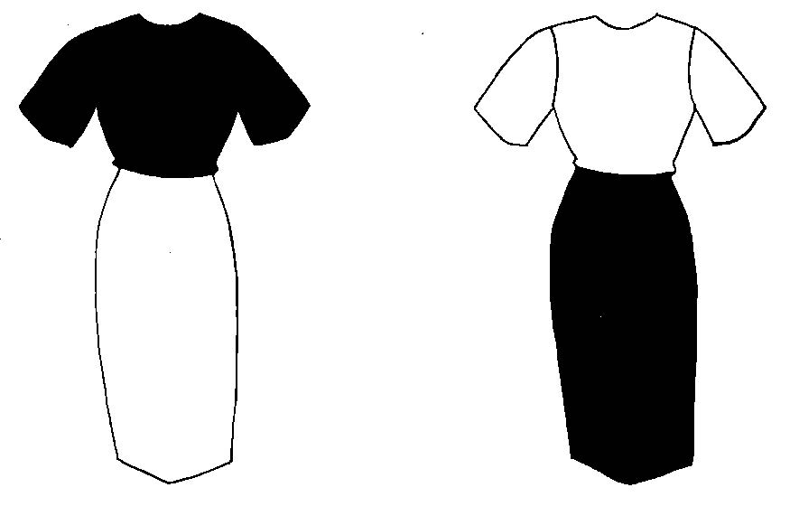
A B
(a) Which dress, A or B, would better flatter the Inverted Triangle body shape shown above? Justify your answer. (3 marks)

Dress: A
Dark colours recede and would make the upper body appear smaller and slimmer

See next page

Question 12 continued
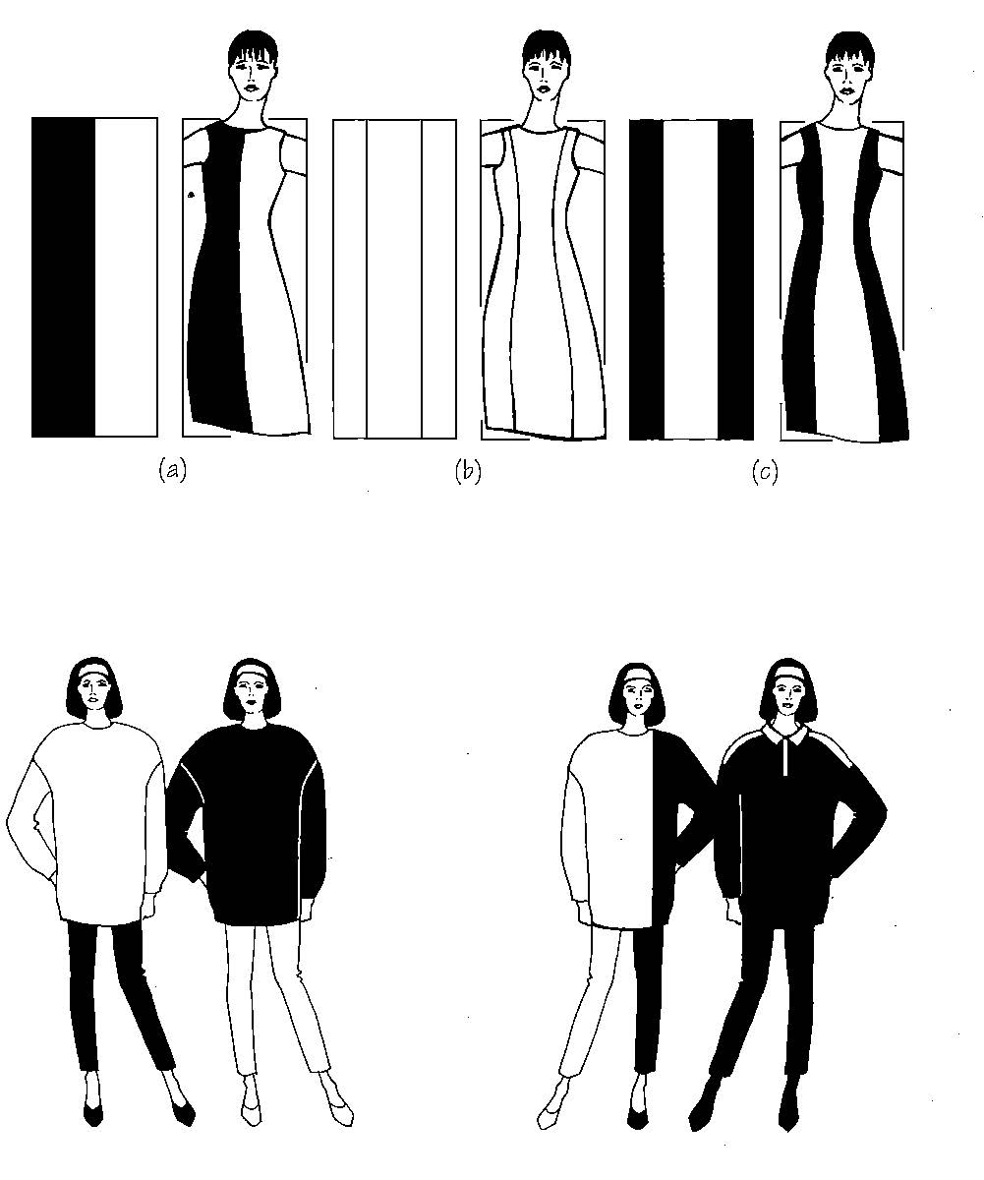
A B C

(b) If you were an Apple body shape, which dress would you choose to best flatter your figure? Justify your answer. (3 marks)

Dress: C
Darker colures gives a slimming line through bust through waist through hips to length

Question Thirteen (10 marks)

This question is about fibres and fabrics used for the school blouse shown below.

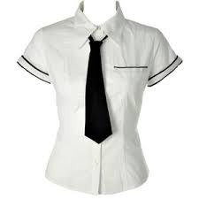

The fabric used in the blouse is a blend of 65% polyester and 35% cotton.

- Explain the properties of this fibre blend which make is suitable for this shirt.
(3 marks)
Cotton: 35% properties
1) cool to wear – good conductor of heat 2) absorbs moisture quickly and dries quickly
3) does not irritate the skin or cause allergies as it is a smooth fibre
4 poor drape – poor elasticity therefore requires a hot iron to remove creases
5) can be bleached – also dyes well 6) will shrink when washed
Polyerster: 65%
Good drape, relatively elastic, poor conductor, cheap to produce, poor absorbency, low shrinkage

- Give THREE (3) advantages of using this fabric blend for the blouse. (3 marks)
- 1) allows easier laundering and care with less need for ironing
- 2) draping qualities are improved with the blend as cotton alone has poor drape
- 3) due tot the dimensional stability or polyester being excellent, there is the opportunity to permanently heat set the fabric
- 4) By blending the fibres – the cost s lower than 100% cotton as polyester is cheaper to produce
See the next page

Question 13 continued
- What are the advantages of blending the following fibres in a fabric?

- Nylon / Lycra (2 marks)
The ability to combine strength of nylon with the stretch of lycra. These combine to produce a fabric which can bit the body, be suitable for active wear such as cycling, swim wear and gym wear etc

- Wool / Nylon (2 marks)
The ability to combine the warmth of wool with the strength of nylon. Wool has a tendency to shrink if not laundered with a constant warm wash and rinse – nylon due to its hydrophobic and crystalline properties has low shrinkage

End of Section Three

Spare Page
Question Number:

Spare Page
Question Number:

Spare Page
Question Number:

Spare Page
Question Number:

