

Methodist Ladies’ College
Examination
Semester One, 2016

Question/Answer Booklet
MATERIALS
DESIGN AND TECHNOLOGY
Units 1 and 2
Sections One, Two, and Three
Student Name:
 | Marks available | Your marks
Section One: Short Answer - General | 15
Section Two: Extended Answer – General | 15
Section Two: Extended Answer – Context | 70
 | 100 | / 100

Time allowed for this paper
Reading time before commencing work: ten minutes
Working time for paper: two hours

Materials required/ recommended for this paper
To be provided by the supervisor:
This Question/ Answer Booklet

To be provided by the candidate:
Standard items: pens (blue/black preferred), pencils (including coloured), sharpener,
correction fluid/tape, eraser, ruler, highlighters

Special items: non-programmable calculators approved for use in the WACE examinations

Important note to candidates
No other items may be taken into the examination room. It is your responsibility to ensure that you do not have any unauthorised notes or other items of a non-personal nature in the examination room. If you have any unauthorised material with you, hand it to the supervisor before reading any further.

Structure of this examination

This Unit 1 & 2 examination is worth 5% of your final course mark for
Materials Design & Technology

Structure of this paper

Section | Number of questions available | Number of questions to be answered |  | Suggested working time (minutes) | Marks available | Percentage of total exam
Section One:  Short answer | 3 | 3 |  | 15 | 15 | 15
Section Two:  Extended answer | 3 | 3 |  | 15 | 15 | 15
Section Three:  Textiles specific context | 7 | 7 |  | 90 | 70 | 70
 |  |  | Total |  | 100 | 100

Instructions to candidates

- Answer the questions according to the following instructions

Sections One, Two, and Three: Answer all questions. Write your answers in this Question/Answer booklet.

- You must be careful to confine your responses to the specific questions asked and to follow any instructions that are specific to a particular question.

- Spare pages are included at the end of this booklet. They can be used for planning your responses and/or as additional space if required to continue an answer.
  - Planning: If you use the spare pages for planning, indicate this clearly at the top of the page.
  - Continuing an answer: If you need to use the space to continue an answer, indicate in the original answer space where the answer is continued, i.e. give the page number. Fill in the number of questions that you are continuing to answer at the top of the page.

Section One: Short Answer (15 marks)

This section has THREE (3) questions. Answer all questions. Write your answers in the spaces provided.

Spare pages are included at the end of this booklet. They can used for planning your responses and/or as additional space if required to continue and answer.
  - Planning: If you use the spare pages for planning, indicate this clearly at the top of the page.
  - Continuing an answer: If you need to use the space to continue an answer, indicate in the original answer space where the answer is continued, i.e. give the page number. Fill in the number of questions that you are continuing to answer at the top of the page.

Suggested working time: 15 minutes

Question One (5 marks)

Select ONE (1) of the items below, by drawing a circle around it, and then answer the following questions relating to that item.

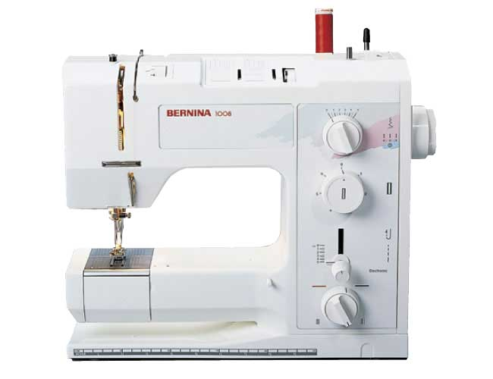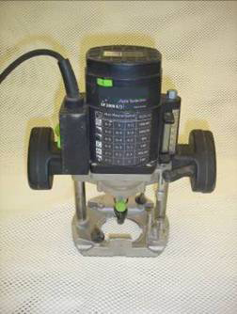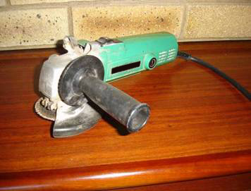

- Name the item you have selected and describe what is it used for? (1 mark)

- Explain TWO (2) safety precautions that should be taken when using the selected item.
(2 marks)

Safety precaution 1:

Safety precaution 2:

see the next page

Question 1 continued
- Explain how this item has replaced a previous manual method of completing the same process (2 marks)

Question Two (4 marks)

Retro is a decorative and architectural style of the period 1960s – 1970s

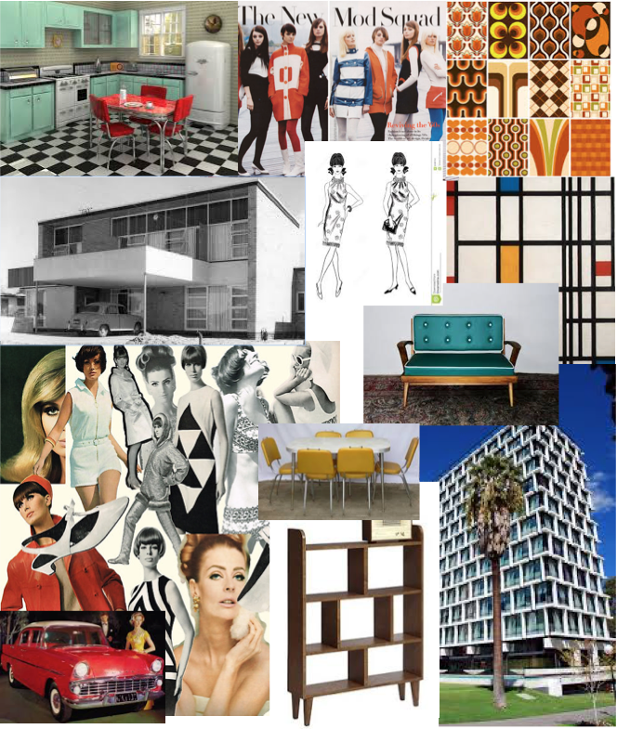
see the next page

Question 2 continued

- Study the Retro mood board above on the previous page and describe FOUR (4) features of Retro style

(4 marks)

Feature 1 Description:

Feature 2 Description:

Feature 3 Description:

Feature 4 Description:

see the next page

Question Three (6 marks)

Products are designed with a specific target user in mind.

- Describe a target user for each of the product pairs shown below. Give THREE (3) reasons for your answer. (3 marks)
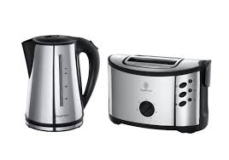
Product Pair A

Kettle A ($40.00) Toaster A ($35.00)

Target User:

Reason 1:

Reason 2:

Reason 3:

see the next page

Question 3 continued

Product Pair B (3 marks)
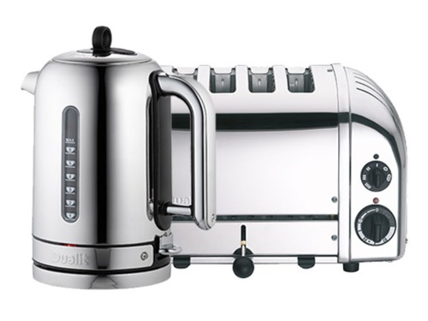

Dualit Kettle B ($249.00) Dualit Toaster B ($238.00)

Target User:

Reason 1:

Reason 2:

Reason 3:

End of Section One

Section Two: Extended Answer (15 marks)

This section has THREE (3) questions. Answer all questions. Write your answers in the spaces provided.

Spare pages are included at the end of this booklet. They can be used for planning your responses and/or as additional space if required to continue and answer.
  - Planning: If you use the spare pages for planning, indicate this clearly at the top of the page.
  - Continuing an answer: If you need to use the space to continue an answer, indicate in the original answer space where the answer is continued, i.e. give the page number. Fill in the number of questions that you are continuing to answer at the top of the page.

Suggested working time: 15 minutes

Question Four (5 marks)

All parts of Question 4 refer to the images below.

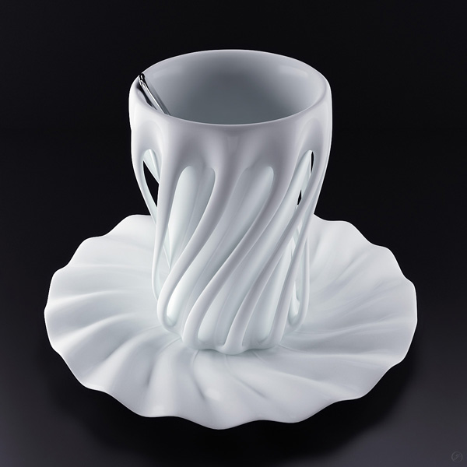

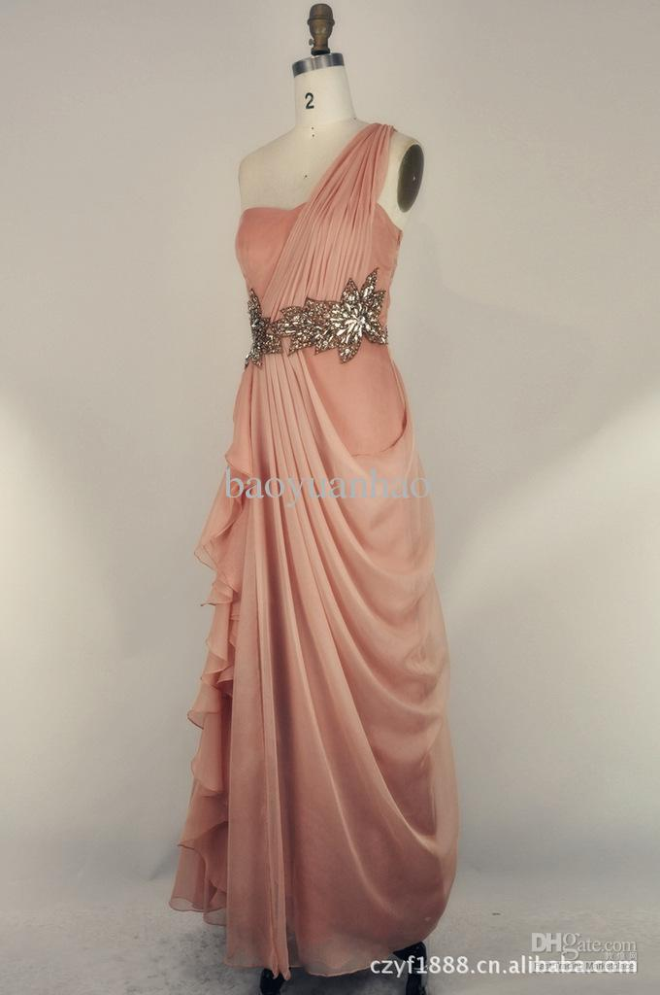

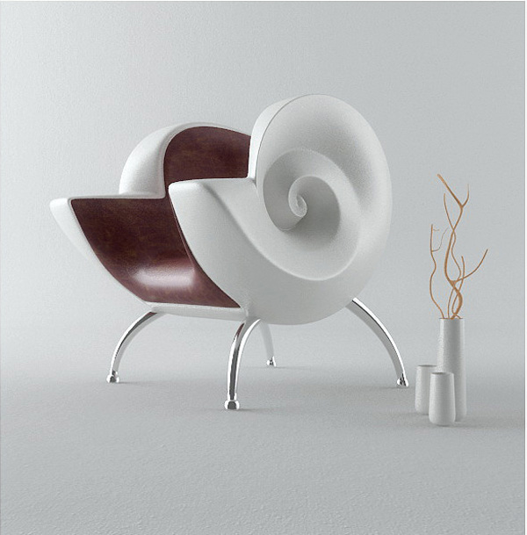
Cup & Saucer
Evening Gown

Shell Chair

See the next page

Question 4 continued

- The products on the previous page have all been made out of materials selected for their aesthetic value. What material property do all these products have in common? Explain.
(1 mark)

- Select ONE (1) of the products shown above and suggest a material that would address the functional and aesthetic properties required for the successful end-use of the product. Justify your answer by referring to the specific properties of the proposed material. (4 marks)

Product chosen:

Material chosen:

Justify your answer with the specific properties of this material:

see the next page

Question Five (6 marks)

- Explain THREE (3) ways in which a designer of your choice has influenced a decade of fashion. (3 marks)

Influence 1:

Influence 2:

Influence 3:

- Explain the use of inspiration / mood boards by a designer. (3 marks)

see the next page

Question Six (4 marks)

In creating new products and items, designers use the technology process to solve problems. Explain the following steps used in this process.

- Investigation / Research (1 mark)

- Planning / Devising (1 mark)

- The influence of evaluation upon the design of a product. (2 marks)

End of Section Two

Section Three: Textiles Specific Context (70 marks)

This section has SEVEN (7) questions. Answer all questions. Write your answers in the spaces provided.

Spare pages are included at the end of this booklet. They can be used for planning your responses and/or as additional space if required to continue and answer.
  - Planning: If you use the spare pages for planning, indicate this clearly at the top of the page.
  - Continuing an answer: If you need to use the space to continue an answer, indicate in the original answer space where the answer is continued, i.e. give the page number. Fill in the number of questions that you are continuing to answer at the top of the page.

Suggested working time: 90 minutes

Question Seven (15 marks)

The following pattern envelope refers directly to all parts of Question 7
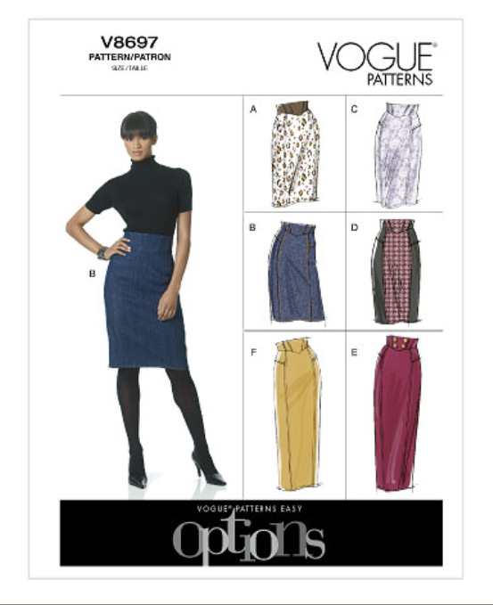
see the next page
Question 7 continued

The following pattern envelope refers directly to all parts of Question 7

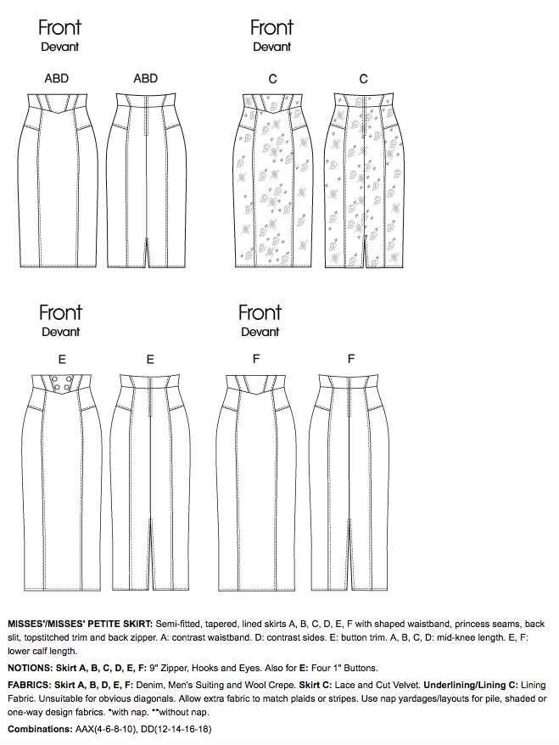

see next page

Question 7 continued

The following pattern envelope refers directly to all parts of Question 7

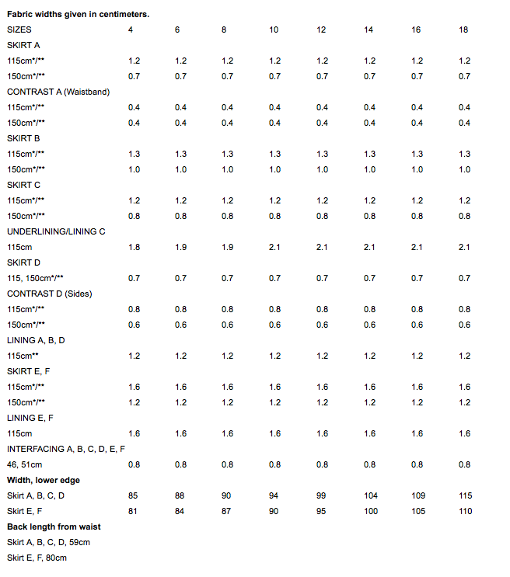

see next page

Question 7 continued

Using the pattern envelope on the previous page answer the following questions

- Name TWO (2) fabrics which would be suitable for the skirt view E (2 marks)
Fabric 1:

Fabric 2:

  - Which skirt view requires buttons?

skirt view ___________ (1 mark)

  - How many buttons would be required to complete the skirt design and what size should the buttons be? (2 marks)

Number of buttons:

Size of buttons:

- How much fabric would you need to purchase for skirt view E, if you chose 150cm wide Velvet and your size was 12. Explain your answer. (2 marks)

See next page

Question 7 continued

  - Does the skirt recommend a lining?

Yes / No (circle your answer) (1 mark)

  - If you answers part (i) as Yes, what is the width of lining fabric and the amount that would be required for skirt view E? (2 marks)

- Pattern pieces are printed on large pieces of tissue paper and marked with appropriate information. Each pattern piece will have pattern markings that need to be followed and sometimes transferred to the fabric you are using.

Draw the symbol for each named pattern marking in the table provided
(5 marks)

Name of symbol | Draw the symbol
Seam allowance

Cutting line

Shorten or lengthen lines

Straight grain of fabric line

Notches numbered in sequence of matching

see next page

Question Eight (12 marks)

Annotate the following images using each the following
- Elements of Design
- Principles of Design
- Silhouette

- Image 1 (3 marks)
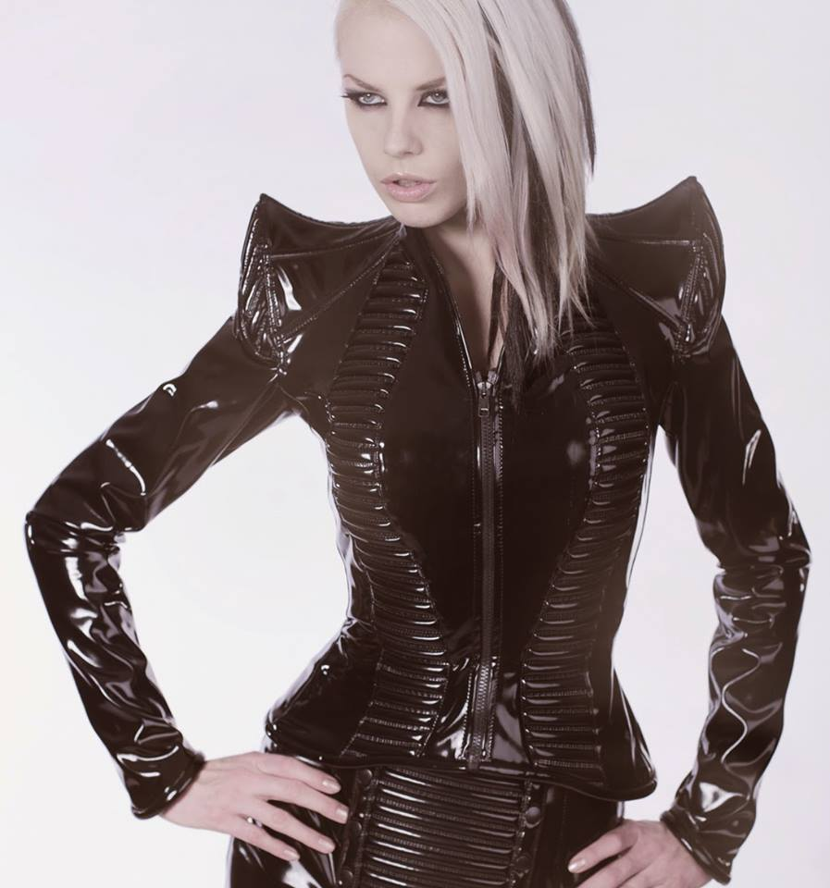
Element:

Principle:

Silhouette

- Image 2 (3 marks)
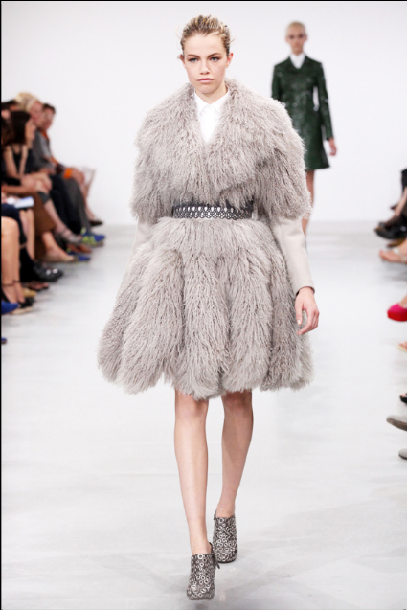

Element:

Principle:

Silhouette

Question 8 continued

- Image 3 (3 marks)
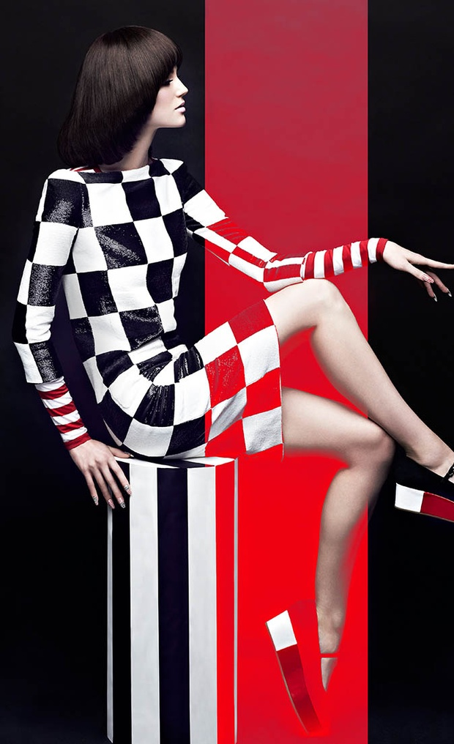

Element:

Principle:

Silhouette

- Image 4 (3 marks)
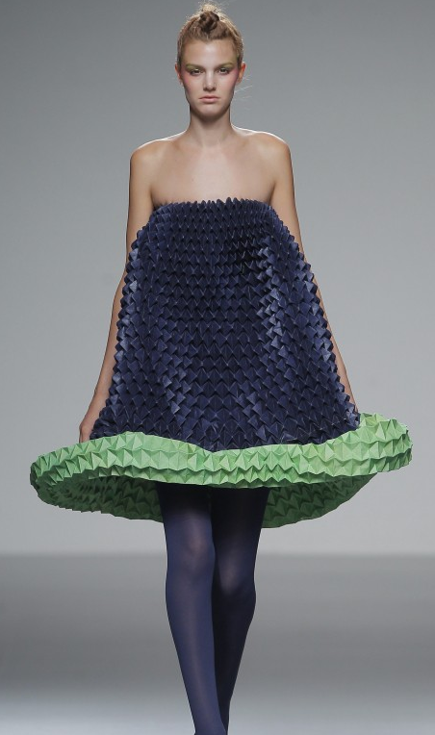

Element:

Principle:

Silhouette

Question Nine (12 marks)

A number of Design Fundamentals are listed below.

- Aesthetic
- Function
- Time Limitation
- Economic
- Safety
- Anthropometric
- Ergonomics
- Social
- Environmental

Name FOUR (4) Design Fundamentals from the list that you have worked with this year and explain how they relate to the following design.

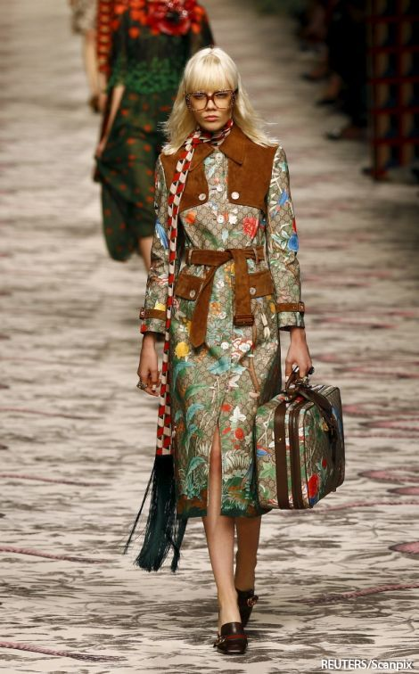
see next page

Question 9 continued

Design Fundamental 1: (3 marks)

Design Fundamental 2 : (3 marks)

Design Fundamental 3: (3 marks)

See next page

Question 9 continued

Design Fundamental 4: (3 marks)

Question Ten (10 marks)

- Label the TWO (2) sets of threads on the diagram of the woven fabric below
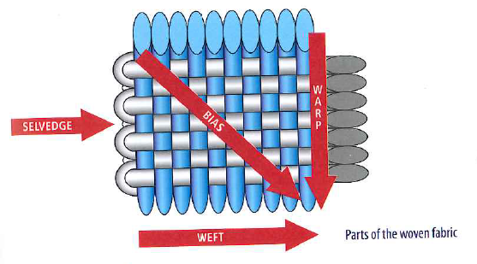
(2 marks)

Thread A:

___________
A
Thread B:

___________

B
B

- Name TWO (2) other fabric structures
(2 marks)

Structure 1:

Structure 2:

See next page

Question 10 continued

- Name each of the fabric weaves in the table and provide a typical use for this weave in the space provided
(6 marks)

 |  | Name Weave | Typical use of weave
1 | 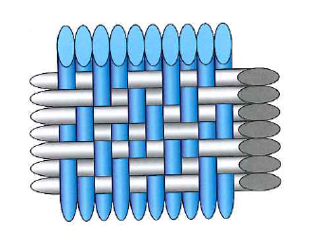
2 | 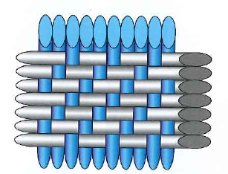
3 | 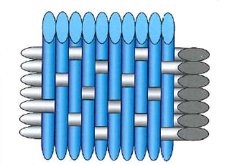

Question Eleven (4 marks)

The following two garments were worn at the 2014/15 Australian Open.

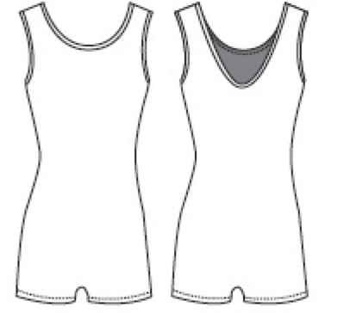
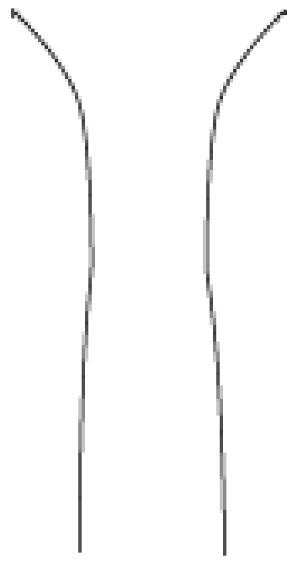
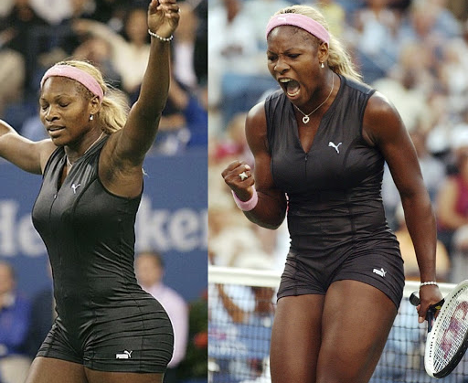

Puma ‘Catsuit’ worn by Serena Williams

Fabric: Polyester and Lycra blend

Features: Centred zip
Body length darts
See next page

Question 11 continued

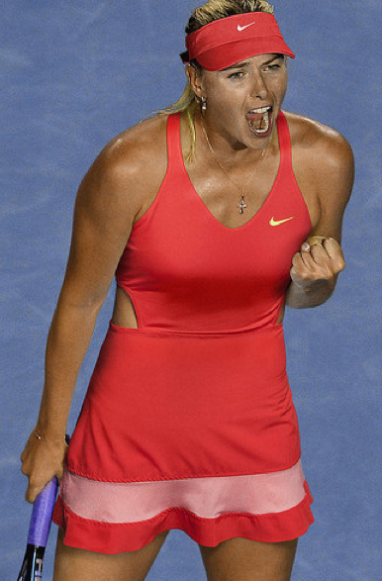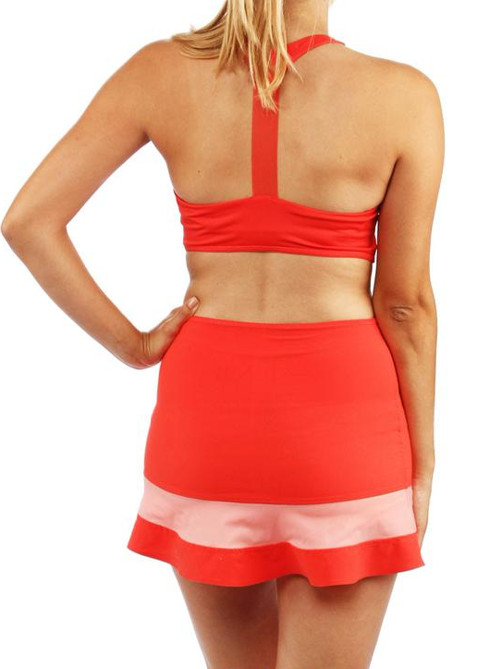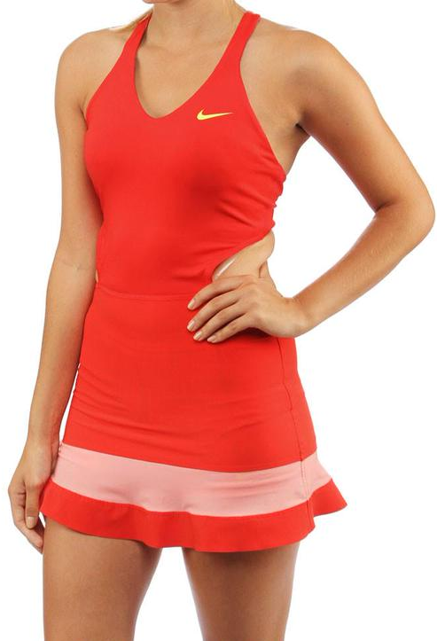

Nike tennis dress worn by Maria Sharapova

Fabric: High technology wicking fabric

Features: Cut away back feature
Halter neck and T-shaped bra

- Select and justify your choice of which of the two garments would be better to wear in a competitive sports context.

Question Twelve (6 marks)

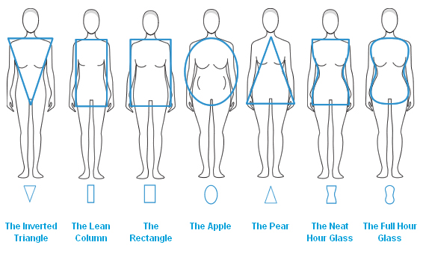

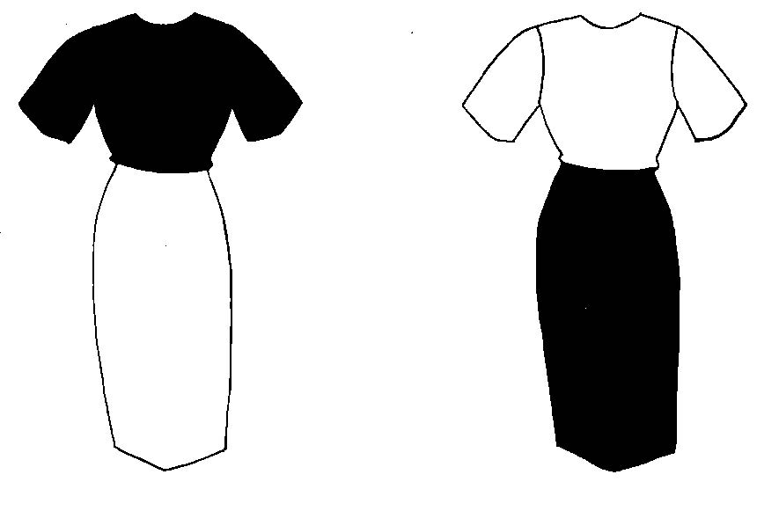
A B
(a) Which dress, A or B, would better flatter the Inverted Triangle body shape shown above? Justify your answer. (3 marks)

Dress:

See next page

Question 12 continued
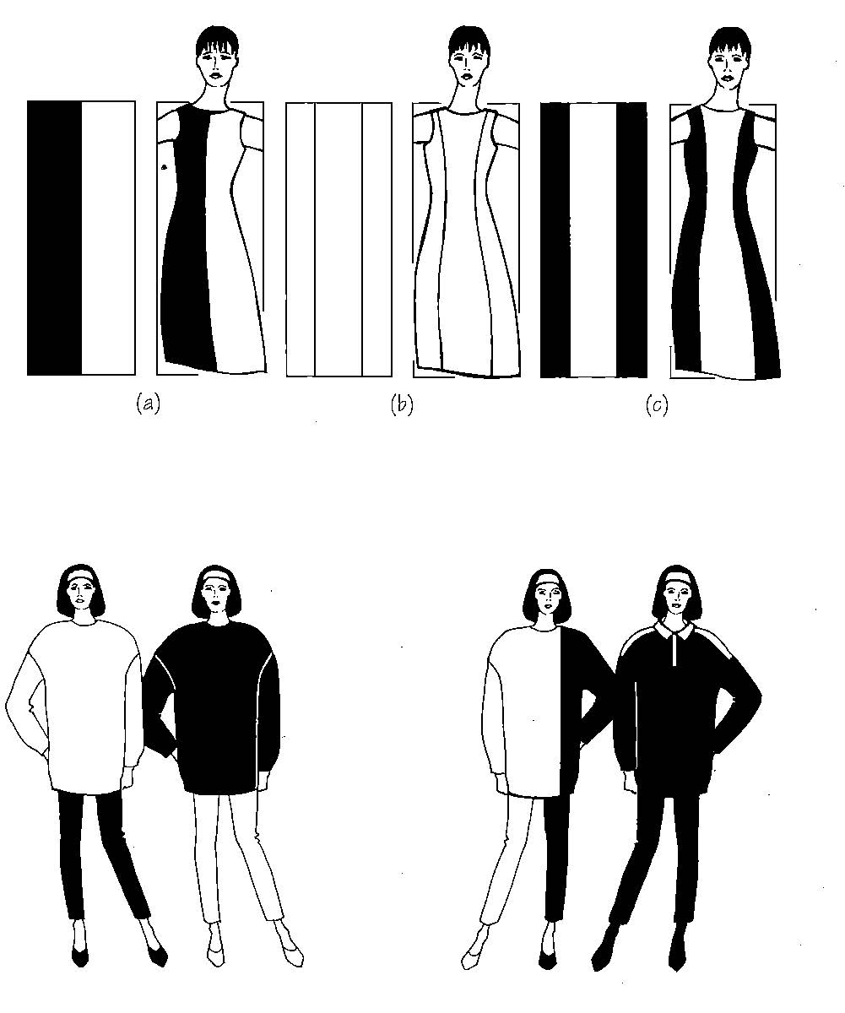
A B C

(b) If you were an Apple body shape, which dress would you choose to best flatter your figure? Justify your answer. (3 marks)

Dress:

Question Thirteen (10 marks)

This question is about fibres and fabrics used for the school blouse shown below.

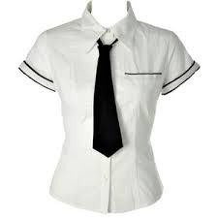

The fabric used in the blouse is a blend of 65% polyester and 35% cotton.

- Explain the properties of this fibre blend which make is suitable for this shirt.
(3 marks)

- Give THREE (3) advantages of using this fabric blend for the blouse. (3 marks)

See the next page
Question 13 continued
- What are the advantages of blending the following fibres in a fabric?

- Nylon / Lycra (2 marks)

- Wool / Nylon (2 marks)

End of Section Three

Spare Page
Question Number:

Spare Page
Question Number:

Spare Page
Question Number:

Spare Page
Question Number:

