
Methodist Ladies’ College
Examination
Semester Two, 2016

Question/Answer Booklet

MATERIALS DESIGN AND TECHNOLOGY
YR 11 ATAR
Units 1 & 2
Sections One, Two & Three

Student Number: In figures

Time allowed for this paper
Reading/planning time before commencing work: ten minutes
Working time for paper: two hours

Material required/recommended for this paper

To be provided by the supervisor

This Question/Answer Booklet
Multiple Choice Answer Sheet

To be provided by the candidate
Standard materials: pens, pencils, eraser, correction fluid, ruler, highlighters

Important note to candidates
No other materials may be taken into the examination room. It is your responsibility to ensure that you do not have any unauthorised notes or other material of a non-personal nature in the examination room. If you have any unauthorised material with you, hand it to the supervisor before reading any further.

Structure of this paper

Section | Number of questions available | Number of questions to be attempted | Suggested working time (minutes) | Marks available | Percentage of exam | Your  Mark
One: Short-answer | 3 | 3 | 20 mins | 15 | 15%
Two: Extended answer | 3 | 3 | 20 mins | 20 | 20%
Three: Textiles specific content | 6 | 6 | 80 mins | 65 | 65%
 |  |  | Total | 100 | 100%

Instructions to candidates

- Answer the questions according to the following instructions

Sections One, Two, and Three: Answer all questions. Write your answers in this Question/Answer booklet.

- You must be careful to confine your responses to the specific questions asked and to follow any instructions that are specific to a particular question.

- Spare pages are included at the end of this booklet. They can be used for planning your responses and/or as additional space if required to continue an answer.
  - Planning: If you use the spare pages for planning, indicate this clearly at the top of the page.
  - Continuing an answer: If you need to use the space to continue an answer, indicate in the original answer space where the answer is continued, i.e. give the page number. Fill in the number of questions that you are continuing to answer at the top of the page.

Section One: Short Answer (15 marks)

This section has THREE (3) questions. Answer all questions. Write your answers in the spaces provided.

Spare pages are included at the end of this booklet. They can used for planning your responses and/or as additional space if required to continue and answer.
  - Planning: If you use the spare pages for planning, indicate this clearly at the top of the page.
  - Continuing an answer: If you need to use the space to continue an answer, indicate in the original answer space where the answer is continued, i.e. give the page number. Fill in the number of questions that you are continuing to answer at the top of the page.

Suggested working time: 15 minutes

Question One (4 marks)

- From the list below, select the TWO (2) most important ‘fundamentals of design’ to consider when designing and manufacturing the Thurle Ride along Mini jogging stroller illustrated bellow. Explain why it is important to consider the selected ‘fundamental of design’ when manufacturing products for young children.
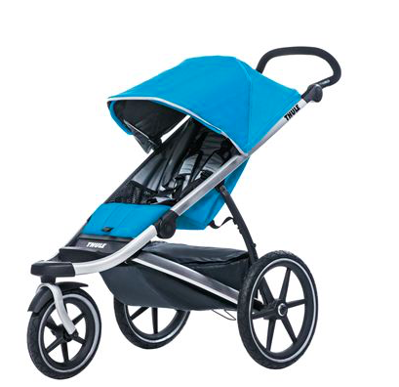

Place the numbers 1 and 2 in the boxes below to indicate your choice.

Function Aesthetics Ergonomics Environment Safety

Fundamental of Design ________________________________________ ( 2 marks)
Reason
__________________________________________________________________________________________________________________________________________________________________________________________________________________________________________________________________________________________________________________________________________________________________________________ See next page
Question One continued
Fundamental of Design ________________________________________ ( 2 marks)
Reason
__________________________________________________________________________________________________________________________________________________________________________________________________________________________________________________________________________________________________________________________________________________________________________________
Question Two (6 marks)

Finishes are often applied to enhance the appearance of a material.
Choose a finishing technique used in your context area to enhance the appearance of a material. Explain how the finish is applied and how it enhances the performance of a chosen material.

Fabric Finish: ___________________________________________ (1 mark)

Chosen Material: ____________________________________________ (1 mark)

Explanation of how finish is applied and how it enhances the performance of a material (4 marks) ________________________________________________________________________________________________________________________________________________________________________________________________________________________________________________________________________________________________________________________________________________________________________________________________________________________________________________________________________________________________________________________________________________________________________________________________________________________________________________________________________________________________________________________________________________________________________________________________________________________________________________________________________________________________________________________________________________________________________________________________________________________________________________________________________________________________________________

See the next page

Question Three ( 5 marks)

- What does PPE stand for? (1 mark)
______________________________________________________________________________________________________________________________________

- What does MSDS stand for? (1 mark)

______________________________________________________________________________________________________________________________________

- A small fire has broken out in the staff kitchen of a textile manufacturing warehouse, all personnel have been evacuated and the fire department has been called.

Identify ONE (1) section of the MSDS the fire department needs to know before proceeding into the property? Justify your answer. (3 marks)

_________________________________________________________________________________________________________________________________________________________________________________________________________
___________________________________________________________________
____________________________________________________________________________________________________________________________________________________________________________________________________________________________________________________________________________
_________________________________________________________________________________________________________________________________________________________________________________________________________
__________________________________________________________________________________________________________________________________________________________________________________________________________________________________________________________________________________________________________________________________________________________________________________________________________________

End of Section One

Section Two: Extended Answer (20 marks)

This section has THREE (3) questions. Answer all questions. Write your answers in the spaces provided.

Spare pages are included at the end of this booklet. They can be used for planning your responses and/or as additional space if required to continue and answer.
  - Planning: If you use the spare pages for planning, indicate this clearly at the top of the page.
  - Continuing an answer: If you need to use the space to continue an answer, indicate in the original answer space where the answer is continued, i.e. give the page number. Fill in the number of questions that you are continuing to answer at the top of the page.

Suggested working time: 15 minutes

Question Four ( 8 marks)
Design elements and principles are carefully considered when designing products.
- Using annotated diagrams, explain what is meant by line and shape in relation to fashion designing. (You may use the fashion template provided at the end of the question paper)
- Line (1 mark)

- Shape (1 mark)

See the next page
Question Four continued
- Sketch and annotate a presentation drawing of a cocktail style dress for a special occasion. The garment must illustrate the use of balance, repetition, emphasis and proportion. (You may use the fashion template provided at the end of the question paper) ( 6 marks)
Special Occasion:____________________________________________________

See the next page
Question Five ( 8 marks)
This question is about trend forecasts and the use of recycled materials in textile products.
- Explain the term ‘trend forecast’ as it is used in the fashion & textile industry.
( 1 mark)

- Explain the research that you can undertake to identify trend forecasts.
( 2 marks)

- Explain how designers use the information from trend forecasts. (2 marks)

See the next page
Question Five continued
- Trend forecasts show that there is a continued interest in the sustainable concept of the three R’s - recycling, reducing and reusing. Explain, giving a specific example of how ONE (1) of the three R’s, can be used in creating a fashionable textile product. (You may use text and diagrams)
( 3 marks)

See the next page
Question Six (4 marks)

Claire is a designer who wants to set up a workshop to produce garments. She intends to employ staff and has the financial backing to achieve this aim. She is concerned about fulfilling her legal obligations regarding the safety of her employees.
Outline in detail the safety requirements for a textile workship / studio.

End of Section Two

Section Three: Textiles Specific Context (65 marks)

This section has SIX (6) questions. Answer all questions. Write your answers in the spaces provided.

Spare pages are included at the end of this booklet. They can be used for planning your responses and/or as additional space if required to continue and answer.
  - Planning: If you use the spare pages for planning, indicate this clearly at the top of the page.
  - Continuing an answer: If you need to use the space to continue an answer, indicate in the original answer space where the answer is continued, i.e. give the page number. Fill in the number of questions that you are continuing to answer at the top of the page.

Suggested working time: 80 minutes

Question Seven (10 marks)

Peter Alexander sleepwear has engaged your services as a designer to design a range of sleepwear for the Summer 2016 range.
- Using your knowledge, and the information provided in the data table below, evaluate the properties of each of the following fibres for the Summer 2016 sleepwear range. (6 marks)
(i) Cotton
(ii) Silk
 | Warmth | Ease of Care | Durability | Elasticity | Crease Resistance
Cotton | ** | *** | **** | * | *
Silk | **** | * | ** | ** | **

Key: * poor ***** excellent
- Cotton Evaluation:

See next page
Question Seven continued

(ii) Silk Evaluation:

See the next page

Question Seven continued
A textile item has the following care label.
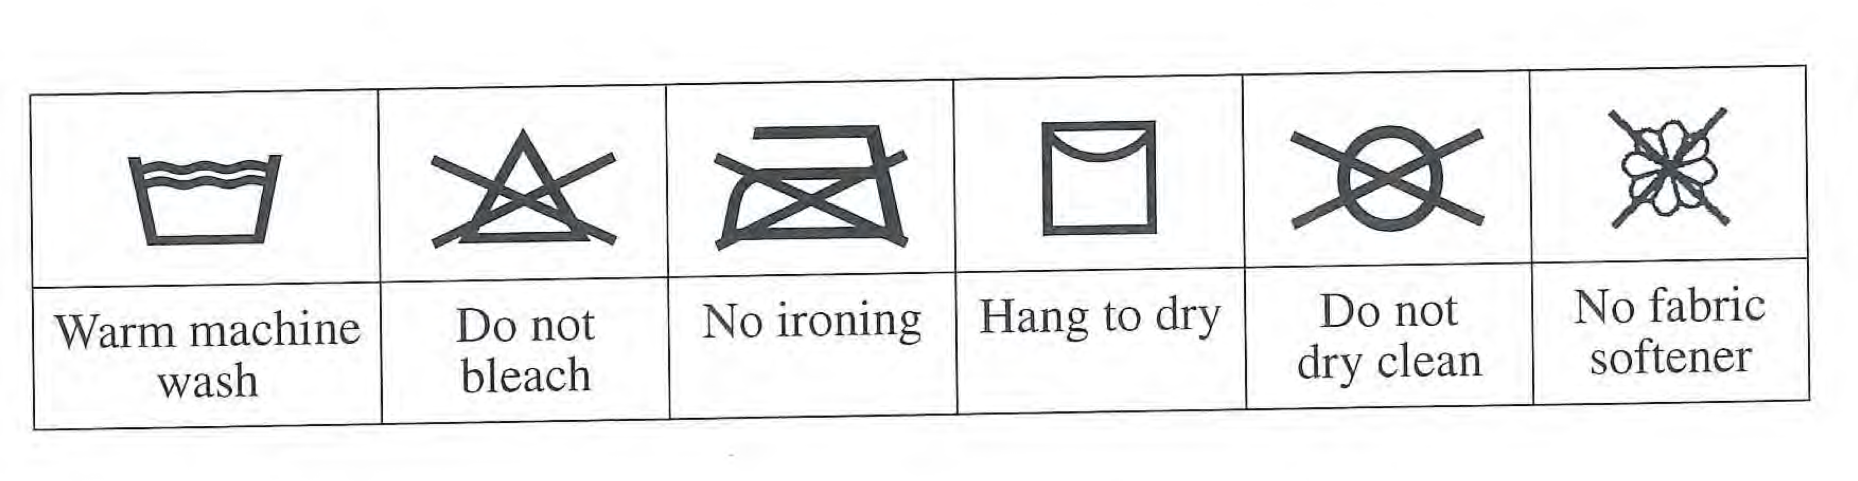
- In which of the following textile items is the care label shown above most likely to be found? (2 marks)
Circle the textile item below that would carry the care label shown above.
  - (i) A cotton bath towel
  - (ii) A wool tailored jacket
  - (iii) A rayon summer shirt
  - (iv) A silk blouse

- Explain your answer (2 marks)

See the next page

Question Eight ( 15 marks)
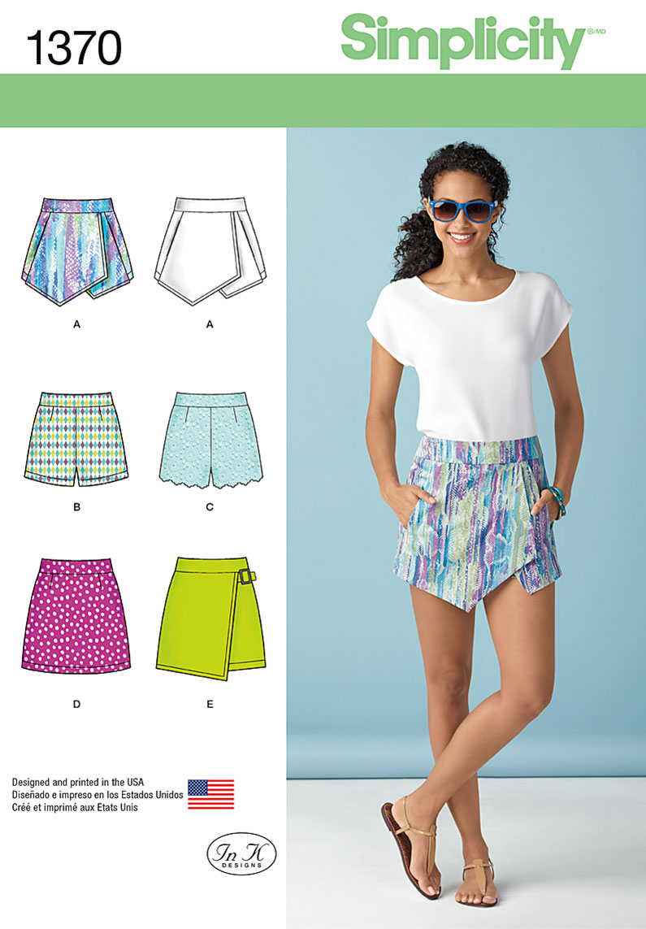

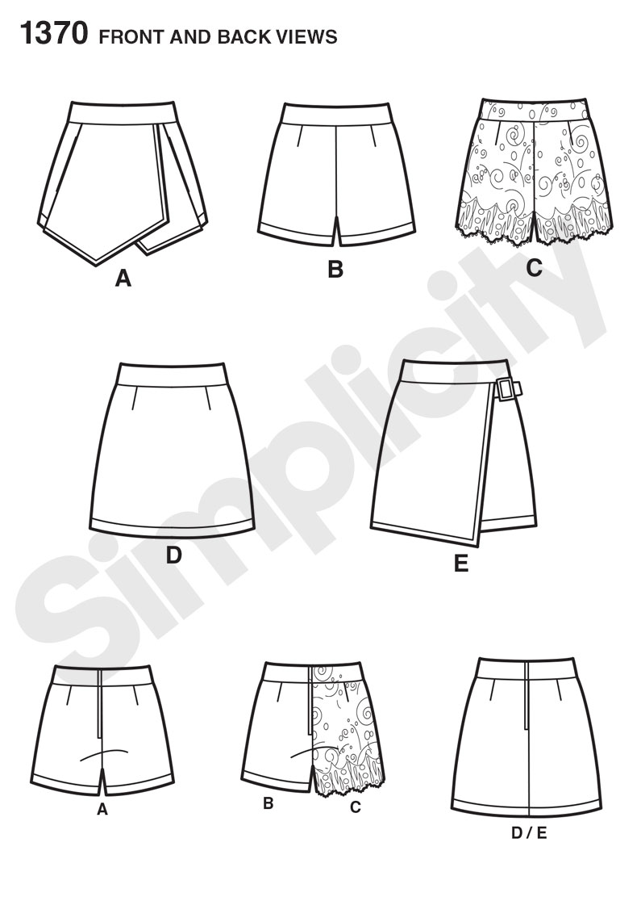

See next page

Question Eight continued
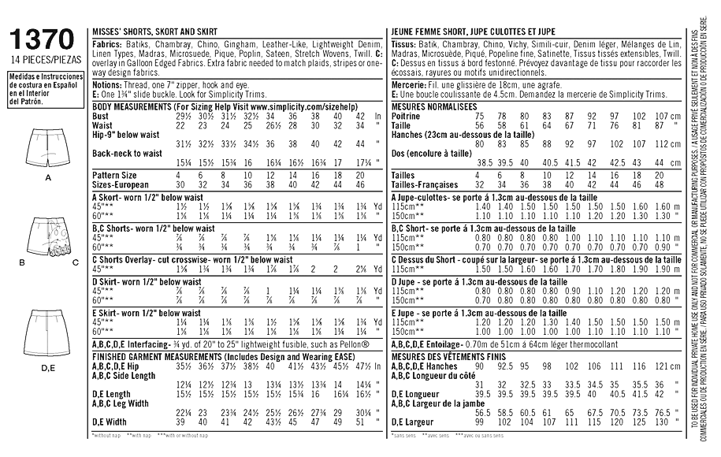

This question refers to Skort pattern View A from Simplicity pattern 1370 shown on the previous page and in the data table above.
The skorts will be made from a medium weight cotton / lycra blended sateen fabric.

a) Using textiles specific terminology, describe the style of this Skort. ( 2 marks)

b) The skorts View A requires a zip closure. Suggest the most appropriate place to insert it and justify your answer. ( 1 mark)

See next page
Question Eight continued

c) Is there another appropriate place to insert the zip in the Skort View A? Justify your answer. ( 1 mark)

d) Suggest and explain a type of hem finish that would be appropriate for the leg hems and justify your answer. (1 mark)

e) Name ONE (1) type of supporting fabric that would be used when making Skort
View A and describe where it would be used.

- Supporting Fabric Name: (1 mark)

- Describe where the supporting fabric would be used: ( 1 mark)

- Describe the function of the supporting fabric when used in this location.
(1 mark)

See next page

Question Eight continued

f) Suggest a process by which you could reduce the bulk of the waistband seam where the band (Yoke) meets the overlay and the skort. (1 marks)

g) A ‘napped’ fabric could be used for the skorts in View A.

i. Give a definition of “with nap” ( 1 mark)

ii. Give ONE (1) disadvantage or difficulty involved with using napped fabrics.
(1 mark)

iii. How will nap affect the pattern layout or construction of Skort View A?
(1 mark)

See next page

Question Eight continued

h) Calculating material requirements:

- Calculate the amount of fabric required to make the Skort View A in a size 10 using 115cms width cotton / lycra blend sateen fabric (1 mark) ________________________________________________________________

- How much interfacing is needed for the Skort View A in a size 10? (1 mark) ________________

- What other notions will be needed to make the Skort View A in a size 10?
(1 mark)
___________________________________________________________________

Question Nine (8 marks)

Outline how an embellishment or decorative technique could be incorporated into a contemporary textile item. Include a simple sketch to support your answer.

Question Ten (10 marks)

- Identify TWO (2) different fabric structures. (2 marks)

Fabric Structure 1:

Fabric Structure 2:

- Describe using text and diagrams how these TWO (2) fabric structures are different.
(8 marks)

Fabric Structure 1:

Fabric Structure 2:

Question Eleven (10 marks)

Natural Fibres are used for a wide range of clothing products.

- Identify TWO (2) natural protein fibres. (2 marks)

- Describe how regenerated cellulose fibres differ from protein fibres? (2 marks)

- Identify TWO (2) properties / characteristics you would expect from a crystalline cellulosic fibre and justify your answer using the microscopic structure and internal molecular structure. (2 marks)

Cellulosic fibre chosen is:

Microscopic structure images:

How this impacts properties/ characteristics:

Question Eleven continued:

Internal molecular structure images:

How this impacts properties/ charcteristics:

- List TWO (2) amorphous fibres (2 marks)

e) Explain the internal molecular structure of an amorphous fibre and describe how it impacts on the fibre properties (2 marks)

Internal molecular structure images:

How this impacts properties/ characteristics:

See next page
Question Twelve ( 12 marks)
The Tanzanian company BioSustain was established with the aim to revive
cotton production using organic farming methods and to provide markets for organic cotton products - with an emphasis on quality.
The Singida region of Tanzania has ideal conditons for cotton production. It is also one of the poorest regions of Tanzania and one third of the region is a game reserve. Sustainable land use is necessary to conserve the area whilst strengthening the economy. BioSustain was established in 2012 with the aim to revive cotton production using organic farming and to provide markets for quality organic cotton products.
Bio Sustain provides farmers with other resources on credit, provide training and technical assistance to farmers as well as support on Fair Trade. Farmers are paid an organic premium for their cotton by BioSustain. To date, more than 3800 small holder producers have entered into contract with BioSustain and this number is expected to significantly increase in the future as BioSustain has acquired a cotton ginnery and oil mill in Singida Town.
Prior to the establishment of this company, cotton manufacture was a cottage industry in Tanzania.

- Describe the environmental impacts you would expect to occur as a result of this development. ( 6 marks)
___________________________________________________________________________________________________________________________________________________________________________________________________________________________________________________________________________________________________________________________________________________________________________________________________________________________________________________________________________________________________________________________________________________________________________________________________________________________________________________________________________________________________________________________________________________________________________________________________________________________________________________________________________________________________________________________________________________________________________________________________________________________________________________________________________________________________________________________________________________________________________________ See next page

Question Twelve continued
___________________________________________________________________________________________________________________________________________________________________________________________________________________________________________________________________________________________________________________________________________________________________________________________________________________________________________________________________________________________________________________________________________________________________________________________________________________________________________________________________________________________________________________________________________________________________________________________________________________________________________________________________________________________________________________________________________________________________________________________________________________________________________________________________________________________________________________________________________________________________________________________________________________________________________________________________________________________________________________________________________________________________________________________________________________________________________________________________________________________________________________________________________________________________________________________________________________________________________________________________________________________________________________________________________________________________________________________________________________________________________________________________________________________________________________________________________________________________________________________________________________________________________________________________________________________________________________________________________________________________________________________________________________________________________________________________________________________________ See next page

Question Twelve continued
- Describe the social and economic impacts you would expect to occur as a result of this development. (6 marks)
_____________________________________________________________________________________________________________________________________________________________________________________________________________________________________________________________________________________________________________________________________________________________________________________________________________________________________________________________________________________________________________________________________________________________________________________________________________________________________________________________________________________________________________________________________________________________________________________________________________________________________________________________________________________________________________________________________________________________________________________________________________________________________________________________________________________________________________________________________________________________________________________________________________________________________________________________________________________________________________________________________________________________________________________________________________________________________________________________________________________________________________________________________________________________________________________________________________________________________________________________________________________________________________________________________________________________________________________________________________________________________________________________________________________________________________________________________________________________________________________________________________________________________________________________________________________________________________________________________________________________END OF EXAM

Spare page
Question number___________ ____________________________________________________________________________________________________________________________________________________________________________________________________________________________________________________________________________________________________________________________________________________________________________________________________________________________________________________________________________________________________________________________________________________________________________________________________________________________________________________________________________________________________________________________________________________________________________________________________________________________________________________________________________________________________________________________________________________________________________________________________________________________________________________________________________________________________________________________________________________________________________________________________________________________________________________________________________________________________________________________________________________________________________________________

Spare Page
Question Number:

Spare Page
Question Number:

Spare Page
Question Number:

